VistA Scheduling Enhancements (VSE)

Technical Manual



December 2019

Version 1.2

Department of Veterans Affairs

Revision History

|  |  |  |  |
| --- | --- | --- | --- |
| Date | Version | Description | Author |
| 12/06/2019 | 1.2 | Additional edits requested; resubmitted | AbleVets |
| 12/03/2019 | 1.1 | Client comments resolved; resubmitted | AbleVets |
| 12/18/2018 | 1.0 | Update versioning | AbleVets |
| 04/26/2018 | 0.1 | Initial draft of the artifact | AbleVets |

Artifact Rationale

A Technical Manual is a required end user document for all Office of Information & Technology (OIT) software releases. The intended audience for this document is local IT support, management, and development personnel for nationally released software. It provides sufficient technical information about the software for developers and technical personnel to operate and maintain the software with only minimal assistance from Product Support staff.

CLIN Satisfaction Statement

This document is submitted in satisfaction of CLIN 8001AY and CLIN 8001CS.

Table of Contents

1. Overview 1

1.1. Security 1

1.2. Rules of Behavior 1

1.3. Orientation 1

2. GUI Implementation and Maintenance 2

2.1. System Requirements 2

2.2. Overview 2

2.3. List of GUI Modules and Components Affected 28

2.3.1. Common 28

2.3.1.1. User Controls 29

2.3.1.1.1. IncrementalSearchComboBox 29

2.3.1.1.2. DateTimePicker Control 30

2.3.2. Modules 33

2.3.2.1. CancelAppt 33

2.3.2.2. ChangeDivision 33

2.3.2.3. CheckIn 33

2.3.2.4. CheckOut 33

2.3.2.5. ContactAttempt 33

2.3.2.6. DataAccess 33

2.3.2.7. ExpandedEntry 33

2.3.2.8. FindAppt 33

2.3.2.9. Management 33

2.3.2.10. MarkAsNoShow 33

2.3.2.11. Navigation 33

2.3.2.12. PatientAppt 33

2.3.2.13. PatientSelection 34

2.3.2.14. Prerequisites 34

2.3.2.15. Reports 34

2.3.2.16. ResourceSelection 34

2.3.2.17. Ribbon 34

2.3.2.18. Task 34

2.3.2.19. UserLogin 34

2.3.2.20. VAR 34

2.3.3. Unit Tests 34

2.3.4. ClinSchd 34

2.3.5. CreateWebServices 35

2.3.6. InstallerCustomActions 35

2.3.7. ClinSchedInstaller 35

2.3.8. VARMobileAppMockup 35

2.3.9. Web Services 35

2.3.9.1. VSE_VAR_Client 35

2.3.9.2. VSE_VAR_DataAccessService 35

2.3.9.3. VSE_VAR_Service 35

2.3.9.4. VSE_VAR_Service_Interfaces 35

2.3.9.5. VSE_VAR_ServiceConsoleHost 35

2.3.9.6. VSE_VAR_TestClient 35

2.4. Structure of Code Modules 35

2.4.1. Module Project 36

2.4.2. Module Class 36

2.4.3. Controller Class 37

2.4.4. Service Class 38

2.5. Organization of Rational Streams 39

2.6. Troubleshooting Using the Trace Log 40

2.7. Configuring the GUI 41

2.7.1. The <appSettings> Section 41

2.7.2. The <system.ServiceModel><client><endpoint> Section 42

2.7.3. Command Line Parameters 42

2.7.3.1. The /trace Command Line Parameter 42

2.7.3.2. The /AutoDump Trace Command Line Parameter 42

2.7.4. The Application Trace File 42

2.8. Client Application Dependencies and Files 42

2.9. VS GUI Trace Log 45

2.10. Request Management 48

2.11. Internal Relations 49

2.12. External Relations 49

2.13. Published Entry Points 49

2.14. Maintaining RC, Test, and Prod Builds 49

2.14.1. Before Making the Builds 49

2.14.2. Create the Builds 52

2.14.3. Editing and Committing the Builds 54

3. Legacy VistA Scheduling Implementation and Maintenance 55

3.1. System Requirements 55

3.2. Package-wide Variables 55

3.3. Routines 56

3.4. Files and Tables 60

3.4.1. File Access 61

3.5. VistA Scheduling GUI Cross References 62

3.5.1. #44 HOSPITAL LOCATION 62

3.5.2. #403.5 RECALL REMINDERS 63

3.5.3. #403.56 – RECALL REMINDERS REMOVED 64

3.5.4. #409.3 – SD WAIT LIST 64

3.5.5. #409.81 SDEC APPLICATION 68

3.5.6. #409.822 SDEC ACCESS GROUP 68

3.5.7. #409.823 SDEC ACCESS TYPE 68

3.5.8. #409.824 SDEC ACCESS GROUP TYPE 69

3.5.9. #409.831 – SDEC RESOURCE 69

3.5.10. #409.832 SDEC RESOURCE GROUP 70

3.5.11. #409.833 – SDEC RESOURCE USER 71

3.5.12. #409.834 – SDEC ADDITIONAL RESOURCE 71

3.5.13. #409.84 – SDEC APPOINTMENT 72

3.5.14. #409.845 SDEC PREFERENCES AND SPECIAL NEEDS 73

3.5.15. #409.85 – SDEC APPT REQUEST 73

3.6. Table File 79

3.6.1. #403.5 RECALL REMINDERS File 79

3.6.2. #403.56 RECALL REMINDERS REMOVED 83

3.6.3. #409.3 SD WAIT LIST 87

3.6.4. #403.5 RECALL REMINDERS 101

3.6.5. #403.56 RECALL REMINDERS REMOVED 105

3.6.6. #409.81 SDEC APPLICATION File 109

3.6.7. #409.822 SDEC ACCESS GROUP 110

3.6.8. #409.823 SDEC ACCESS TYPE 111

3.6.9. #409.824 SDEC ACCESS GROUP TYPE 113

3.6.10. #409.831 SDEC RESOURCE 114

3.6.11. #409.832 SDEC RESOURCE GROUP 118

3.6.12. #409.833 SDEC RESOURCE USER 119

3.6.13. #409.834 SDEC ADDITIONAL RESOURCE 121

3.6.14. #409.84 SDEC APPOINTMENT 122

3.6.15. #409.845 SDEC PREFERENCES AND SPECIAL NEEDS 128

3.6.16. #409.85 SDEC APPT REQUEST 129

3.6.17. #409.86 SDEC CONTACT 141

3.6.18. #409.97 SD AUDIT STATISTICS 144

3.7. Exported Options 149

3.8. Parameter Definitions 150

3.9. Security Keys 150

3.10. Archiving and Purging 151

4. Generating Online Documentation 151

4.1. %Index 151

4.2. List File Attributes 152

4.3. Standards and Conventions, Requirements and Exemptions 152

4.4. Callable Routines 152

A. Appendix 1: Acronyms and Abbreviations 153

Table of Figures

Figure 1: VistA Scheduling GUI Main Screen 2

Figure 2: Pending Request List - Print 4

Figure 3: Ribbon Bar Tools Menu, Query Option 4

Figure 4: User Preferences 5

Figure 5: RM Grid Option Menu 6

Figure 6: Appointment Request Type 7

Figure 7: Appointment Request 8

Figure 8: New Appointment Popup 9

Figure 9: Appointment Start Time 10

Figure 10: Patient Contacts 11

Figure 11: Patient Information 12

Figure 12: Patient Inquiry Detail 13

Figure 13: Patient Flags Dialog 13

Figure 14: Sensitive Patient Dialog 14

Figure 15: Appointment Check-In 15

Figure 16: Appointment Check-Out 16

Figure 17: Cancel Appointment Dialog 17

Figure 18: MRTC Cancel Appointment Dialog 18

Figure 19: Appointment No-Show 19

Figure 20: MRTC Find Appointment Dialog 20

Figure 21: Expanded Entry Dialog 21

Figure 22: Print Pending Appointments 21

Figure 23: Pending Appointments Printout 22

Figure 24: Pending Appointments Date Filter 22

Figure 25: Clinic Availability Selection Dialog 23

Figure 26: Availability Dialog 24

Figure 27: Scheduling Management - Prohibited Clinics 25

Figure 28: Scheduling Management - Clinic Groups 25

Figure 29: Reports Tab - Audit Activity 26

Figure 30: Reports Tab - Clinic Reports 26

Figure 31: Trace Log 27

Figure 32: VSE GUI Logon 28

Figure 33: Code Extract 1 32

Figure 34: Code Extract 2 32

Figure 35: Trace Log Capability Shortcut 45

Figure 36: Show Trace Log Menu Option 46

Figure 37: Trace Log 46

Figure 38: Saving the Trace Log 47

Figure 39: Request Query 48

Figure 40: Query Results 49

Figure 41: ClinSchedInstaller Properties Dialog 51

Figure 42: ProductCode Update Dialog 51

Figure 43: ClinSchedInstaller Properties Page and Upgrade Code Dialog 52

Figure 44: ClinSchedInstaller Properties Page and Product Code Dialog 53

Figure 45: Editing the ProductVersion Field Under Property 54

Figure 46: Editing the Name Field Under Shortcut 55

Table of Tables

Table 1: DateTimePicker Control Details 30

Table 2: Module Project 36

Table 3: Module Class 36

Table 4: Controller Class 37

Table 5: Service Class 38

Table 6: Rational Streams 39

Table 7: Clinical Scheduler Files 42

Table 8: Third-Party Controls 44

Table 9: Client Configuration Files 44

Table 10: Upgrade Codes 52

Table 11: Routines and Descriptions 56

Table 12: File Names and Numbers 61

Table 13: File Access 62

Table 14: Exported Options and Descriptions 149

Table 15: Parameter Descriptions 150

Table 16: Exported Security Keys 150

Table 17: Acronyms and Abbreviations 153

# Overview

This manual provides Department of Veterans Affairs (VA) site managers with a technical description of the Veterans Health Information System and Technology Architecture (VistA) Scheduling (VS) Graphical User Interface (GUI) routines, files, menus, cross references, globals, and other necessary information required to effectively manage the system.

The VistA Scheduling GUI module has the following features:

* Microsoft (MS) Windows user interface
* Graphical patient, clinic, provider, and resource scheduling
* Tight linkage to VistA patient and clinic data
* Graphical resource and clinic availability scheduling
* Printing and What You See Is What You Get (WYSIWYG) print preview of clinic schedules
* Graphical patient check-in links to VistA/Patient Care Components Plus (PCC+) check-in
* Reschedule and manipulate appointments using standard Windows cut/paste metaphors utilities procedures
* Schedule multiple appointments during a time block
* Store and retrieve clinic availability patterns
* Simultaneously view schedules for multiple clinics
* Resource Management Reporting for viewing metrics related clinic appointments and patient encounters in VistA

## Security

The VistA Scheduling GUI uses VistA security keys to limit users’ ability to change system setup parameters and patient information. In other words, not all VistA Scheduling GUI options are available to all users. Contact the Site Administrator to determine or change security keys.

## Rules of Behavior

All VistA users are required to observe VA rules of behavior regarding patient privacy and the security of both patient information, and VA computers and networks.

## Orientation

The VistA Scheduling GUI module has no VistA server menu options. The only VistA server preparation specifically required to run VistA Scheduling GUI v1.6 is to install Patch SD*5.3*686 and use the Kernel Installation and Distribution System (KIDS) module to assign the appropriate security keys to users. The rest of the module runs on the PC client and can be managed from there. The executable runs on the PC client whether it is obtained from a local hard drive or downloaded from a central server.

Interaction of VistA Scheduling GUI with the VistA system is accomplished entirely via the use of Remote Procedure Calls (RPCs).

# GUI Implementation and Maintenance

## System Requirements

* Client Operation
  + Windows 7 or later
  + .NET version 4.0 or higher
  + Four (4) gigabyte (GB) random access memory (RAM)
* Client Development/Maintenance
  + Windows 7 or later
  + Visual Studio 2017
  + Rational Source Repository
  + Rational Source Control Plug-In
  + VistA instance with RPC Broker for unit testing
  + VistA Scheduling Patch SD*5.3*686

## Overview

The main screen of the VistA Scheduling GUI is shown in Figure 1. After logon, the main screen is displayed. A call to SDECIDX GETREC with subsequent calls to SDEC ARGET, SDEC WLGET, SDEC RECGET and SDEC REQGET RPCs is made to populate the Request Management (RM) Grid.

Figure 1: VistA Scheduling GUI Main Screen

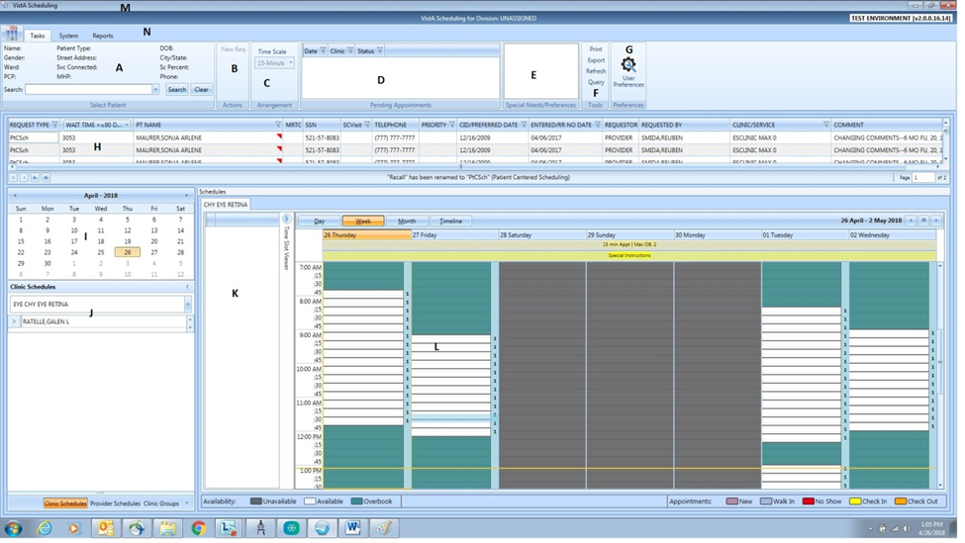

The principal sections of this screen are as follows (letters refer to the markings in the figure):

**A. Ribbon Bar Patient Information**

This part of the main GUI screen is used to search for and select a patient and to display information about the patient. The SEARCH button invokes the SDEC PTLOOKRS RPC to match patients in the VistA PATIENT File (#2) with the input entered into the associated search box. A list of matching names is displayed in a result list beneath the search box. Clicking on a listed patient displays demographic data (reused from the SDEC PTLOOKRS RPC call previously made) in the fields shown in the Ribbon Bar. Once a patient is selected, the New Req. link in the Ribbon Bar Actions Menu is also activated.

If a patient is selected from the results list, the Clear button removes them from the search box results, deselects the patient, and refreshes the **Request Management (RM) Grid**.

When selecting an Appointment Request in the RM Grid or an Appointment from a **Calendar Schedule** SDEC GETREGA is called to populate the Patient Information.

 **NOTE:** Some data returned by RPC calls is cached by the GUI for a minimum of 5 minutes or until the Refresh button in the Ribbon Bar Tools Menu is clicked.

**B. Ribbon Bar Actions Menu**

This pane in the Ribbon Bar contains a link to begin appointment request creation (see Appointment Request Type Dialog below).

**C. Ribbon Bar Arrangements Menu**

This pane in the Ribbon Bar is now inoperative. Business Owners from Veterans Health Administration (VHA) advised that this pane can be removed from the Ribbon Bar.

**D. Pending Appointments**

This pane contains a sortable list of pending appointments for a patient. RPC SDEC FAPPTGET is called with a date range of 365 days in the past to 1000 days in the future to populate the list. The data is organized in three columns (date, clinic, appointment status), and can be sorted in ascending or descending order or filtered by the user (see Pending Appointments Column Filters below).

Clicking on an appointment calls a series of RPCs including but not limited to SDEC RESOURCE, SDEC CLINSET, SDEC APPSLOTS and SDEC CRSCHED to populate the Calendar Schedule. Right-clicking in this pane, except in the header, produces an appointment context menu (see Print Pending Appointments below) that can be used to display additional appointment information or that can be used to print pending appointments.

**E. Patient Special Needs/Preferences Window**

This pane displays a patient’s special needs or preferences. The data comes from the SDEC PTLOOKRS or SDEC GETREGA RPCs that are called when the patient is selected (see Ribbon Bar Patient Information). The special needs or preferences can be modified by right-clicking in the Ribbon Bar Patient Information and using the Patient Information Dialog.

**F. Ribbon Bar Tools Menu**

This pane has four selection options: Print, Export, Refresh, and Query. Print (Figure 2) and Export allow the user to output the pending request list (stored in the RM Grid) as either a printout or a spreadsheet. Refresh and Clear both remove the patient from context, and reloads the pending request list with all requests for the facility.

Query (Figure 3) allows the user to select specific data filters to use to repopulate the entries on the pending request list.

Figure 2: Pending Request List - Print

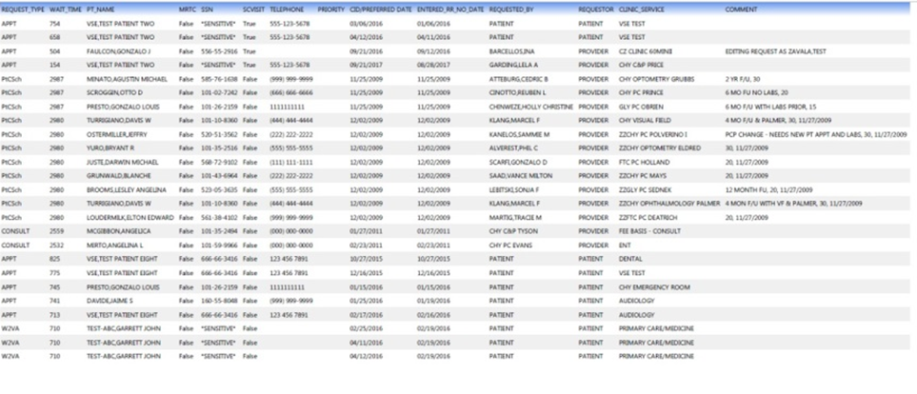

Figure 3: Ribbon Bar Tools Menu, Query Option

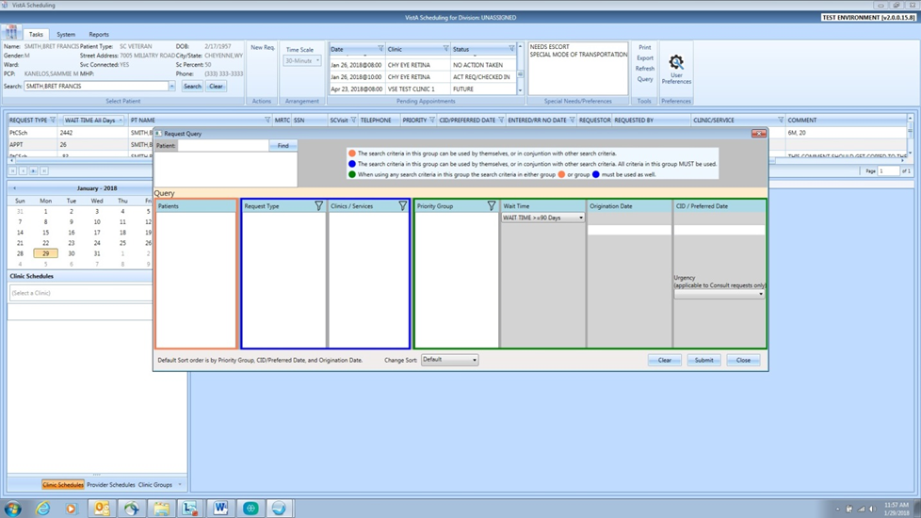

**G. User Preferences**

In this window, the user specifies the criteria applied to selecting appointment requests to be displayed in the pending request list (RM Grid). User settings are obtained from VistA by calling the SDECRMGP GETRMGUP RPC. If the user checks the save as default box, the changed criteria are stored back in VistA via the SDECRMGP PUTRMGUP RPC.

Figure 4: User Preferences

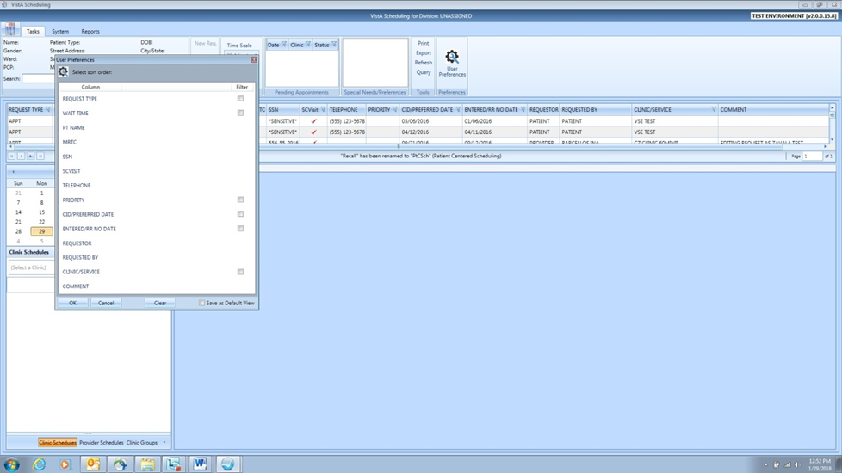

**H. Request Management (RM) Grid**

Upon initial logon, the RM Grid displays the facility’s pending request list or a pending request list based on the user’s previously saved user preferences. If a patient has been selected (Ribbon Bar Patient Information), the patient’s outstanding pending appointment requests are displayed. Data for either version of this list are obtained from VistA via a call to SDECIDX GETREC with subsequent calls to SDEC ARGET, SDEC WLGET, SDEC RECGET and SDEC REQGET RPCs. Right-clicking on an appointment request opens an option menu (Figure 5) which allows the user to open selected appointment request context windows (Figure 7) or to access Patient Contacts.

Figure 5: RM Grid Option Menu

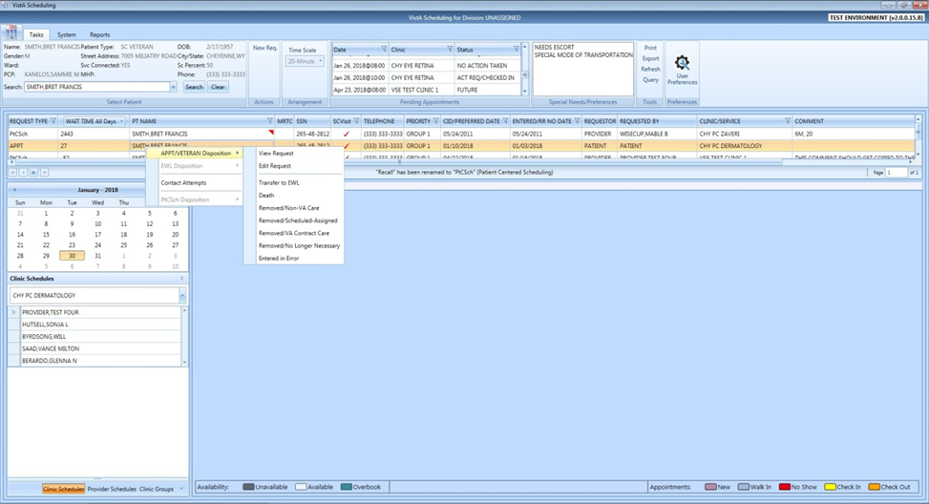

**I. Calendar Navigation Pane**

This pane allows the user to switch dates in the Calendar Schedule when a clinic, provider or clinic group has been selected in the Clinic/Provider Navigation Pane. Clicking on a date invokes the SDEC APPSLOTS, SDEC CRSCHED, and other RPCs to populate the calendar.

**J. Clinic/Provider Navigation Pane**

This pane allows the user to select a specific clinic, provider, or clinic group for display in the Calendar Schedule. The GUI calls a VistA RPC (SDEC RESOURCE with different input parameters for clinics and providers, or SDEC RESGPUSR for clinic groups) when the user pauses typing and at least 2 characters of the clinic, provider, or clinic group name has been entered.

**K. Time Slot Viewer**

This pane shows characteristics of the time slot selected in the Calendar Schedule. It displays the date and time of the slot, along with the number of appointments permitted to be scheduled in the slot. The data displayed comes from the same RPC calls used to populate the Calendar Schedule.

**L. Calendar Schedule**

This section of the main screen displays a calendar of appointments scheduled for the selected clinic, provider, or clinic group (see Clinic/Provider Navigation Pane). The data shown is obtained via calls to the VistA RPCs SDEC APPSLOTS and SDEC CRSCHED.

**M. Title Bar**

Right-clicking on the Title Bar at the top of the main screen opens the standard Windows option menu (e.g., minimize, close) that includes a link to the Trace Log.

**N. Option Tabs**

There are three option tabs near the top of the main screen. The Tasks tab encompasses what is described as the main screen. The other tabs are the System and Reports tabs.

In addition to the main screen, the GUI employs many popup windows to fulfill its scheduling duties. These additional windows are:

**Appointment Request Type Dialog**

The Appointment Request Type popup window (Figure 6) appears when a user clicks *New Req.* in the Ribbon Bar Actions Menu. The link is disabled unless a patient has been selected in the Ribbon Bar Patient Information.

Figure 6: Appointment Request Type

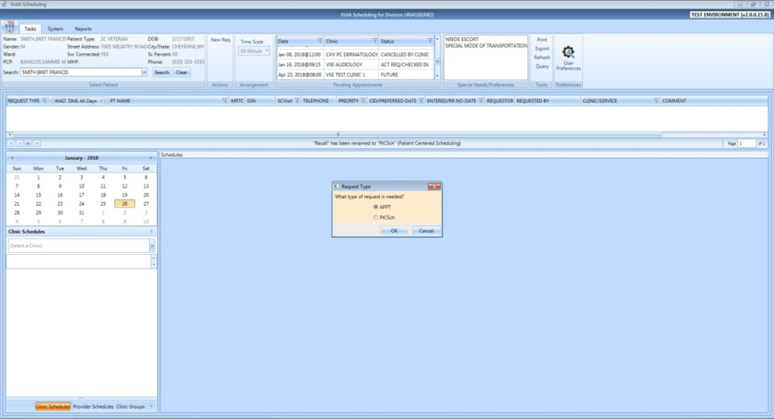

**Appointment Request Dialog**

The Appointment Request popup window (Figure 7) appears when the user clicks OK in the Appointment Request Type Dialog. The patient’s demographic information is displayed from the cached RPC data (SDEC PTLOOKRS). Clinic lookup is done by a call to the SDEC RESOURCE and SDEC CLINSET RPCs. If PROVIDER is selected in the Entered By dropdown box, the name entered in the Provider box is matched against VistA with a call to the SDEC RESOURCE RPC. Clicking OK files the appointment request in VistA through a call to the SDEC ARSET RPC. The user may also specify a Multiple Return to Clinic (MRTC) Request by checking the Multiple Request Required checkbox, then specifying the number of appointments and duration between appointments. Doing so will create a Parent MRTC Request.

Figure 7: Appointment Request

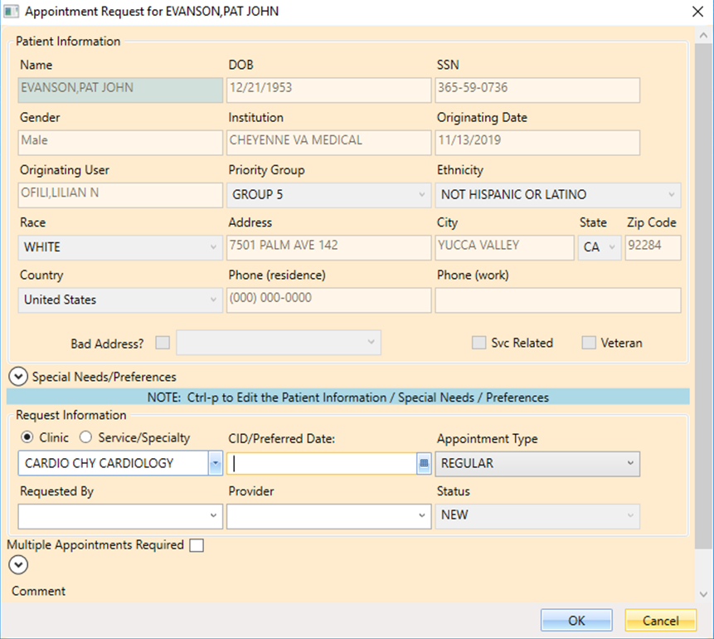

**Appointment Dialog**

The Appointment popup window (Figure 8) appears when the user selects a calendar timeslot for an appointment request, and right-clicks and selects Add Appointment or Create Walk-in Appointment. The data to populate the window comes from cached SDEC PTLOOKRS RPC data (patient demographics) and from the appointment request (appointment date and clinic). Appointment conflicts are obtained by a call to the SDEC FAPPTGET RPC, targeting only the day of the new appointment. If the user clicks on the Start Time entry box (Figure 9), the popup is populated with timeslot start times calculated from clinic setup data obtained via the SDEC APPSLOTS RPC call. The “standard” start time for a clinic is 0800, but this can vary if a clinic schedule is set up in VistA using the SDBUILD option.

Figure 8: New Appointment Popup

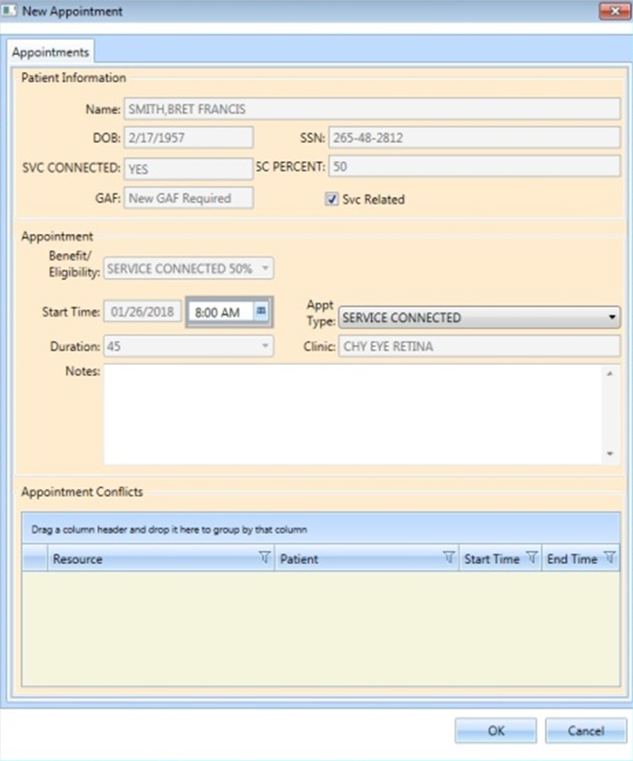

Figure 9: Appointment Start Time

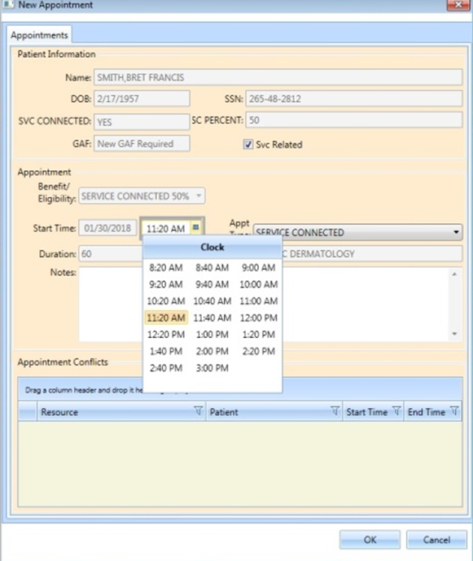

**Patient Contacts**

The Patient Contacts window (Figure 10) appears through interaction on the RM Grid. The data displayed in this popup comes from a call to the SDEC CONTACT DISPLAY and SDEC CONTACT MULI-DISPLAY RPCs. Data entered in the New Contact Attempt section is stored in VistA via a call to the SDEC CONTACT UPDATE RPC.

Figure 10: Patient Contacts

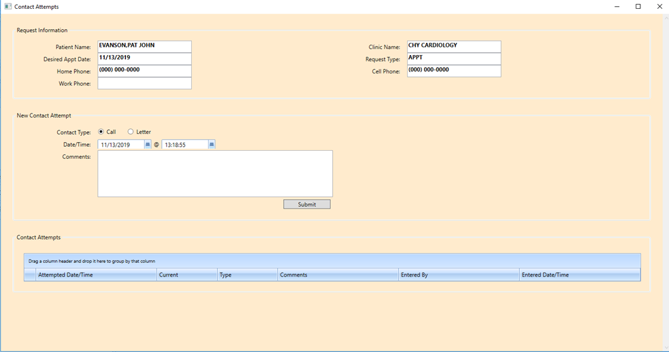

**Disabilities Dialog/Patient’s Eligibility**

This popup window (Figure 7) appears to the left of the Appointment Request Dialog or the Appointment Dialog. It displays data obtained from VistA via an SDECDIS DISABIL RPC call.

**Similar Patient Dialog**

The Similar Names dialog displays when the system finds patients with a similar name and the same last 4 digits of the Social Security Number. The user is able to select a patient from the list and continue, or cancel and return to searching for patients. In addition to the RPC calls used in Ribbon Bar Patient Information, this dialog also calls DG CHK BS5 XREF ARRAY.

**Patient Information Dialog**

This popup (Figure 11) appears when the user right-clicks in the Ribbon Bar Patient Information pane or presses CTRL+P. The data displayed comes from cached data obtained from the SDEC PTLOOKRS RPC.

Figure 11: Patient Information

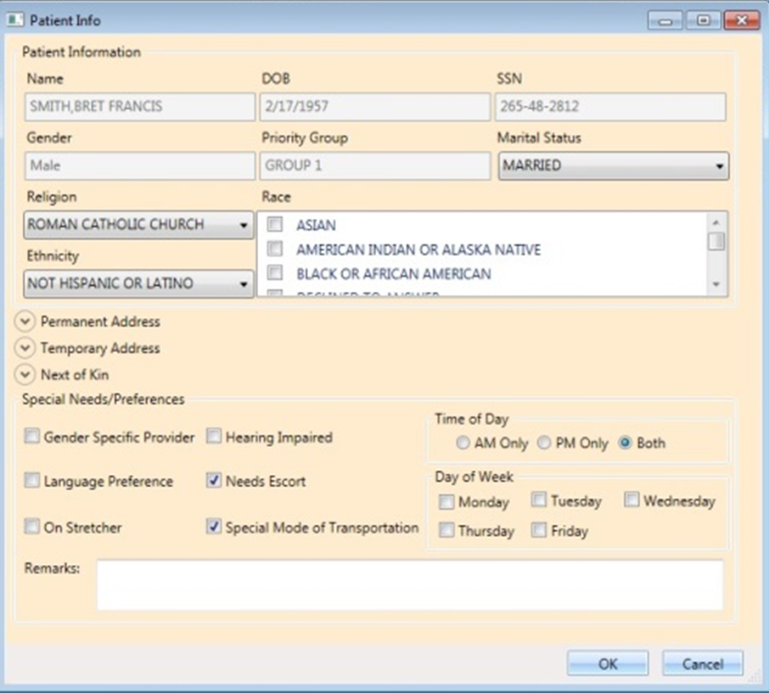

**Patient Inquiry Detail**

The Patient Inquiry Detail popup (Figure 12) appears if the user clicks anywhere in the Ribbon Bar Patient Information. The data displayed comes from a call to the SDEC PTINQ RPC.

Figure 12: Patient Inquiry Detail

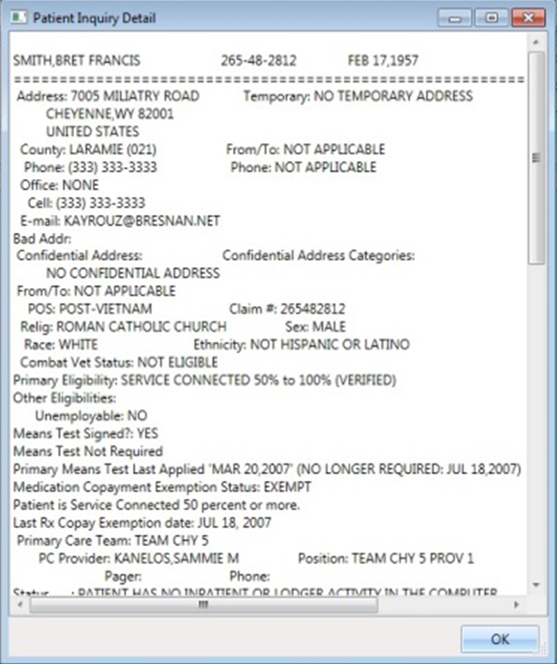

**Patient Flags Dialog**

The Patient Flags dialog (Figure 13) displays important Patient Flags and Prompts. The information displayed in the Patient Flags dialog is retrieved by a call to the ORPRF GETFLF RPC call.

Figure 13: Patient Flags Dialog

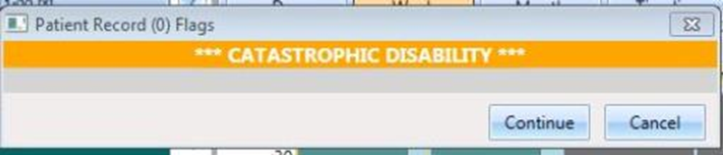

**Sensitive Patient Dialog**

The purpose of the Sensitive Patient Dialog (Figure 14) is to notify the user that the patient he/she is about to access has characteristics different from the norm. When search results include a sensitive patient, their date of birth and Social Security Number are masked, and the *SENSITIVE* designation can be seen in the results list. The user can choose to continue to see the patient’s information or not select the patient.

There are three different types of sensitive patient dialogs that vary by background color and the effect on the user. The GUI obtains sensitive patient data and its severity from the DG SENSITIVE RECORD ACCESS RPC.

A white background is the lowest level of sensitivity. A user who clicks through (continue button) a sensitive patient warning with a white background is not otherwise encumbered. A window with a yellow background notifies the user that if they access the patient, the Information Security Officer (ISO) will be notified (via the DG SENSITIVE RECORD BULLETIN RPC), and they must justify access. A window with a red background prevents the user from accessing the patient’s record. The programmed STOP prevents the user from, for example, accessing their own record.

Figure 14: Sensitive Patient Dialog

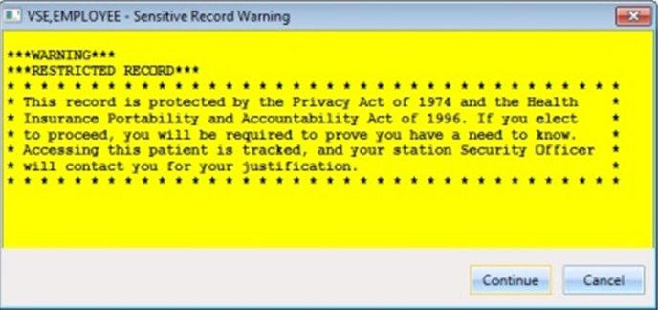

**Check-in Dialog**

This popup window (Figure 15) appears when the user right-clicks on a current or past appointment on the Calendar Schedule and selects Check In Patient. The data entered in the window is passed back to VistA via a call to the SDEC CHECKIN RPC.

Figure 15: Appointment Check-In

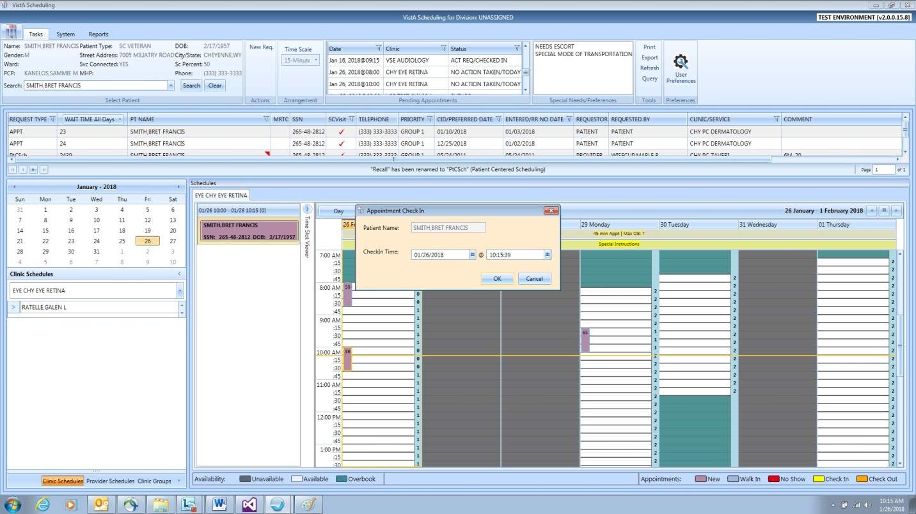

**Check-Out Dialog**

The Appointment Check-Out Dialog (Figure 16) appears when the user right-clicks on a current or past appointment on the Calendar Schedule, Pending Appointment List, or the Timeslot Viewer and selects Check Out Patient. The data entered in the window is passed back to VistA via a call to the SDEC CHECKOUT RPC.

Figure 16: Appointment Check-Out

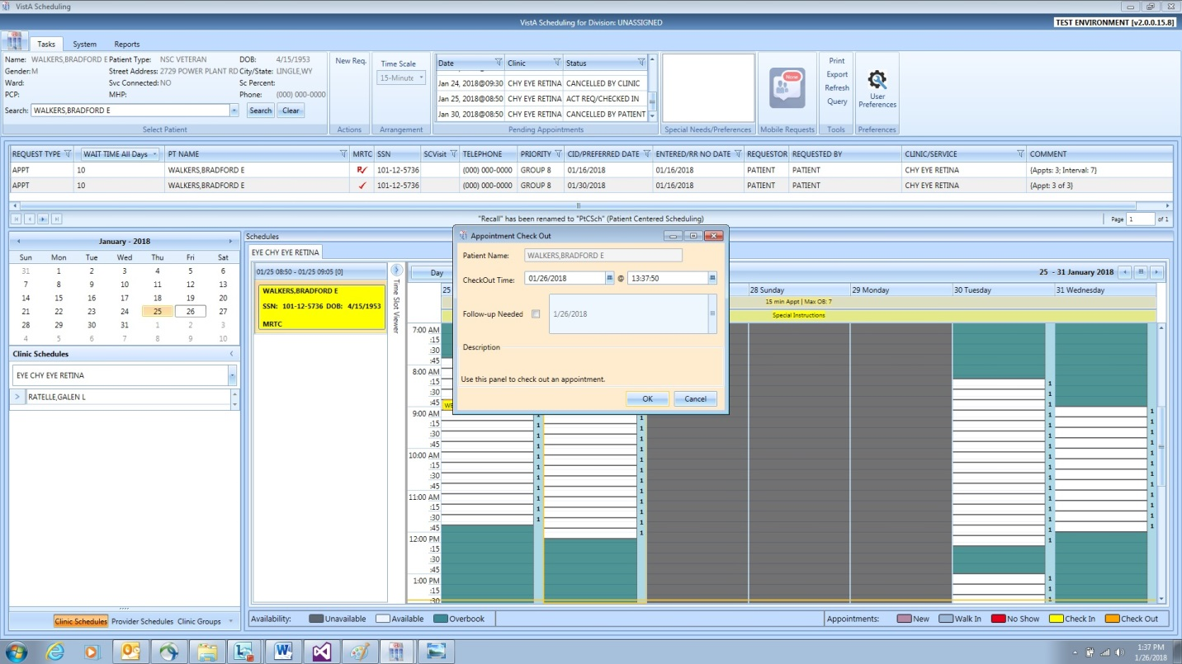

**Cancel Appointment Dialog**

The Cancel Appointment Dialog (Figure 17) appears when the user right-clicks on an appointment on the Calendar Schedule and selects Cancel Appointment, or right-clicks on an appointment in Pending Appointments. The data entered in the window is passed back to VistA via a call to the SDECCAP CANRPC.

 **NOTE:** The same functionality accessible via the Pending Appointments list is now available in the Timeslot Viewer.

Figure 17: Cancel Appointment Dialog

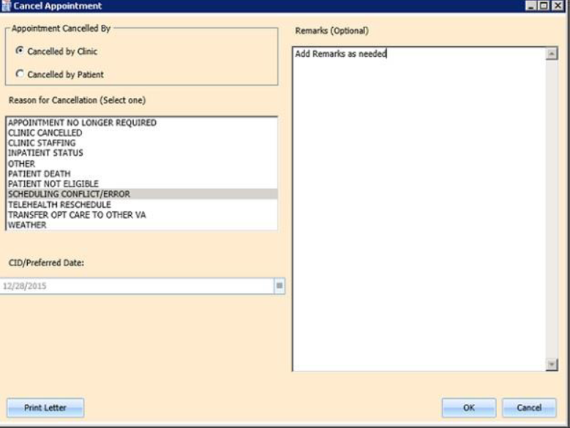

**MRTC Cancel Appointment Dialog**

The MRTC (Multiple Return to Clinic, or Multi-Book) Cancel dialog (Figure 18) is used to cancel MRTC appointments, and is populated when right-clicking an appointment in the Calendar section, Pending Appointments list, or Timeslot Viewer. The user has options to cancel the single selected appointment or all appointments associated with the MRTC Parent Request, as long as the appointment has not been completed. The user may also close the Appointment Request associated with the current appointment or close all child appointment requests, as well as the Parent MRTC Appointment Request.

Figure 18: MRTC Cancel Appointment Dialog

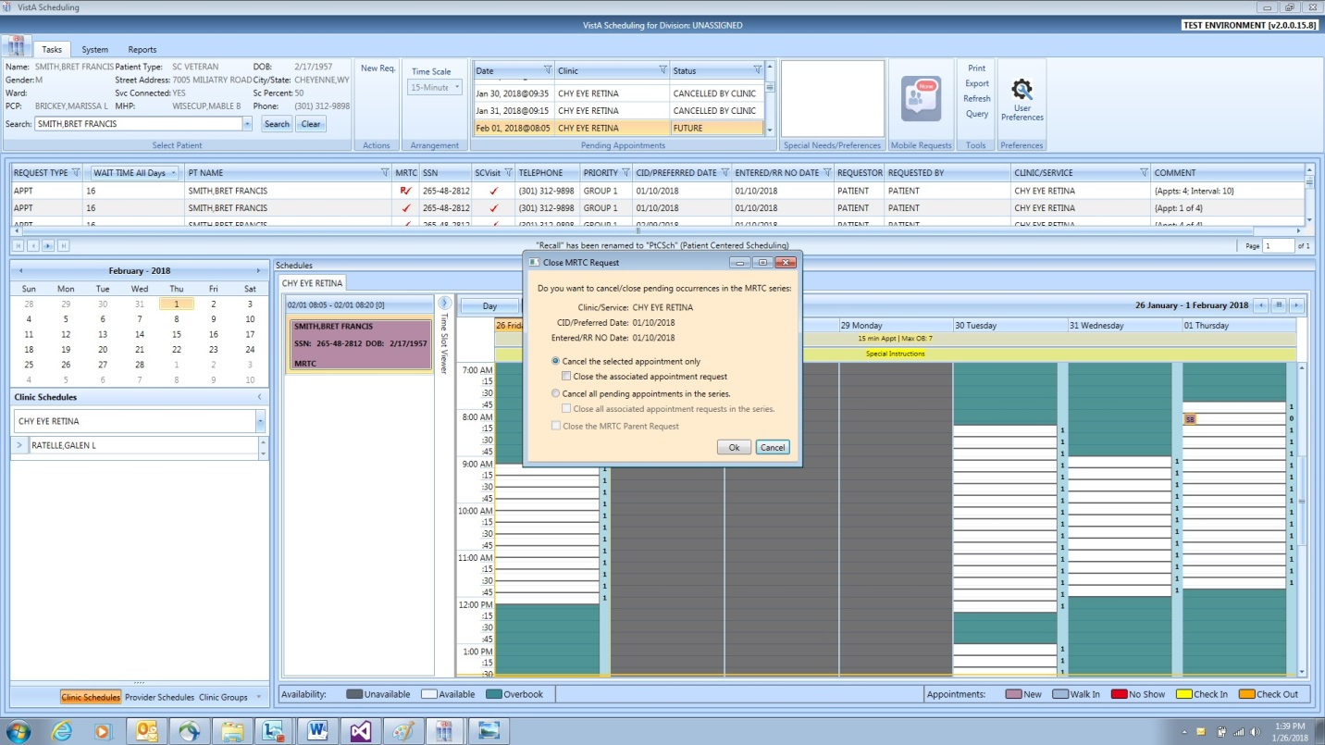

**No-Show Dialog**

The popup window in Figure 19 appears when the user right-clicks on a current or past appointment in the Calendar Schedule, Pending Appointments List, or Timeslot Viewer and selects Mark as No Show. The data entered in the popup is passed back to VistA via a call to the SDEC NOSHOW RPC.

 **NOTE:** The Mark as No Show popup includes an outdated instruction, “To print a no show letter click the Print Letter button below.” This instruction will be removed in an upcoming release.

Figure 19: Appointment No-Show

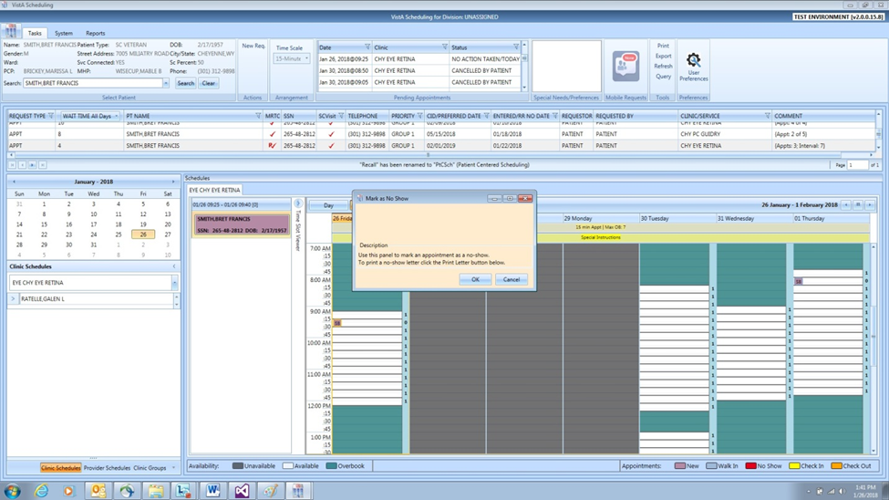

**MRTC Find Appointment Dialog**

The MRTC Find Appointment dialog (Figure 20) opens after a user selects a Parent MRTC Request from the RM Grid, or immediately after completing an appointment request that selected Multiple Appointments Required. This dialog manages the creation of the Child MRTC Appointment Requests and the booking of the associated Child MRTC appointments. Additionally, during the booking process the MRTC Booking Status dialog will open to display the status of the child MRTC Requests and Appointments. The whole MRTC process uses various RPC calls that are referenced in the FindAppt module.

Figure 20: MRTC Find Appointment Dialog

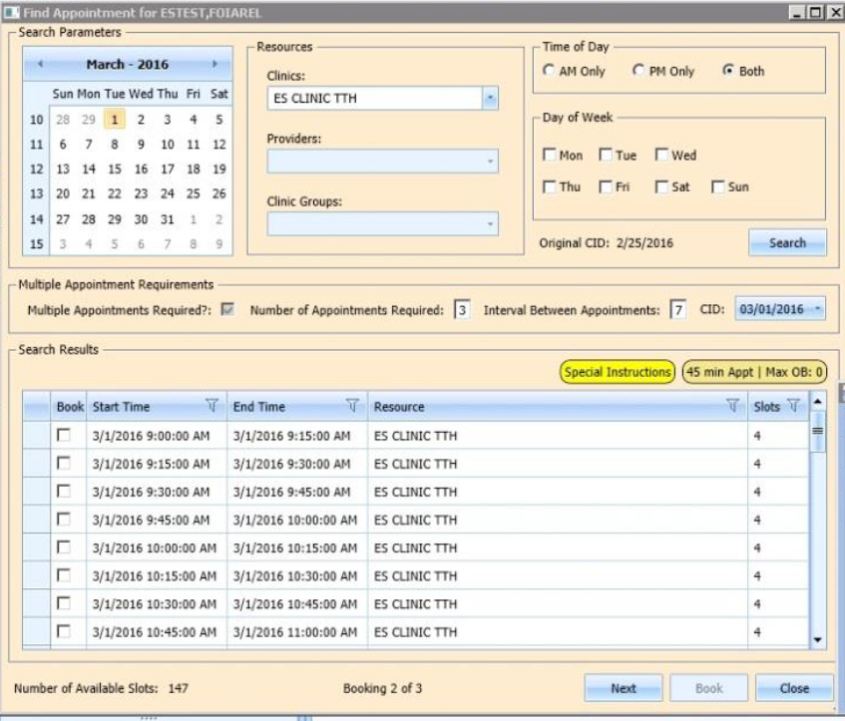

**Expanded Entry Dialog**

The Expanded Entry popup (Figure 21) appears when the user right-clicks on an appointment in the Calendar Schedule and selects Expand Entry, or right-clicks on an appointment in either the Pending Appointment List or Timeslot Viewer and selects Expand Entry. The data displayed in the window is obtained from VistA via calls to SDEC EP CLASSIFICATION, SDEC EP CPT, SDEC EP DEMOGRAPHICS, SDEC EP DIAGNOSIS, SDEC EP EVENT LOG, SDEC EP PROVIDER, SDEC EP PT INFO, SDEC EP STOP CODE, and SDEC EP WAIT TIME RPCs.

Figure 21: Expanded Entry Dialog

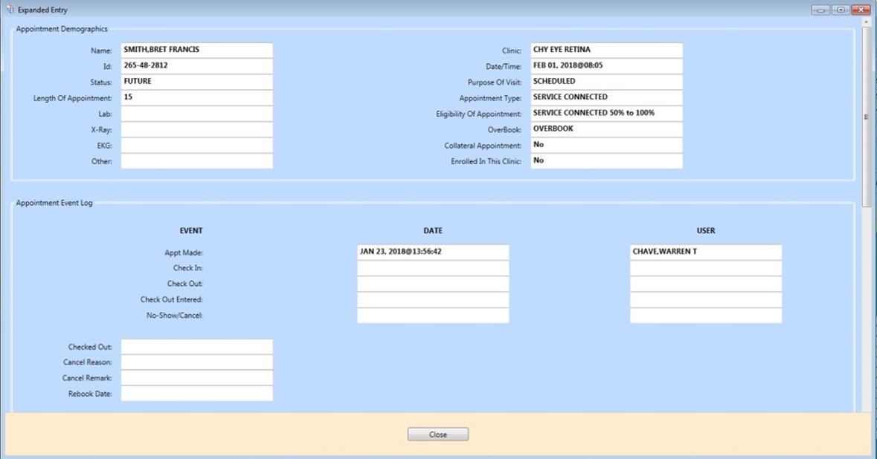

**Print Pending Appointments**

A user can print a patient’s pending appointments by right-clicking anywhere (except the header row) in the Pending Appointments pane and selecting Print Pending (Figure 22). A standard Windows print dialog then appears, and the list is printed (Figure 23).

Figure 22: Print Pending Appointments

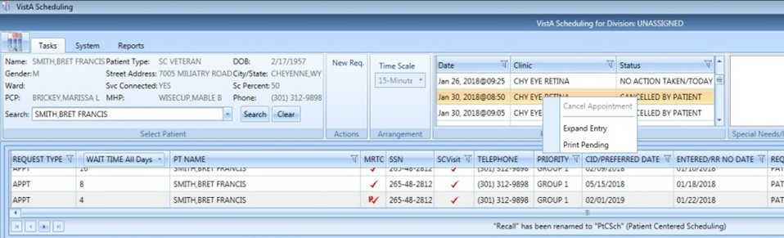

Figure 23: Pending Appointments Printout

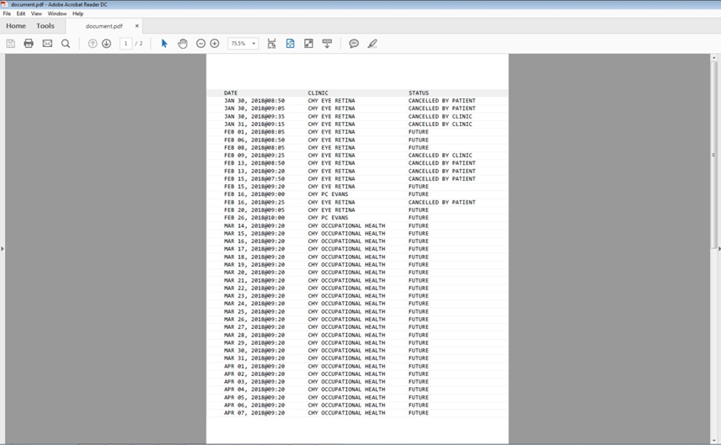

**Pending Appointments Column Filters**

Users can filter pending appointments (Figure 24) by clicking on any column in Pending Appointments. Filtering is native to the Telerik control where pending appointments are displayed.

Figure 24: Pending Appointments Date Filter

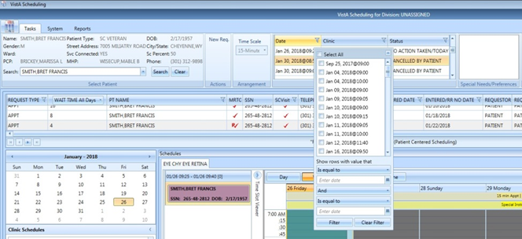

**System Tab**

**Availability Dialog**

The Availability window (Figure 25 and Figure 26) shows data for a clinic that is obtained via a call to the SDEC RESOURCE and SDEC APPSLOTS RPC.

Figure 25: Clinic Availability Selection Dialog

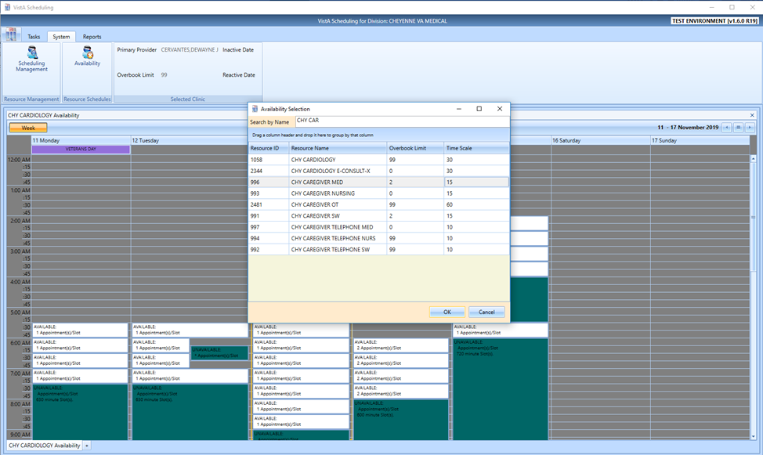

Figure 26: Availability Dialog

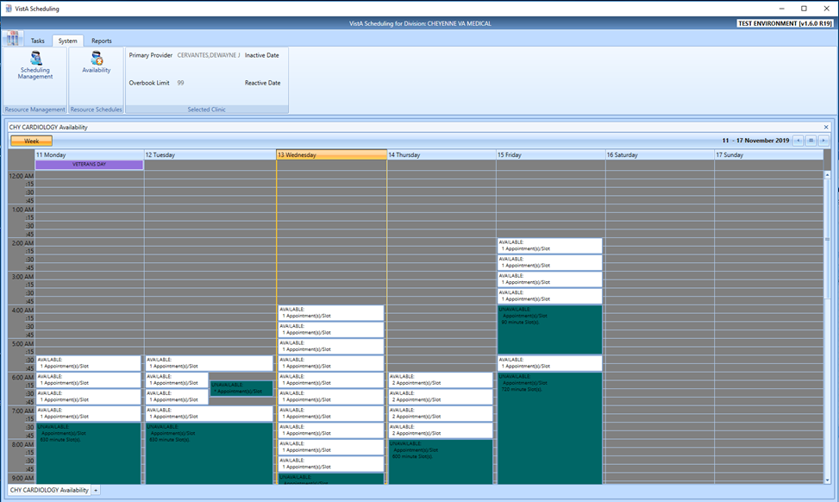

**Scheduling Management Dialog**

Scheduling Management is used to control access to Prohibited Clinics (Figure 27) and to Clinic Groups (Figure 28).

The RPCs used to maintain prohibited clinics are:

* + SDEC SCHUSR: User list
  + SDEC RESOURCE: Prohibited clinic search
  + SDEC RESUSER: Privileged users list
  + SDECLOC UPDPRIV: Add or remove user

The RPCs used to maintain clinic groups are:

* + SDEC RESOURCE: List of resource selections
  + SDEC RESGRPUS: Clinic group list, resource list, resources in clinic group list
  + SDEC ADDRG: Add/edit clinic group
  + SDEC DELRESGP: Delete clinic group
  + SDEC ADDRGI: Add resource to clinic group
  + SDEC DELRGI: Remove resource from clinic group

 **NOTE:** The Manage Clinic Groups feature is not visible unless the user is configured as a Manager.

Figure 27: Scheduling Management - Prohibited Clinics

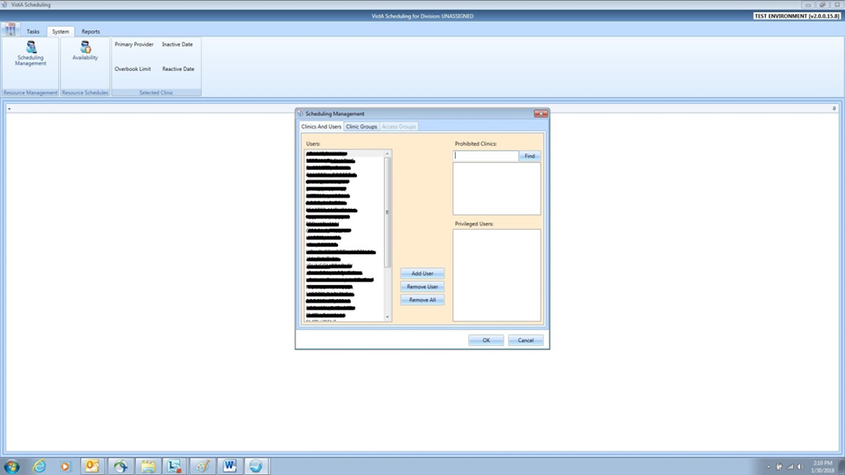

Figure 28: Scheduling Management - Clinic Groups

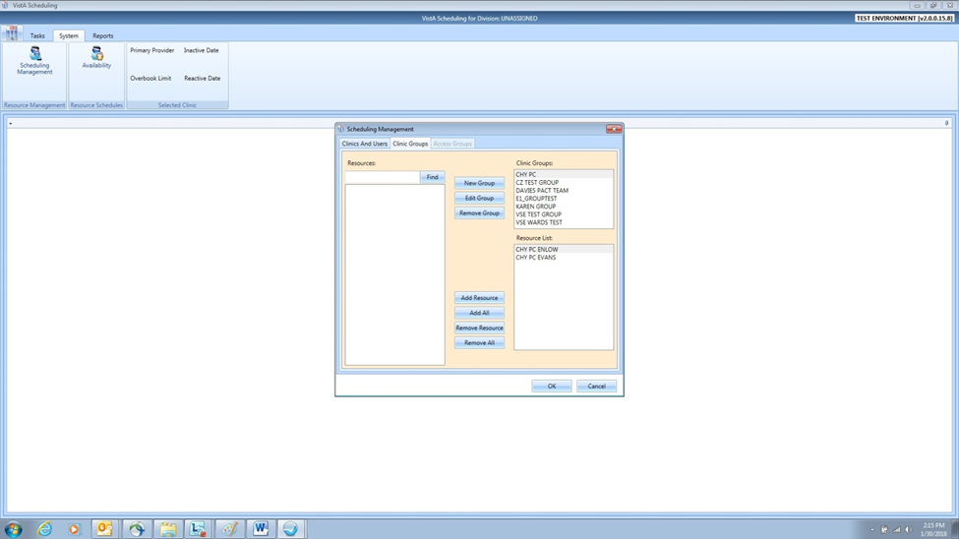

**Reports Tab**

There are two reports available under the Reports tab. The first shows activity by schedulers (Figure 29). It is produced via calls to the SDEC SUMMGET2 RPC. The second displays information about clinics (Figure 30). It is produced via calls to the SDEC REP1GET RPC.

Figure 29: Reports Tab - Audit Activity

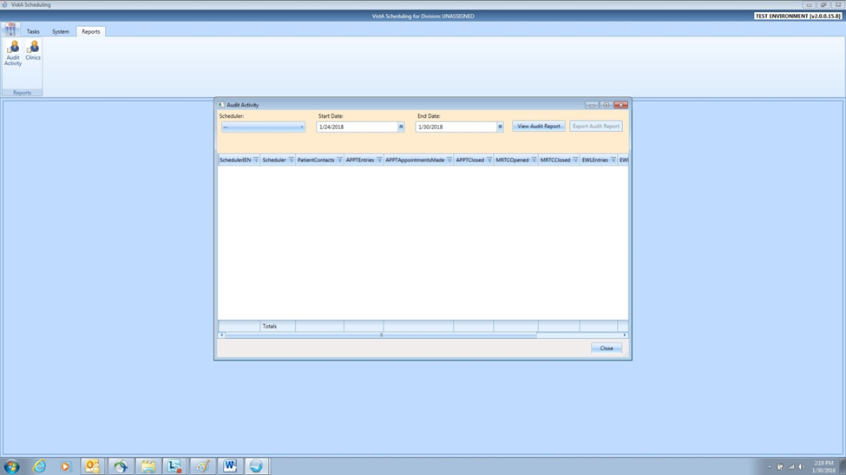

Figure 30: Reports Tab - Clinic Reports

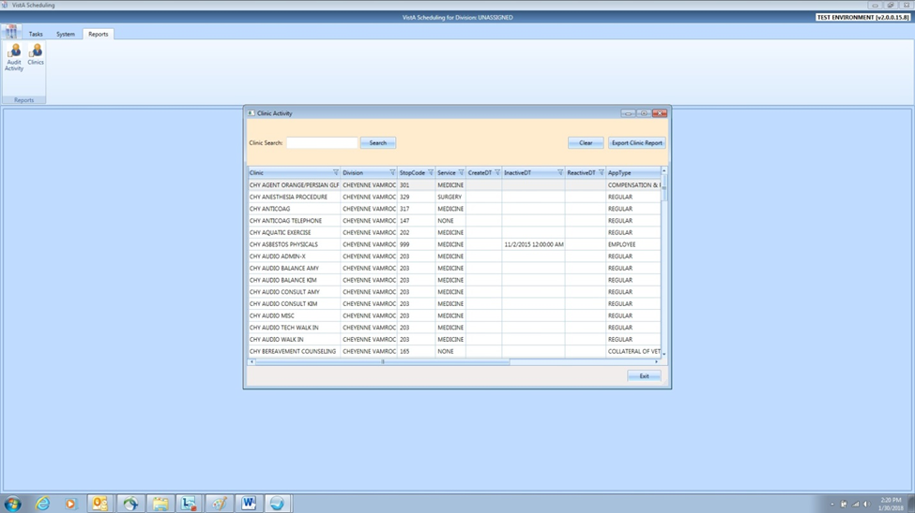

**Trace Log**

The trace log (Figure 31) stores RPC calls and the data returned, error information, and other logged information. See additional information in VistA Scheduling GUI Trace Log. Right-clicking the Title Bar at the top of the main screen opens the standard Windows option menu (e.g., minimize, close) that includes a link to the Trace Log.

Figure 31: Trace Log

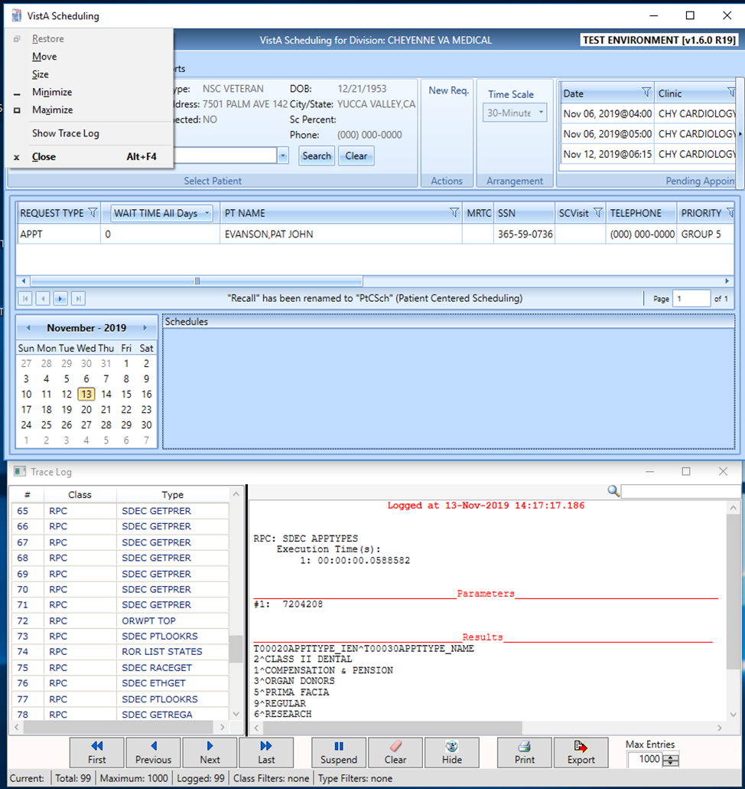

**Logon Screen**

The logon screen appears when the GUI is first opened (Figure 32). Users can log on using their Personal Identification Verification (PIV) card and Personal Identification Number (PIN), or with their VistA Access and Verify codes. PIV and PIN are authenticated via a call to the XUS ESSO VALIDATE RPC, while Access and Verify codes are authenticated via a call to the XUS SIGNON SETUP and XUS AV CODE RPCs.

Figure 32: VSE GUI Logon

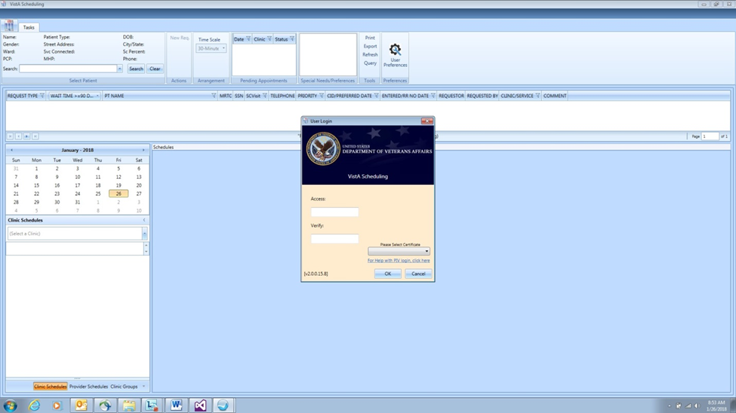

**Veteran Appointment Request (VAR)/VA Online Scheduling (VAOS) Button**

The code for this option is under development.

## List of GUI Modules and Components Affected

The following subsections describe the primary groupings of the VS GUI source code in Visual Studio Solution Explorer.

### Common

The Common section contains infrastructure related code and structures. Global variables associated with the Keys class and global methods are defined here. Additional items in the Common section include controls, extension methods, event aggregators, and data models/structures. Keys contains references to almost all VistA RPCs called to extract and update data in the database. The Trace Log class is common to the application and stores all RPC calls, request data, and responses. PIV authentication uses the code stored under Single Sign-on (SSOi). The Factories subsection is not widely used by the VS GUI.

A new RPC used by the application must be defined in the RpcCalls sub-class of the Keys static class. A new method would be added to Modules.DataAccess\Services\DataAccessService.cs as well as to the IDataAcctessService interface in the Interfaces subsection. CLaunchWindow is a static class with a Launch method that can be called to display a UserControl as a popup or dialog window.

The ExtensionMethods subsection is where a new method is added if the method is used by more than one module, and if it extends a specific class.

#### User Controls

##### IncrementalSearchComboBox

The “IncrementalSearchComboBox” (IncrementalSearchComboBox.xaml), as with other custom WPF user controls, have their source code files organized under the \Scheduling - VistA Scheduling GUI\ClinSchd\Desktop\ClinSchd.Infrastructure\Controls\ folder and compile under the ClinSchd.Infrastructure.Controls namespace into the ClinSchd.Infrastructure.dll assembly.

The IncrementalSearchComboBox user control wraps a Telerik RadComboBox setting a certain number of default properties, giving it a default behavior and exposing other important properties required by consumers as Dependency Properties, events, and delegates. Internally, the user control has a timer that is used to delay the delegate call to handle searching via a DataAccessService RPC call method that provides a brief pause to capture changing user input search text that minimizes the RPC call frequency to optimize performance and enhance user experience. The user control can be used in an MVVM manner (recommended) or manipulating data directly via the Items property (not recommended, except in backward compatibility code refactoring areas).

Internal private event handlers not to be implemented by end users are:

* + LostFocus
  + SelectionChanged
  + KeyUp
  + TextBoxBase.TextChanged

Dependency properties publicly exposed for end-users to set are:

* + EmptyText
  + TabIndex
  + IsDropDownOpen (as required)
  + Text (as required)
  + SelectedText (as required)
  + ItemTemplate (optional)
  + ItemSource (MVVM only)
  + SelectedItem (MVVM only)
  + Text.SearchTextPath (MVVM only)
  + DisplayMemberPath

Delegate Public Event Handers:

The following public delegates are implemented by the end user and are wired up in the constructor of the view code-behind so that the calls will execute the required custom logic to handle searching and population of returned data (search results).

* + DoSearchProcess (handles RPC DataAccessService call)
  + DoEnterKeyUpProcess (handles any additional special logic for Key Up)
  + DoLostFocusProcess (handles any additional special logic for Lost Focus)
  + DoSelectionChangedProcess (handles any additional special logic for SelectionChanged)

Example Locations of IncrementalSearchComboBox usage:

To get an understanding of how the user control is implemented in the application look at the following locations:

MVVM examples:

* + GroupView.xaml (Desktop\ClinSchd.Modules.Navigation\Group\)
  + FindApptView.xaml (Desktop\ClinSchd.Modules.FindAppt\FindAppt\)

Items Manual example:

* + RequestManagement.xaml (Desktop\ClinSchd.Modules.Ribbon\Schedule\)

##### DateTimePicker Control

The “DateTimePicker” (DateTimePicker.xaml), as with other custom WPF user controls, has its source code files organized under the \Scheduling - VistA Scheduling GUI\ClinSchd\Desktop\ClinSchd.Infrastructure\Controls\ folder, and compile under the ClinSchd.Infrastructure.Controls namespace into the ClinSchd.Infrastructure.dll assembly.

The DateTimePicker user control wraps single instances of Telerik RadDatePicker and RadTimePicker, setting a certain number of default properties, giving it a default behavior, and exposing other important properties required by consumers as Dependency Properties, events, and delegates. The user control can be configured to display a combination of date and time, date only, or time only controls. The user control can be used in an MVVM manner (recommended), or by manipulating data directly via the various properties (not recommended, except in backward compatibility code refactoring areas).

In addition to entry of standard date\time strings, the DateTimePicker user control also wraps entering relative date strings. This allows a user to enter date strings similar to “t”, “t+1”, “t-2w”, which are converted to valid date values by interpreting t as today and adding or subtracting the number of days, weeks, or months. Time strings can be entered into the time control as “now”, “now+1”, or “now-2h”, where now is interpreted as the current time with the number of seconds, minutes, or hours added or subtracted.

Table 1 details the custom methods, properties, and events implemented for the DateTimePicker control.

Table 1: DateTimePicker Control Details

|  |  |  |  |
| --- | --- | --- | --- |
| Target | Name | Type | Description |
| General | DisplayMode | DisplayModes enum | Sets the control display mode:  Both: date and time entry.  DateOnly: date ONLY entry.  TimeOnly: time ONLY entry. |
| General | FixZeroTime | Boolean | Used in some date conversion processes to deal with zero-time inconsistencies. |
| General | SelectedDateTime | DateTime? | Gets\sets the selected date\ time. The value is split into separate DatePicker and TimePicker values. |
| General | SelectedDateTimeFormatted | String | SelectedDateTime value formatted in External format. |
| General | SelectedDateTimeFormatted | String | SelectedDateTime value formatted in Internal format. |
| General | TruncateSeconds | Boolean | If true, the time part of the SelectedDateTime and the Selected Time value are truncated to the minute. |
| Date Picker | DateErrorToolTipContent | String | Text displayed by the DatePickerww when date validation fails. Defaults to “Enter a valid date!” |
| Date Picker | DateToolTipContent | String | DatePicker tool tip content. |
| Date Picker | DateWatermarkContent | String | DatePicker Watermark text. |
| Date Picker | IsDateDropDownOpen | Boolean | Indicates if the DatePicker calendar is open or closed. |
| Date Picker | IsDateValueRequired | Boolean | Indicates if the DatePicker date value is required to be set. |
| Date Picker | IsInputRestrictedToSelectableDates | Boolean | Indicates if date entry should be restricted to the SelectableDateStart\SelectableDateEnd date range. |
| Date Picker | SelectableDateEnd | DateTime? | The latest valid date that can be entered. Default is DateTime.MinDateValue. |
| Date Picker | SelectableDateStart | DateTime? | The earliest valid date that can be entered. Default is DateTime.MinDateValue. |
| Date Picker | SelectedDate | DateTime? | Gets\sets the selected Date from the SelectedDateTime value. |
| Time Picker | ClockEndTime | TimeSpan? | The latest time accepted. Defaults to end of day. |
| Time Picker | ClockErrorTooTipContent | String | Text displayed by the time control when time validation fails. Defaults to “Enter a valid time!” |
| Time Picker | ClockItemsSource | IEnumerable<TimeSpan> | List of TimeSpan values used to populate the TimePicker dropdown. Defaults to null. |
| Time Picker | ClockStartTime | TimeSpan? | The earliest time accepted. Defaults to start of day. |
| Time Picker | ClockTimeInterval | TimeSpan? | A value used to automatically populate the TimePicker dropdown. Defaults to 15-minute intervals. |
| Time Picker | ClockToolTipContent | String | TimePicker tool tip content. |
| Time Picker | IsClockTimeValueRequired | Boolean | Indicates if the time value is required to be set. |
| Time Picker | IsInputRestrictedToSelectableTimes | Boolean | Indicates if time entry should be restricted to the ClockStartTime\ ClockEndTime span. |
| Time Picker | IsTimeDropDownOpen | Boolean | Indicates if the TimePicker dropdown is open. |
| Time Picker | SelectedTime | TimeSpan? | Gets\sets the current time from the SelectedDateTime value |
| Time Picker | TimeWatermarkContent | String | TimePicker watermark content. |

In all of these, remember the user control view will need to include references to the controls assembly and the user control will need to be contained within an appropriate container control such as a Grid and the row and column set for the control and other display properties overridden such as margins, and width, height, and so forth to control its styling, as required.

Figure 33: Code Extract 1

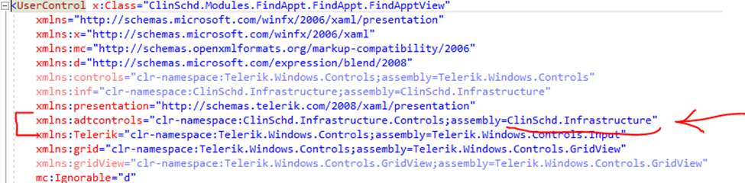

Figure 34: Code Extract 2

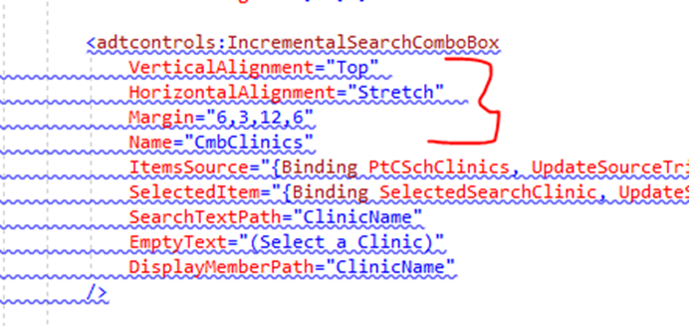

### Modules

#### CancelAppt

Code in this section processes an appointment cancellation.

#### ChangeDivision

Code in this section is not enabled in the GUI. It was originally accessible via a currently hidden menu item in the System Menu. Its purpose was to allow users to switch facilities but was never fully functional.

#### CheckIn

Code in this section processes an appointment check in.

#### CheckOut

Code in this section processes an appointment check out.

#### ContactAttempt

Code in this section is used to record attempts to contact patients by phone or letter. It applies to the patient recall (PtCSch) request type.

#### DataAccess

Code in this section connects to VistA to get or set data via RPC calls.

#### ExpandedEntry

Code in this section displays an appointment expanded entry.

#### FindAppt

MRTC processes.

#### Management

Code in this section supports the functions associated with System Tab.

#### MarkAsNoShow

Code in this section processes an appointment as a no show.

#### Navigation

Code in this section handles processing for Calendar Navigation Pane and Clinic/Provider Navigation Pane.

#### PatientAppt

Code in this section processes Appointment Dialog for new appointments, walk-in appointments, and the Disabilities Dialog/Patient’s Eligibility.

#### PatientSelection

Code in this section supports Patient Information Dialog.

#### Prerequisites

VA developer code. Launched when selecting an appointment request.

#### Reports

Code in this section supports the functions associated with Reports Tab. It also prints patient letters.

#### ResourceSelection

The code in this section is not utilized.

#### Ribbon

Code in this section supports the functions associated with:

1. Ribbon Bar Patient Information
2. Ribbon Bar Actions Menu
3. Ribbon Bar Arrangements Menu
4. Pending Appointments
5. Patient Special Needs/Preferences Window
6. Ribbon Bar Tools Menu
7. User Preferences
8. Appointment Request Dialog

#### Task

Code in this section supports the Calendar Schedule.

#### UserLogin

Code in this section processes the Logon Screen.

#### VAR

Code in this section implements the VAR/VAOS button and the interface with the VAR system.

### Unit Tests

The code in this section is obsolete.

### ClinSchd

This section hosts the application, and contains the config file. It will only be modified if a new module is added.

### CreateWebServices

The code in this section is obsolete.

### InstallerCustomActions

The code in this section is used by the installer.

### ClinSchedInstaller

The code in this section supports creation of a build package.

### VARMobileAppMockup

The code in this section is a testing app to simulate a Veteran entering a mobile request.

### Web Services

#### VSE_VAR_Client

The code in this section is an app to test web service connectivity.

#### VSE_VAR_DataAccessService

The code in this section provides the WCF VSE_VAR_Service web services to access the VAOS\VAR Oracle database.

#### VSE_VAR_Service

The code in this section encompasses the WCF VSE_VAR_Service.

#### VSE_VAR_Service_Interfaces

Web service interface/contracts (description of data to be transmitted between server and client). The .dll created in this project MUST be included in any client that will communicate with the VSE_VAR_Service web service.

#### VSE_VAR_ServiceConsoleHost

Used in testing to run the WCF service in a console.

#### VSE_VAR_TestClient

Test app to simulate VSE activities for VAR.

## Structure of Code Modules

A module project contains a VSE .dll assembly and should contain a specific set of functionalities. Apart from some core modules, properly executed modules should be able to be removed from VSE without affecting the ability to run the application.

A module contains code to register classes with the Unity Dependency Injection (DI) engine, event subscriptions for the Event Aggregator, and the code to execute specific functionalities.

### Module Project

A module contains a module class, one or more controllers, one or more services and views, view models, and possibly models to implement the module functionality. A typical module project might look like Table 2.

Table 2: Module Project

|  |
| --- |
| ClinSchd.Modules. <%Module Name%>  Properties  References  <%Module Name%>  I<%Module Name%>PresentationModel.cs  I<%Module Name%>View.cs  <%Module Name%>View.xaml  <%Module Name%>View.xaml.cs  <%Module Name%>PresentationModel.cs  Controllers  I<%Module Name%>Controller.cs  <%Module Name%>Controller.cs  Services  I<%Module Name%>Service.cs  <%Module Name%>Service.cs  <%Module Name%>Module.cs |

### Module Class

The module class must implement IModule and contains code to register module classes and interfaces with the Unity DI engine. The class instantiates all controllers and performs any other initialization functions required for the module to execute. The module class is typically named <%Module Name%>Module.cs and is in the root folder of the module project. The class should also implement a constructor that includes parameters for IUnityContainer and IEventAggregator. A typical module class can be seen in Table 3.

Table 3: Module Class

|  |
| --- |
| using Microsoft.Practices.Composite.Modularity;  using Microsoft.Practices. Unity;  using Microsoft.Practices.Composite.Events;  using Microsoft.Practices.Composite.Presentation.Events;  using ClinSchd.Infrastructure;  using ClinSchd.Infrastructure.Models;  using ClinSchd.Infrastructure.Interfaces;  using ClinSchd.Modules.<%Module Name%>;  using ClinSchd.Modules.<%Module Name%>.Controllers;  namespace ClinSchd.Modules.<%Module Name%>  {  public class <%Module Name%> : IModule  {  private readonly IUnityContainer _container;  private readonly IEventAggregator _eventAggregator;  private I<%Module Name%>Controller _controller;  public <%Module Name%>Module (IUnityContainer container, IEventAggregator eventAggregator)  {  _container = container;  _eventAggregator = eventAggregator;  }  public void Initialize()  {  RegisterViewsAndServices();  /* Create any controllers */  _controller = _container.Resolve<I<%Module Name%>Controller> ();  /* Start all created controllers */  _controller.Run ();  }  protected void RegisterViewsAndServices()  {  _container.RegisterType<I<%Module Name%>Controller, <%Module Name%>Controller> ();  _container.RegisterType<I<%Module Name%>Service, <%Module Name%>Service> ();  /* Register other types as required */  }  }  } |

### Controller Class

Normally the controller class contains the EventAggregator subscriptions for the module and controls access to the module functionalities. One can also expose module functionalities by registering module classes in the Unity DI engine in the module class, allowing the module classes to be instantiated from anywhere in the application that can access the module interfaces. A typical controller looks like Table 4.

Table 4: Controller Class

|  |
| --- |
| using System;  using System.Collections.Generic;  using ClinSchd.Infrastructure.Interfaces;  using Microsoft.Practices.Composite.Events;  using ClinSchd.Infrastructure;  using ClinSchd.Infrastructure.Models;  using ClinSchd.Modules. <%Module Name%>.Services;  using Microsoft.Practices.Composite.Presentation.Events;  using Microsoft.Practices.Unity;  namespace ClinSchd.Modules. <%Module Name%>.Controllers  {  public class <%Module Name%>Controller : I<%Module Name%>Controller  {  private readonly IUnityContainer _container;  private readonly I<%Module Name%>Service _service;  private readonly IEventAggregator _eventAggregator;  private readonly IDataAccessService _dataAccessService;  public <%Module Name%>Controller (  IUnityContainer container,  I<%Module Name%>Service <%Module Name%>Service,  IEventAggregator eventAggregator,  IDataAccessService dataAccessService)  {  _container = container;  _service = <%Module Name%>Service;  _eventAggregator = eventAggregator;  _dataAccessService = dataAccessService;  }  public void Run()  {  _eventAggregator.GetEvent<<%Module Name%>Event> ().Subscribe (<%Module Name%>EventHandler, ThreadOption.UIThread, true);  }  public void <%Module Name%>EventHandler (<%Module Name%>EventPayload payload)  {  _service.DoEventHandler(payload);  }  }  } |

### Service Class

The service class typically implements the module functionality code, like running a process, displaying windows, or creating a user control to be docked elsewhere in the application. A typical service class is displayed in Table 5.

Table 5: Service Class

|  |
| --- |
| using System;  using ClinSchd.Modules. <%Module Name%>.<%Module Name%>;  namespace ClinSchd.Modules. <%Module Name%>.Services  {  public class <%Module Name%>Service : I<%Module Name%>Service  {  public <%Module Name%>Service ()  {  }  #region I<%Module Name%> Members  public void DoEventHandler (<%Module Name%>EventPayload payload)  {  /* Do the functionality work here */  }  #endregion I<%Module Name%> Members  }  } |

## Organization of Rational Streams

There are seven Rational streams associated with the project (Table 6). Five are code streams, one is for delivering install packages, and one is for documentation.

Table 6: Rational Streams

|  |  |
| --- | --- |
| Rational Stream | Description |
| ConDEV | ConDEV is used for current development. |
| ConTEST | Once current development has passed unit testing and is ready for Component Integration Testing (CIT), the development is promoted to ConTEST. Builds for CIT are created from this stream. |
| ConSQA | Once a build is ready to move to Software Quality Assurance (SQA) testing, the changes are promoted to ConSQA. Builds for SQA are made from this stream. If SQA testing returns defects, they are fixed and tested here, then merged into current development. **NOTE:** Work on the next iteration may be in progress. |
| ConIOC | Once a build has cleared SQA and is ready for Initial Operating Capacity (IOC) testing, the code is promoted to ConIOC. Builds for IOC are made from this stream. If IOC testing returns defects, they are fixed and tested here, then merged into current development (and possibly also SQA). **NOTE:** Streams may contain different iterations. |
| ConPROD | Once a build has cleared IOC testing and is installed at field sites, the code is promoted to ConPROD. This stream serves as a reference copy of Production to research reported defects, as the Dev streams will be on different iterations. The only active development that takes place in ConPROD is for emergency fixes that are disconnected from the current versions in SQA or IOC. |
| Scheduling Documentation | This stream serves as the repository for project documentation (CLIN deliverables and reference documents). |
| VSE Installers | This stream holds the install packages for each build of the software, serving as both a distribution point and repository, to allow installing previous versions for research. |

## Troubleshooting Using the Trace Log

The Trace Log is a tool used to troubleshoot problems within the VS GUI. The GUI must be executed with the /trace command line parameter for the Trace Log to be available (See Command Line Parameters). Access the Trace Log by right-clicking the GUI title bar and selecting Trace Log from the resulting menu.

The Trace log contains a log of all RPC calls made by the VS GUI. Information in the log includes the RPC Name, Inputs (Parameters), and returns. Returns can be various results, including error information reported by the called RPC, and in many cases includes error information reported from the GUI application. Sometimes a user-friendly error message is displayed, and the Trace Log must be accessed to view the error details. Exceptions/errors caught within the GUI and logged using the TraceLog.LogError method will include the full error stack, when present.

The Trace Log can be exported to an XML file for analysis. When the /AutoDumpTrace command line parameter is added, the GUI will attempt to save the current Trace Log to the C:\Program Data\Vista Scheduling GUI\TraceLog.xml file. Each successive save of the current log overwrites the previously saved log.

A developer can write to the Trace Log by including the ClinSchd.Infrastructure namespace, then calling one of the TraceLog.Log . . . methods.

RPC Data returned in the Trace Log may be a single string, an array of strings, a list of strings (possibly including an array item), or a record set.

Returned arrays are generally formatted as:

Array[n]

#0: value

#1: value

. . .

#n: value

Record sets generally appear as:

T00020HEADER_1^T00020HEADER_2^ . . . ^T00030HEADER_N

Record1_Value1^Record1_Value2^ . . . ^Record1_ValueN

Record2_Value1^Record2_Value2^ . . . ^Record2_ValueN

. . .

RecordN_Value1^RecordN_Value2^ . . . ^RecordN_ValueN

Record sets can be copied and saved to a text file and imported into Excel as a ^ delimited file for easier review.

## Configuring the GUI

The VistaSchedulingGUI.exe.config file is found in the application folder location, C:\ Program Files (x86)\VistA Scheduling GUI_x, where _x is not present in the Visual Studio development environment, but may be _P (Production Release), _T (Test Release), or _RC (Release Candidate) when VSE is installed using one of the .msi files.

The config file is initialized during the installation process or by modifying the app.config file within the ClinSchd project in Visual Studio.

The config file can also be modified using a text editor such as Notepad or Notepad++.

There are two sections in the config file that may need to be configured. It is highly recommended that other sections of this file be modified.

### The <appSettings> Section

The <appSettings> section contains several <add key . . . > options that can be modified.

* <add key=”host” value=”” />: This key value holds the address or URL of the host VistA instance.
* <add key=”port” .value=”” />: This key value holds the port number assigned to the VistA instance on the host machine.
* <add key=”nspace” value=”” />: This key value holds the Name Space assigned the VistA instance on the host machine.
* <add key=”MaxPatientsToReturn” value=”50” />: This key value adjusts the maximum number of patients returned by the Patient Search on the ribbon bar. The default\recommended value is 50.
* <add key=”var_service_url” value=”” />: This key value is used to determine if the VSE\VAOS (VAR) interface is available to those users holding the SDEZ REQUEST key. The value SHOULD match the <endpoint address=”” /> value indicated in the <system.ServiceModel><client> section as discussed below, however, VSE is only looking for a value containing the “VSE_VAR_Service” string. If the value is empty or does not contain that string VSE will not activate the VSE\VAOS (VAR) functionality.

At this time any other <appSettings> key value pairs are ignored.

### The <system.ServiceModel><client><endpoint> Section

The VSE\VAOS (VAR) interface talks to a WCF web service. The <system.ServiceModel> section describes connection properties used by VSE for this purpose. The <endpoint> subsection is found within the <client> subsection.

Modify the <endpoint address=”” /> value to change the location URL of the VSE_VAR_Service web service. If this value is not exactly correct, VSE will be unable to communicate with the VSE_VAR_Service web service, and communication errors will be reported in the VSE Trace Log.

It is highly recommended that the <endpoint> address and the <appSettings><add key=”var_service_url” are set to the same value.

### Command Line Parameters

The VSE application allows for two command line parameters. These parameters can be added to the application shortcut as needed.

#### The /trace Command Line Parameter

When the /trace command line parameter is present, VSE turns on and initializes Trace Log functionality.

#### The /AutoDump Trace Command Line Parameter

When the /AutoDumpTrace command line parameter is present, VSE attempts to save the current Trace Log to a file when exiting the application, or when the application terminates due to an error. The saved Trace Log file is located in the C:\ProgramData\VA VistA Scheduler\VSETraceLog.xml file.

Each successive Trace Log dump overwrites previous Trace Log dumps.

The /trace command line parameter is required for the /AutoDumpTrace functionality to work.

### The Application Trace File

The application Trace file is generated by the VSE application. Successive VSE executions will be recorded in the same Trace file. Some error information may be present in the Trace file if VSE crashes. The Trace file is always located at C:\ProgramData\VA VistA Scheduler\trace.log.

## Client Application Dependencies and Files

Table 7, Table 8, and Table 9 list client application dependency files and their descriptions.

Table 7: Clinical Scheduler Files

|  |  |
| --- | --- |
| Clinical Scheduler Files | Description |
| ClinSchd.exe | This executable launches the application. |
| ClinSchd.Infrastructure.dll | This library contains application models, behaviors, events, interfaces, static information, threading capability, and other common functionality used by the application and its supporting modules. |
| CancelAppt.dll | This is required functionality for cancelling appointments and appointment requests. |
| ChangeDivision.dll | This is required functionality for changing divisions and invoking authentication functionality for division. |
| CheckIn.dll | This is required functionality to check in patients for a selected appointment. |
| CheckOut.dll | This is required functionality to check out patients for a selected appointment. |
| DataAccess.dll | This is the primary data access layer designed to interface with VistA RPCs. |
| FindAppt.dll | This is required functionality for searching and finding appointments based on criteria set. |
| Management.dll | This is required functionality for managing users, clinics, and clinic groups. |
| MarkAsNoShow.dll | This is required functionality to update appointment status to No Show. |
| Navigation.dll | This library handles the layout and grouping of services and objects within the GUI display. |
| PatientAppt.dll | This is required functionality to create new appointments. |
| PatientSelection.dll | This is required functionality to select a patient from the VistA PATIENT File. |
| Reports.dll | This required functionality supports the GUI reports implemented in E1/E2 and E3. |
| ResourceSelection.dll | This is required functionality for users to select resources, clinics, and clinic groups. |
| Ribbon.dll | This library contains the tabs and controls displayed in the application that allow the user to view high-level dashboard functionality, and the tabs required to switch between scheduling functions, user and system management, and reports. |
| Task.dll | This library contains functionality for users to manage schedules and appointments associated with clinic, provider, and clinic group schedules (creating, modifying, and cancelling appointments). |
| Microsoft Practices Libraries:  Microsoft.Practices.Composite.dll  Microsoft.Practices.Composite.Presentation.dll  Microsoft.Practices.Composite.UnityExtensions.dll  Microsoft.Practices.EnterpriseLibrary.Common.dll  Microsoft.Practices.EnterpriseLibrary.ExceptionHandling.dll  Microsoft.Practices.EnterpriseLibrary.Logging.dll  Microsoft.Practices.ObjectBuilder2.dll  Microsoft.Practices.ServiceLocation.dll  Microsoft.Practices.Unity.dll | The Microsoft Enterprise Library is a collection of reusable software components (application blocks) designed to assist developers with common Enterprise development, cross-cutting concerns like logging, validation, data access, and exception handling. Application blocks are provided as source code, test cases, and documentation that can be used as is, extended, or modified by developers to use on complex, Enterprise-level, line-of-business development projects. |

Table 8: Third-Party Controls

|  |  |
| --- | --- |
| Third-Party Control | Description |
| Telerik Windows Controls (v 2010.1.603.35):  Telerik.Windows.Controls.Charting.dll  Telerik.Windows.Controls.dll  Telerik.Windows.Controls.Docking.dll  Telerik.Windows.Controls.GridView.dll  Telerik.Windows.Controls.Input.dll  Telerik.Windows.Controls.Navigation.dll  Telerik.Windows.Controls.RibbonBar.dll  Telerik.Windows.Controls.Scheduler.dll | Telerik Windows controls are used by the GUI to display dialog boxes, user input fields (such as text, radio/check buttons, dropdown/combination lists), and other UI elements. Telerik controls can be transferred without issue. Telerik controls are Technical Reference Model (TRM)-approved, according to <https://www.va.gov/TRM/SearchPage.asp>. |

Table 9: Client Configuration Files

|  |  |
| --- | --- |
| Client Configuration Files | Description |
| ClinSchd.exe.config | This file contains configuration for internal functionality, as well as configuration information for the client to connect to the VistA server. The **Application Settings** section of this file allows the user to modify the default VistA server connection needed to authenticate against during application startup.  <appSettings>  <add key="host" value="*ServerName*" />  <add key="port" value="*Port*" />  <add key="nspace" value="*Namespace*" />  </appSettings>  **NOTE:** In addition to connecting to a valid VistA server, port, and namespace, users are required to supply valid Access and Verify codes with the proper keys and permissions to authenticate. |
| ClinSchd.Infrastructure.xml | This file contains configuration information for the client infrastructure project and dynamic application information for the ClinSchd.Infrastructure project. Data contained in this file does not need to be modified for environments. |
| Telerik Configuration Files | Telerik.Windows.Controls.Charting.xml  Telerik.Windows.Controls.Docking.xml  Telerik.Windows.Controls.GridView.xml  Telerik.Windows.Controls.Input.xml  Telerik.Windows.Controls.Navigation.xml  Telerik.Windows.Controls.RibbonBar.xml  Telerik.Windows.Controls.Scheduler.xml  Telerik.Windows.Data.xml |
| Microsoft.Practices Configuration Files | Microsoft.Practices.Composite.Presentation.xml  Microsoft.Practices.Composite.UnityExtensions.xml  Microsoft.Practices.Composite.xml  Microsoft.Practices.ObjectBuilder2.xml  Microsoft.Practices.ServiceLocation.xml  Microsoft.Practices.Unity.xml |

## VS GUI Trace Log

The VS GUI Trace Log is a custom GUI designed to inspect and debug server-side VistA RPCs. The UI for this application displays the input and results for RPC calls. To launch the GUI with access to the trace log, the executable must be launched with the following command “/trace” (Figure 35).

Figure 35: Trace Log Capability Shortcut

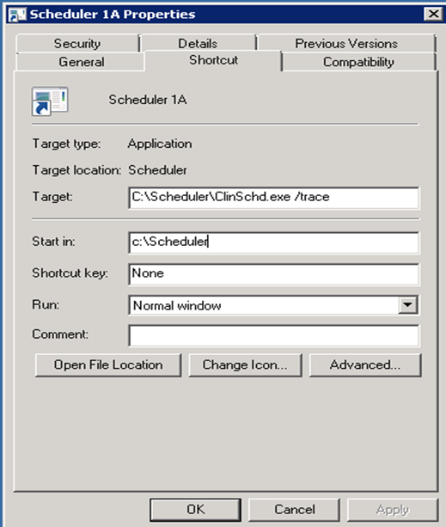

Launch the Trace Log by right-clicking in the title bar of the window and selecting the Show Trace Log option from the resulting menu (Figure 36).

Figure 36: Show Trace Log Menu Option

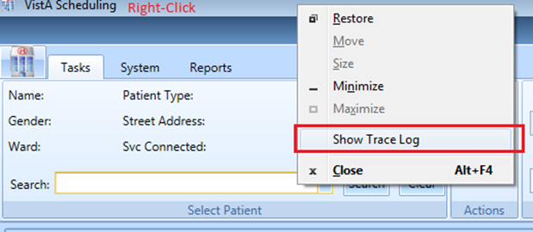

The Trace Log will appear (Figure 37). Click the Export button to open Windows Explorer.

Figure 37: Trace Log

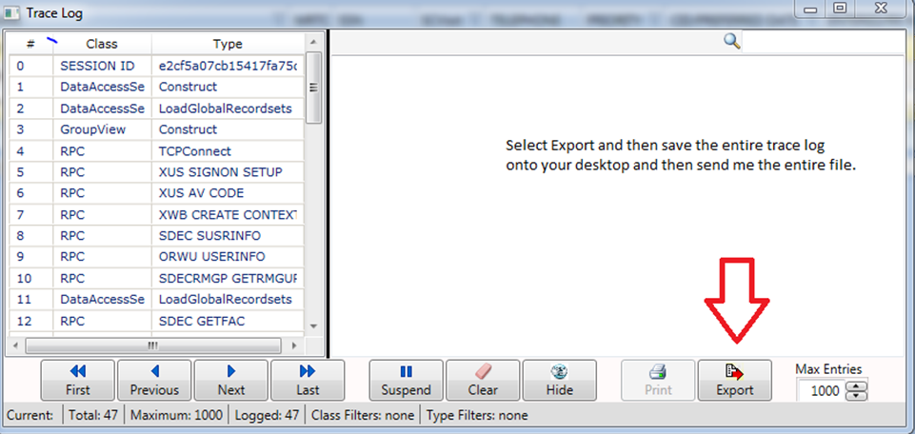

Name the Trace Log, select the desktop as the save location, and click the Save button save the Trace Log (Figure 38).

Figure 38: Saving the Trace Log

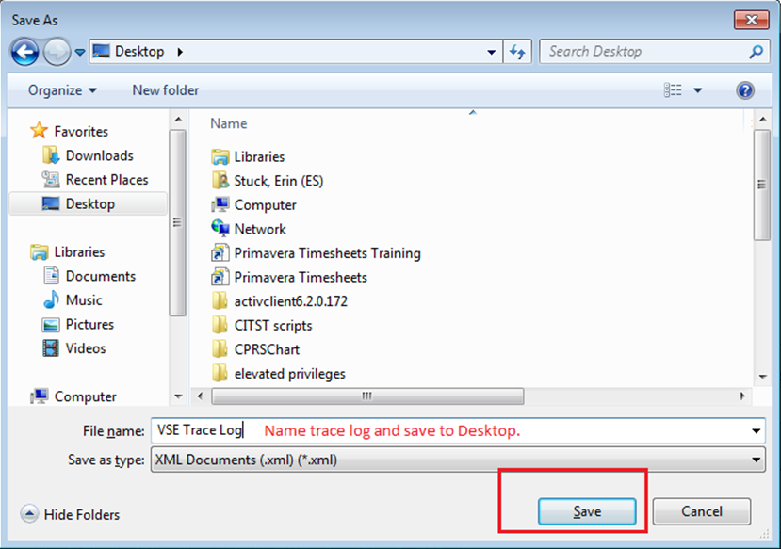

If an error causes VS GUI to close unexpectedly, follow the instructions below to access the Trace Log.

The VS GUI has error trapping in place for when errors occur inside the VS GUI that cause unhandled exceptions or unknown issues cause the GUI to abruptly close out. This error trapping occurs on the desktop for the user who encountered the error. The data is written back to a file called VSETraceLog.xml and is stored in the C:\ProgramData\VA VistA Scheduler file on the specific user’s work station.

On the same workstation, just after being kicked off the VS GUI application, navigate to the C:\ drive, look for ProgramData folder. If you do not see the ProgramData folder, it is probably hidden from view. Perform the following steps to unhide the folder:

1. Open the Windows Control Panel
2. Search for Folder Options
3. Select Folder Options
4. Click the View tab
5. Click the 'Show Hidden files, folders, and drives' radio button

Once the ProgamData folder is unhidden, open the C:\ProgramData\VA VistA Scheduler folder and send a copy of VSETraceLog.xml found in that folder. This file can be opened in any text editor/viewer for inspection.

## Request Management

Schedulers create and manage several different types of appointment requests: appointments (APPT), electronic wait list (EWL) entries, PtCSch, and consults. These requests are retrieved and stored in different VistA files.

Users must submit queries to the VistA server to retrieve individual requests (Figure 39). Users can search by patient name, request type, clinic or service/specialty clinic, priority group, wait time, service, connection, desired date, and origination date. Once the query is submitted to the server, the records are filtered based on the query type.

Users can specify the sort order for the records based on patient name, request type, clinic, wait time, priority group, origination date, desired date of appointment, and service connection. The default sort order is first by priority group, then by desired date, and by origination date.

Figure 39: Request Query

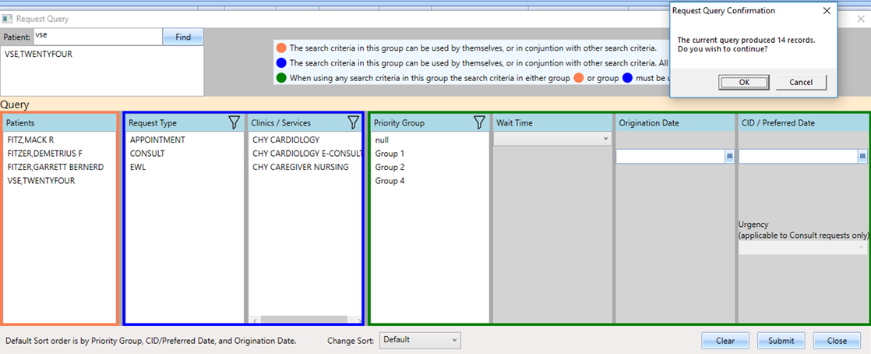

Records meeting the query criteria are filtered and sorted on the server and returned to the GUI, and displayed 25 at a time. The RM Grid contains paging functionality to display results beyond the initial 25 records.

 **NOTE:** The system retrieves a maximum of 200 records per query. The pagination and page navigation functionality will be improved in an upcoming release.

Figure 40: Query Results

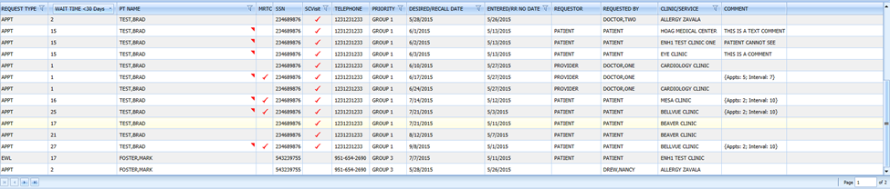

## Internal Relations

There are no documented internal relations in the VS GUI.

## External Relations

No special integration agreements exist between the VS GUI and any other package.

## Published Entry Points

No published entry points exist in VS GUI.

## Maintaining RC, Test, and Prod Builds

The development team produces three builds of the product each time code is ready to release for testing. Two are expected as part of deployment operations, and the third is useful for running multiple copies of the software side-by-side. The upgrade and product codes of the three builds are different, allowing Windows to treat them as completely separate applications, meaning they can have separate configurations and multiple versions of the application can be run simultaneously to compare behavior between different versions.

The upgrade and product codes must be specified in Visual Studio before (re)building the solution, and a few properties must be changed (using SuperOrca) in order to differentiate the three builds.

 **NOTE:** At the time of this writing, the Development team is looking into using three copies of the installer project to simplify this process.

### Before Making the Builds

The first step is to update the build number in Visual Studio. First, you’ll need to know the build number that you will be using. The first three pieces of the build number are fixed, the fourth iterates once per major release, or once every three sprints. The fifth piece iterates each time builds are produced for testing, as many times as necessary, possibly several times a week.

While still working in the Dev stream, the version number should be updated in the code itself. This involves editing two or three files.

1. /MSC/SolutionInfoInfo.cs
   1. This file needs only be updated once for each release, before the first build for that release.
   2. Update the following two lines at the bottom of the file to the current release number (only the first four pieces).

**[assembly: AssemblyVersion("2.0.0.16")]**

**[assembly: AssemblyFileVersion("2.0.0.16")]**

1. /ClinSchd/Desktop/ClinSchd/App.xaml.cs
   1. This file should be updated with each set of builds, but only needs to be done once before beginning work on each of the three individual builds.
   2. The line to change here is the second line of the App class, and this contains the fifth piece of the build number (start over from 1 for the first build of each release).

**private static string BUILD_SUFFIX = ".14";**

1. /ClinSchedInstaller/ClinSchedInstaller.vdproj
   1. This file should be updated with each set of builds. It should be edited once before committing the code to Test, and then again between creating the three builds working from the Test stream.
   2. This editing occurs in the Properties pane that appears below the Solution Explorer in Visual Studio. In Solution Explorer, navigate to the ClinSchedInstaller project (which should be the last project listed in the solution).
   3. Change the Version property. This only allows three pieces, so flatten the first four pieces into two for this field – 2.0.0.16.14 becomes 20.016.14.

Figure 41: ClinSchedInstaller Properties Dialog

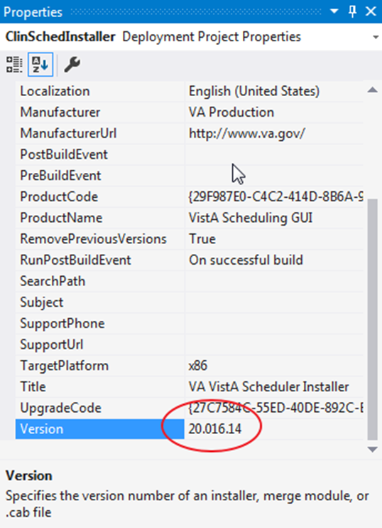

* 1. Upon exiting the field, a popup appears that says “It is recommended that the ProductCode be changed if you change the version. Do you want to do this?” Choose Yes.

Figure 42: ProductCode Update Dialog

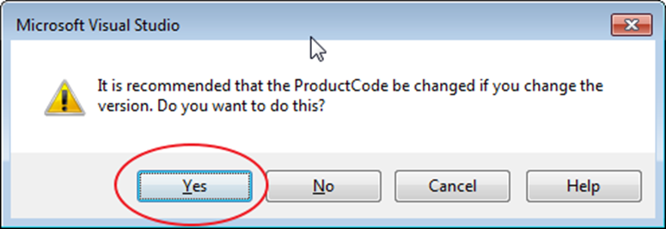

* 1. Save all your changes, commit them to Dev, and proceed to the next step.

### Create the Builds

The Test stream is used to create the three builds for testing. The essence of this step is building the solution three times and updating the ProductCode and UpgradeCode between each one.

1. Switch sandboxes in Visual Studio to the sandbox tied to your Test stream
2. Open the build project properties pane by selecting the build project and hitting the F4 key
3. Find the UpgradeCode on the ClinSchedInstaller properties page and confirm that it is correct
   1. Upon clicking in the field, an ellipsis (…) button appears
   2. Click the ellipsis button to open a dialog box that will make it easier to see and edit the full value

Figure 43: ClinSchedInstaller Properties Page and Upgrade Code Dialog

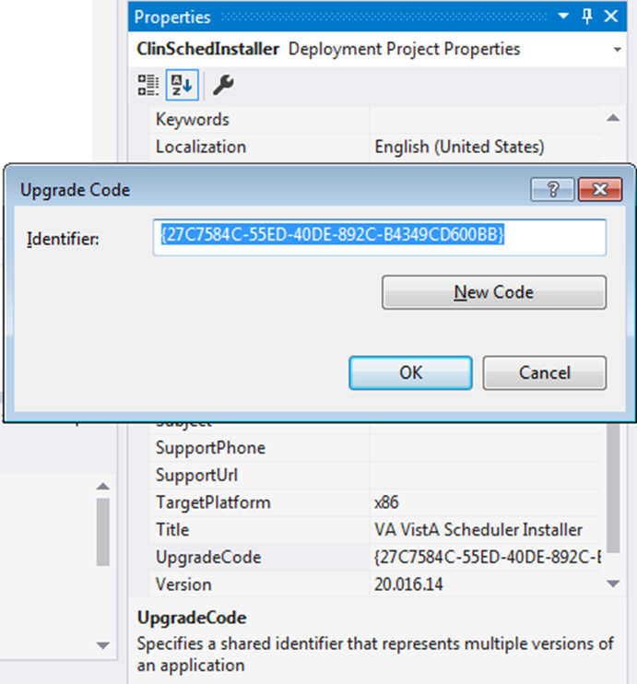

1. By default, this is saved to the repository with the UpgradeCode for the Test version, but copy the value from Table 10 for the build you are creating

Table 10: Upgrade Codes

|  |  |
| --- | --- |
| Build | Upgrade Code |
| Release Candidate (RC) | {5F2AD4CA-24A2-427C-BB46-9B61E6BF9743} |
| Test | {27C7584C-55ED-40DE-892C-B4349CD600BB} |
| Production (Prod) | {F573836B-D355-4712-94B1-60F61CD8319E} |

If the UpgradeCode is changed, the ProductCode must be changed:

1. Open the ClinSchedInstaller properties page
2. Click within the ProductCode field
3. Click the ellipsis button to open the Product Code dialog
4. Click the New Code button to generate a new GUID

Figure 44: ClinSchedInstaller Properties Page and Product Code Dialog

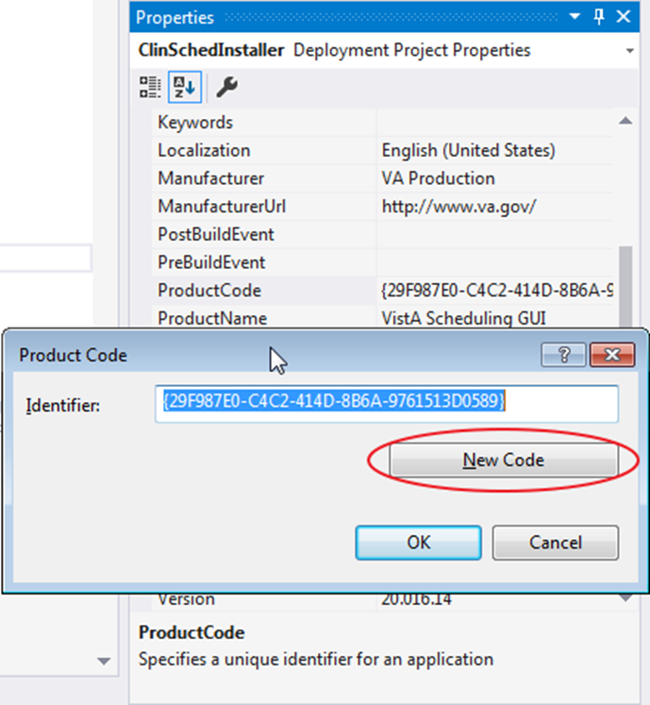

The build can now be created.

1. In the top-level menu, click Build > Rebuild Solution

**NOTE:** The rebuild of the solution may take a while

1. Open two File Explorer windows:
   1. One to ConTEST\ClinSchedInstaller\Release (in the Test stream sandbox)
   2. One to Installers\Scheduling Releases (in the Installers sandbox)

Once the build is finished, it will appear in the Release folder as VistASchedulingGUIInstaller.msi

1. Rename the build to something like VistASchedulingGUIInstaller-2.0.0.16.14-T.msi, replacing the build number with the correct one, and the letter(s) at the end with RC for Release Candidate, T for Test, or P for Production
2. Move the renamed installer to the Scheduling Releases folder

### Editing and Committing the Builds

After the three builds are in the Scheduling Releases folder, edit each one using SuperOrca. Either File > Open or just dragging and dropping an installer onto the SuperOrca window will open it for editing. Changes are saved as they are made, so there is no need to manually save changes. This should be done for each of the three builds.

1. In the pane on the left, select Property
   1. There are two values to change on the right-hand side: ProductName and ProductVersion
   2. Upon double-clicking on the value column (not the one that shows the name of each specific property), the system will open a popup where the value can be edited

Figure 45: Editing the ProductVersion Field Under Property

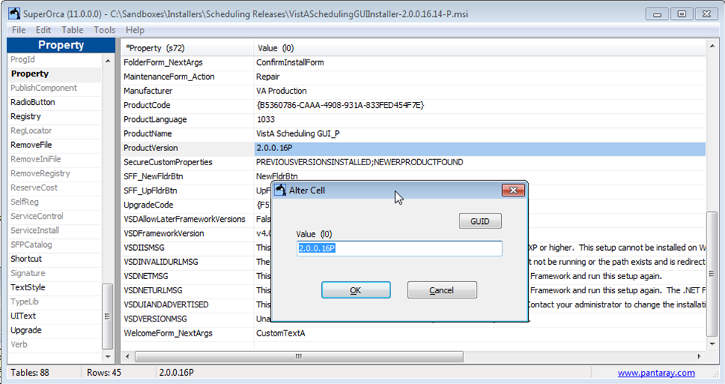

1. For the ProductName field, append either “_RC” for the Release Candidate build, “_T” for the Test build, or “_P” for the Prod build
2. For the ProductVersion field, enter the first four pieces of the build number followed by the letters representing the build (for example, 2.0.0.16P for any Prod build of the 2.0.0.16 release)
3. Select Shortcut in the left-hand pane. There are two values to edit here, also

Figure 46: Editing the Name Field Under Shortcut

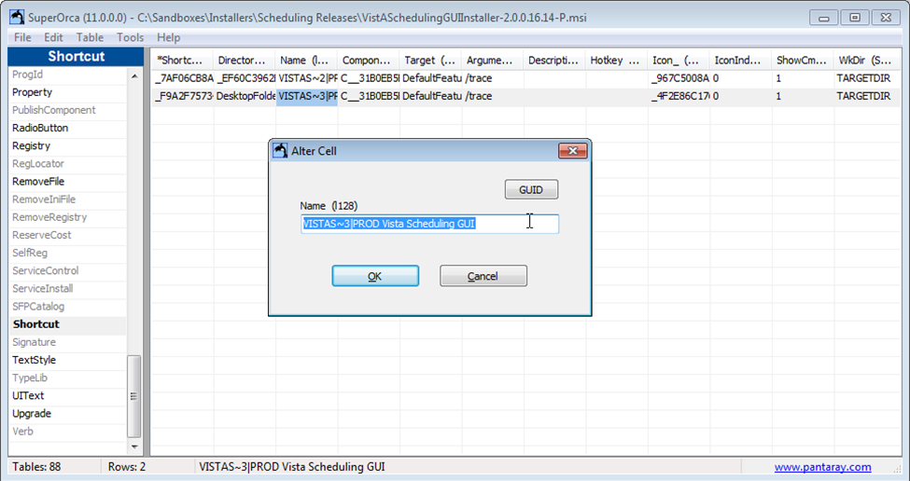

1. Double-click on the value in the Name column for each of the two rows
2. After the pipe (“|”), add “RC”, “Test”, or “PROD”, then a space, before the “VistA Scheduling GUI” in the value for that cell, depending on the build being edited

After performing these steps for all three builds, and installing at least one of them to verify, the installers can be committed to the Installers stream.

# Legacy VistA Scheduling Implementation and Maintenance

The VS GUI provides a Windows interface for the Patient Information Management System (PIMS) scheduling software and is designed to interoperate with existing PIMS schedules.

## System Requirements

The system requirements are:

* Server
  + Cache version 5.0
  + Kernel version 8
  + PIMS version 5.3 patch 1012
  + VistA Scheduling Patch SD*5.3*686

## Package-wide Variables

There are no package-wide variables associated with the PIMS package.

## Routines

Table 11 lists routines and their descriptions.

Table 11: Routines and Descriptions

|  |  |
| --- | --- |
| Routine | Description |
| SDAM2 | ALB/MJK - Appt Mgt (cont) |
| SDAMWI1 | ALB/MJK - Walk-Ins (cont.) |
| SDAPIAP | ALB/MJK - Outpatient API/Appointments |
| SDB | FLA/RF,BSN/GRR - SET UP A CLINIC |
| SDB1 | ALB/GRR - SET UP A CLINIC |
| SDC | MAN/GRR,ALB/LDB - CANCEL A CLINIC'S AVAILABILITY |
| SDCNP0 | ALB/LDB - CANCEL APPT. FOR A PATIENT |
| SDCNSLT | ALB/HAG - LINK APPOINTMENTS TO CONSULTS |
| SDCODEL | ALB/RMO,ESW - Delete - Check Out |
| SDEC | ALB/SAT - VISTA SCHEDULING RPCs modified for patch SD*5.3*679 |
| SDEC01 | ALB/SAT - VISTA SCHEDULING RPCs |
| SDEC01A | ALB/SAT - VISTA SCHEDULING RPCs |
| SDEC01B | ALB/SAT - VISTA SCHEDULING RPCs |
| SDEC02 | ALB/SAT - VISTA SCHEDULING RPCs |
| SDEC03 | ALB/SAT - VISTA SCHEDULING RPCs |
| SDEC04 | ALB/SAT - VISTA SCHEDULING RPCs |
| SDEC05 | ALB/SAT - VISTA SCHEDULING RPCs |
| SDEC06 | ALB/SAT - VISTA SCHEDULING RPCs |
| SDEC07 | ALB/SAT - VISTA SCHEDULING RPCs |
| SDEC07A | ALB/SAT - VISTA SCHEDULING RPCs modified for patch SD*5.3*679 |
| SDEC07B | ALB/SAT - VISTA SCHEDULING RPCs |
| SDEC08 | ALB/SAT - VISTA SCHEDULING RPCs |
| SDEC09 | ALB/SAT - VISTA SCHEDULING RPCs modified for patch SD*5.3*679 |
| SDEC12 | ALB/SAT - VISTA SCHEDULING RPCs |
| SDEC13 | ALB/SAT - VISTA SCHEDULING RPCs |
| SDEC14 | ALB/SAT - VISTA SCHEDULING RPCs |
| SDEC15 | ALB/SAT - VISTA SCHEDULING RPCs |
| SDEC16 | ALB/SAT - VISTA SCHEDULING RPCs |
| SDEC17 | ALB/SAT - VISTA SCHEDULING RPCs |
| SDEC18 | ALB/SAT - VISTA SCHEDULING RPCs |
| SDEC19 | ALB/SAT - VISTA SCHEDULING RPCs |
| SDEC20 | ALB/SAT - VISTA SCHEDULING RPCs |
| SDEC21 | ALB/SAT - VISTA SCHEDULING RPCs |
| SDEC22 | ALB/SAT - VISTA SCHEDULING RPCs |
| SDEC23 | ALB/SAT - VISTA SCHEDULING RPCs |
| SDEC24 | ALB/SAT - VISTA SCHEDULING RPCs |
| SDEC25 | ALB/SAT - VISTA SCHEDULING RPCs |
| SDEC25A | ALB/SAT - VISTA SCHEDULING RPCs |
| SDEC25B | ALB/SAT - VISTA SCHEDULING RPCs |
| SDEC26 | ALB/SAT - VISTA SCHEDULING RPCs |
| SDEC27 | ALB/SAT - VISTA SCHEDULING RPCs |
| SDEC28 | ALB/SAT - VISTA SCHEDULING RPCs modified for patch SD*5.3*679 |
| SDEC29 | ALB/SAT - VISTA SCHEDULING RPCs |
| SDEC30 | ALB/SAT - VISTA SCHEDULING RPCs |
| SDEC31 | ALB/SAT - VISTA SCHEDULING RPCs |
| SDEC32 | ALB/SAT - VISTA SCHEDULING RPCs modified for patch SD*5.3*679 |
| SDEC33 | ALB/SAT - VISTA SCHEDULING RPCs |
| SDEC34 | ALB/SAT - VISTA SCHEDULING RPCs |
| SDEC35 | ALB/SAT - VISTA SCHEDULING RPCs |
| SDEC36 | ALB/SAT - VISTA SCHEDULING RPCs |
| SDEC37 | ALB/SAT - VISTA SCHEDULING RPCs |
| SDEC38 | ALB/SAT - VISTA SCHEDULING RPCs |
| SDEC40 | ALB/SAT - VISTA SCHEDULING RPCs |
| SDEC44 | ALB/SAT - VISTA SCHEDULING RPCs |
| SDEC45 | ALB/SAT - VISTA SCHEDULING RPCs |
| SDEC46 | ALB/SAT - VISTA SCHEDULING RPCs |
| SDEC47 | ALB/SAT - VISTA SCHEDULING RPCs |
| SDEC48 | ALB/SAT - VISTA SCHEDULING RPCs |
| SDEC49 | ALB/SAT - VISTA SCHEDULING RPCs |
| SDEC50 | ALB/SAT - VISTA SCHEDULING RPCs |
| SDEC51 | ALB/SAT - VISTA SCHEDULING RPCs |
| SDEC51A | ALB/SAT – VISTA SCHEDULING RPCs |
| SDEC52 | ALB/SAT - VISTA SCHEDULING RPCs |
| SDEC52A | ALB/SAT - VISTA SCHEDULING RPCs |
| SDEC52B | ALB/SAT - VISTA SCHEDULING RPCs |
| SDEC53 | ALB/SAT - VISTA SCHEDULING RPCs modified for patch SD*5.3*679 |
| SDEC54 | ALB/SAT - VISTA SCHEDULING RPCs |
| SDEC54A | ALB/SAT - VISTA SCHEDULING RPCs |
| SDEC55 | ALB/SAT - VISTA SCHEDULING RPCs |
| SDEC55A | ALB/SAT - VISTA SCHEDULING RPCs |
| SDEC56 | ALB/SAT - VISTA SCHEDULING RPCs |
| SDEC57 | ALB/SAT - VISTA SCHEDULING RPCs |
| SDEC57A | ALB/SAT - VISTA SCHEDULING RPCs |
| SDEC658 | ALB/SAT VISTA SCHEDULING PRE/POST |
| SDEC658A | ALB/SAT/JSM - VISTA SCHEDULING PRE/POST (CONTINUED) |
| SDEC658B | ALB/SAT/JSM - VISTA SCHEDULING PRE/POST (CONTINUED) |
| SDECAUD | ALB/WTC - VISTA SCHEDULING - Audit Statistics Compiler |
| SDECALV | ALB/SAT - VISTA SCHEDULING RPCs |
| SDECALV1 | ALB/SAT - VISTA SCHEDULING RPCs |
| SDECALVR | ALB/SAT - VISTA SCHEDULING RPCs |
| SDECAPI | ALB/SAT - VISTA SCHEDULING RPCs |
| SDECAPI4 | ALB/SAT - VISTA SCHEDULING RPCs |
| SDECDIQ1 | ALB/SAT - VISTA SCHEDULING RPCs |
| SDECAR | ALB/SAT - VISTA SCHEDULING RPCs |
| SDECAR1 | ALB/SAT - VISTA SCHEDULING RPCs |
| SDECAR1A | ALB/SAT - VISTA SCHEDULING RPCs |
| SDECAR2 | ALB/SAT - VISTA SCHEDULING RPCs |
| SDECAR3 | ALB/SAT/JSM – VISTA SCHEDULING RPCs |
| SDECCLN | ALB/RBD - VISTA SCHEDULING CLEANUP UTILITY |
| SDECDEM | ALB/SAT – VISTA SCHEDULING RPCs |
| SDECDEV | ALB/SAT - VISTA SCHEDULING RPCs |
| SDECDIQ1 | ALB/SAT - VISTA SCHEDULING RPCs |
| SDECDIS | ALB/SAT - VISTA SCHEDULING RPCs |
| SDECEKL | ALB/SAT - VISTA SCHEDULING RPCs |
| SDECERR | ALB/SAT - VISTA SCHEDULING RPCs |
| SDECF | ALB/SAT - VISTA SCHEDULING RPCs |
| SDECF2 | ALB/SAT - VISTA SCHEDULING RPCs |
| SDECFUNC | ALB/SAT - VISTA SCHEDULING RPCs |
| SDECGMR | ALB/SAT - VISTA SCHEDULING RPCs |
| SDECI2 | ALB/SAT - VISTA SCHEDULING RELEASE 2 PRE/POST INSTALL |
| SDECIDX | ALB/SAT - VISTA SCHEDULING RPCs |
| SDECINI1 | ALB/SAT - VISTA SCHEDULING PRE/POST INSTALL |
| SDECINI2 | ALB/SAT - VISTA SCHEDULING PRE/POST INSTALL |
| SDECINIT | ALB/SAT - VISTA SCHEDULING PRE/POST INSTALL |
| SDECLK | ALB/SAT - VISTA SCHEDULING RPCs |
| SDECLOC | ALB/SAT – VISTA SCHEDULING RPCs |
| SDECNEW | ALB/SAT - VISTA SCHEDULING RPCs |
| SDECPAT | ALB/SAT - VISTA SCHEDULING RPCs |
| SDECPAT1 | ALB/SAT - VISTA SCHEDULING RPCs |
| SDECPAT2 | ALB/SAT - VISTA SCHEDULING RPCs |
| SDECPAT3 | ALB/SAT - VISTA SCHEDULING RPCs |
| SDECPAT4 | ALB/SAT - VISTA SCHEDULING RPCs |
| SDECPT | ALB/SAT - VISTA SCHEDULING RPCs |
| SDECPTCX | ALB/SAT - VISTA SCHEDULING RPCs |
| SDECPTPC | ALB/SAT - VISTA SCHEDULING RPCs |
| SDECPTPL | ALB/SAT - VISTA SCHEDULING RPCs |
| SDECRMG | ALB/SAT - VISTA SCHEDULING RPCs |
| SDECRMG1 | ALB/SAT - VISTA SCHEDULING RPCs |
| SDECRMG2 | ALB/SAT - VISTA SCHEDULING RPCs |
| SDECRMGP | ALB/JSM - VISTA SCHEDULING RPCs |
| SDECRPC | ALB/SAT - VISTA SCHEDULING RPCs |
| SDECRPT | ALB/BNT - SCHEDULING ENHANCEMENTS CLINIC REPORTS |
| SDECRPT1 | ALB/JSM - SCHEDULING ENHANCEMENTS CLINIC REPORTS |
| SDECRT | ALB/SAT - VISTA SCHEDULING RPCs |
| SDECRT0 | ALB/SAT - VISTA SCHEDULING RPCs |
| SDECRT1 | ALB/SAT - VISTA SCHEDULING RPCs |
| SDECRT2 | ALB/SAT - VISTA SCHEDULING RPCs |
| SDECSFGR | ALB/SAT - VISTA SCHEDULING RPCs |
| SDECU | ALB/SAT - VISTA SCHEDULING RPCs |
| SDECU2 | ALB/SAT - VISTA SCHEDULING RPCs |
| SDECU3 | ALB/SAT – VISTA SCHEDULING RPCs |
| SDECU4 | ALB/JSM - VISTA SCHEDULING RPCs |
| SDECUT1A | ALB/SAT - VISTA SCHEDULING RPCs |
| SDECUTL | ALB/SAT - VISTA SCHEDULING RPCs |
| SDECUTL1 | ALB/SAT - VISTA SCHEDULING RPCs |
| SDECUTL2 | ALB/SAT - VISTA SCHEDULING RPCs |
| SDECV | ALB/SAT - VISTA SCHEDULING RPCs |
| SDECWL | ALB/SAT - VISTA SCHEDULING RPCs |
| SDECWL1 | ALB/SAT - VISTA SCHEDULING RPCs |
| SDECWL2 | ALB/SAT - VISTA SCHEDULING RPCs |
| SDECWL3 | ALB/SAT - VISTA SCHEDULING RPCs |
| SDM1A | SF/GFT,ALB/TMP - MAKE APPOINTMENT |
| SDMM1 | ALB/GRR - MULTIPLE BOOKINGS |
| SDN | SF/GFT,ALB/LDB - RECORD NO SHOWS |
| SDNACT | ALB/TMP - INACTIVATE A CLINIC |
| SDREACT | ALB/TMP - REACTIVATE A CLINIC |
| SDRRISRU | 10N20/MAH; Recall Reminder Utilities |
| SD628PST | SD*5.3*628 Post Install Routine |
| SDCED | VSE ENCOUNTER XREF |
| SDCED1 | VSE ENCOUNTER XREF |
| SDCED2 | VSE ENCOUNTER XREF |
| SDECRPT | VSE CLINIC APPOINTMENTS |
| SDECSTP | VSE RESOURCE MANAGEMENT REPORT STOP CODES |
| SDWLPL | IOFO BAY PINES/DMR,ESW - WAIT LIST PICK LIST |
| SDECXML | VSE RESOURCE MANAGEMENT REPORT XML DATA |
| SDECXML1 | VSE RESOURCE MANAGEMENT REPORT XML DATA |
| SDECXML2 | VSE RESOURCE MANAGEMENT REPORT XML DATA |
| SDECXML3 | VSE RESOURCE MANAGEMENT REPORT XML DATA |
| SDECXML4 | VSE RESOURCE MANAGEMENT REPORT XML DATA |
| SDECXML5 | VSE RESOURCE MANAGEMENT REPORT XML DATA |
| SDECXUTL | VSE RESOURCE MANAGEMENT REPORT XML UTILITY |
| SDECCON | SPFO/DMR SCHEDULING ENHANCEMENTS VSE CONTACT API |
| SDECEP | SPFO/DMR SCHEDULING ENHANCEMENTS VSE EP API |
| SDECEPT | SPFO/RT SCHEDULING ENHANCEMENTS VSE EP API |
| SDECELG | SPFO/DMR SCHEDULING ENHANCEMENTS VSE API |
| SDEC07 | ALB/SAT - VISTA SCHEDULING RPCS |
| SDEC07B | ALB/SAT - VISTA SCHEDULING RPCS |
| SD53699 | SPFO/DMR SCHEDULING ENCHANCEMENTS VSE |

## Files and Tables

Table 12 lists the file names and numbers used by the VS GUI.

Table 12: File Names and Numbers

| File Number | File Name |
| --- | --- |
| 44 | HOSPITAL LOCATION |
| 403.5 | RECALL REMINDERS |
| 403.56 | RECALL REMINDERS REMOVED |
| 409.3 | SD WAIT LIST |
| 409.822 | SDEC ACCESS GROUP |
| 409.824 | SDEC ACCESS GROUP TYPE |
| 409.823 | SDEC ACCESS TYPE |
| 409.834 | SDEC ADDITIONAL RESOURCE |
| 409.81 | SDEC APPLICATION |
| 409.84 | SDEC APPOINTMENT |
| 409.845 | SDEC PREFERENCES AND SPECIAL NEEDS |
| 409.85 | SDEC APPT REQUEST |
| 409.831 | SDEC RESOURCE |
| 409.832 | SDEC RESOURCE GROUP |
| 409.833 | SDEC RESOURCE USER |
| 409.86 | SDEC CONTACT |
| 409.97 | SD Audit Statistics |

### File Access

Table 13 lists the files accessed by the VS GUI.

Table 13: File Access

| File Number | GLOBAL | READ | WRITE | LAYGO | DATA DICTIONARY | DELETE |
| --- | --- | --- | --- | --- | --- | --- |
| 44 | ^SC( | D | D | D | @ | @ |
| 403.5 | ^SD(403.5, |  |  | @ | @ | @ |
| 403.56 | ^SD(403.56, |  |  | @ | @ | @ |
| 409.3 | ^SDWL(409.3, |  | D | D | @ | @ |
| 409.822 | ^SDEC(409.822, |  |  |  |  |  |
| 409.824 | ^SDEC(409.824, |  |  |  |  |  |
| 409.823 | ^SDEC(409.823, |  |  |  |  |  |
| 409.834 | ^SDEC(409.834, |  |  |  |  |  |
| 409.81 | ^SDEC(409.81, |  |  |  |  |  |
| 409.84 | ^SDEC(409.84, |  |  |  |  |  |
| 409.85 | ^SDEC(409.85, |  |  |  |  |  |
| 409.845 | ^SDEC(409.845, |  |  |  |  |  |
| 409.831 | ^SDEC(409.831, |  |  |  |  |  |
| 409.832 | ^SDEC(409.832, |  |  |  |  |  |
| 409.833 | ^SDEC(409.833, |  |  |  |  |  |
| 409.86 | ^SDEC(409.86, |  |  |  |  |  |
| 409.97 | ^SDAUDIT( |  | @ | @ | @ | @ |

## VistA Scheduling GUI Cross References

### #44 HOSPITAL LOCATION

**TRADITIONAL CROSS-REFERENCE LIST -- FILE #44**

File #44

Subfile #44.1

Traditional Cross-references:

ADPR MUMPS WHOLE FILE (#44)

Field: DEFAULT PROVIDER (44.1,.02)

1)= S:X ^SC("ADPR",DA(1),DA)=""

2)= K ^SC("ADPR",DA(1),DA)

AVADPR MUMPS WHOLE FILE (#44)

Field: PROVIDER (44.1,.01)

Description: FINDS A PROVIDER'S CLINICS Cross-reference to easily find all clinics for a particular provider and if that provider is listed as default.

1)= S ^SC("AVADPR",X,DA(1),DA)=$P(^SC(DA(1),"PR",DA,0),U,2)

2)= K ^SC("AVADPR",X,DA(1),DA)

B REGULAR

Field: PROVIDER (44.1,.01)

1)= S ^SC(DA(1),"PR","B",$E(X,1,30),DA)=""

2)= K ^SC(DA(1),"PR","B",$E(X,1,30),DA)

**INDEX AND CROSS-REFERENCE LIST -- FILE #44, FIELD #2**

New-Style Indexes:

AG (#1345) RECORD REGULAR IR SORTING ONLY

Short Descr: Index by TYPE and NAME.

Description: This cross reference is used to sort by TYPE and NAME.

Set Logic: S ^SC("AG",X(1),X(2),DA)=""

Kill Logic: K ^SC("AG",X(1),X(2),DA)

Whole Kill: K ^SC("AG")

X(1): TYPE (44,2) (Subscr 1) (forwards)

X(2): NAME (44,.01) (Subscr 2) (forwards)

### #403.5 RECALL REMINDERS

**INDEX AND CROSS-REFERENCE LIST -- FILE #403.5, FIELD #7.5**

New-Style Indexes:

AC (#1346) RECORD REGULAR IR SORTING ONLY

Short Descr: Index by DATE/TIME RECALL ADDED and USER WHO ENTERED RECALL

Description: This cross reference is used to sort by DATE/TIME RECALL

ADDED and USER WHO ENTERED RECALL.

Set Logic: S ^SD(403.5,"AC",X(1),X(2),DA)=""

Kill Logic: K ^SD(403.5,"AC",X(1),X(2),DA)

Whole Kill: K ^SD(403.5,"AC")

X(1): DATE/TIME RECALL ADDED (403.5,7.5) (Subscr 1) (forwards)

X(2): USER WHO ENTERED RECALL (403.5,7) (Subscr 2) (forwards)

### #403.56 – RECALL REMINDERS REMOVED

**INDEX AND CROSS-REFERENCE LIST -- FILE #403.56, FIELD #7.5**

New-Style Indexes:

AC (#1347) RECORD REGULAR IR SORTING ONLY

Short Descr: Index by DATE/TIME RECALL ADDED and USER WHO ENTERED RECALL

Description: This cross reference is used to sort by DATE/TIME RECALL

ADDED and USER WHO ENTERED RECALL.

Set Logic: S ^SD(403.56,"AC",X(1),X(2),DA)=""

Kill Logic: K ^SD(403.56,"AC",X(1),X(2),DA)

Whole Kill: K ^SD(403.56,"AC")

X(1): DATE/TIME RECALL ADDED (403.56,7.5) (Subscr 1) (forwards)

X(2): USER WHO ENTERED RECALL (403.56,7) (Subscr 2) (forwards)

### #409.3 – SD WAIT LIST

**INDEX AND CROSS-REFERENCE LIST -- FILE #409.3, FIELD #8.5**

Traditional Cross-References:

AE REGULAR

Field: WL SPECIFIC HOSPITAL LOCATION (409.3,8.5)

Description: This xref is used to find entries associated with a particular HOSPITAL LOCATION.

1)= S ^SDWL(409.3,"AE",$E(X,1,30),DA)=""

2)= K ^SDWL(409.3,"AE",$E(X,1,30),DA)

**INDEX AND CROSS-REFERENCE LIST -- FILE #409.3, FIELD #23**

E MUMPS

Field: CURRENT STATUS (409.3,23)

Description: This xref is used to speed up the lookup of open or closed wait list entries for a given time range.

1)= S:$P(^SDWL(409.3,DA,0),U,2)'="" ^SDWL(409.3,"E",X,$P(^S

DWL(409.3,DA,0),U,2),DA)=""

2)= K:$P(^SDWL(409.3,DA,0),U,2)'="" ^SDWL(409.3,"E",X,$P(^S

DWL(409.3,DA,0),U,2),DA)

**INDEX AND CROSS-REFERENCE LIST -- FILE #409.3, FIELD #1**

ETOO MUMPS

Field: ORIGINATING DATE (409.3,1)

Description: This xref actually updates the "E" xref for CURRENT STATUS in the event that the ORIGINATING DATE is changed. This xref is used to speed up the lookup of open or closed wait list entries for a given time range.

1)= S:$P(^SDWL(409.3,DA,0),U,17)'="" ^SDWL(409.3,"E",$P(^SD

WL(409.3,DA,0),U,17),X,DA)=""

2)= K:$P(^SDWL(409.3,DA,0),U,17)'="" ^SDWL(409.3,"E",$P(^SD

WL(409.3,DA,0),U,17),X,DA)

**INDEX AND CROSS-REFERENCE LIST -- FILE #409.3, FIELD #.01**

New-Style Indexes:

AD (#1349) RECORD REGULAR IR SORTING ONLY

Short Descr: Index by PATIENT and WL SPECIFIC HOSPITAL LOCATION

Description: This cross reference is used to sort by PATIENT and WL SPECIFIC HOSPITAL LOCATION.

Set Logic: S ^SDWL(409.3,"AD",X(1),X(2),DA)=""

Kill Logic: K ^SDWL(409.3,"AD",X(1),X(2),DA)

Whole Kill: K ^SDWL(409.3,"AD")

X(1): PATIENT (409.3,.01) (Subscr 1) (forwards)

X(2): WL SPECIFIC HOSPITAL LOCATION (409.3,8.5) (Subscr 2) (forwards)

**Subfile #409.345**

**Traditional Cross-References:**

B REGULAR

Field: DATE EDITED (409.345,.01)

1)= S ^SDWL(409.3,DA(1),6,"B",$E(X,1,30),DA)=""

2)= K ^SDWL(409.3,DA(1),6,"B",$E(X,1,30),DA)

New-Style Indexes:

GS (#1387) RECORD REGULAR IR LOOKUP & SORTING

Short Descr: SORT BY CLINIC STOP (SERVICES) ID AND ORIGINATING DATE

Description: This xref is used to sort/filter Wait List entries by the CLINIC STOP id and the ORIGINATING DATE field (#1). The CLINIC STOP id comes from the SD WL SERVICE/SPECIALTY file (#409.31). The WL SERVICE/SPECIALTY field (#7) in the SD WAIT LIST file (#409.3) contains the pointer to the SD WL SERVICE/SPECIALTY file.

Set Logic: S ^SDWL(409.3,"GS",X(1),X(2),DA)=""

Kill Logic: K ^SDWL(409.3,"GS",X(1),X(2),DA)

Whole Kill: K ^SDWL(409.3,"GS")

X(1): Computed Code: S X=$P($G(^SDWL(409.31,+$P($G(^SDWL(409.3,DA ,0)),U,8),0)),U,1) (Subscr 1) (forwards)

X(2): ORIGINATING DATE (409.3,1) (Subscr 2) (forwards)

**GSP (#1389) RECORD REGULAR IR LOOKUP & SORTING**

Short Descr: SORT BY CLINIC STOP (SERVICES) ID, ENROLLMENT PRIORITY, AND ORIGINATING DATE

Description: This xref is used to sort Wait List entries by the CLINIC STOP id, Patient's ENROLLMENT PRIORITY, and the ORIGINATING DATE field (#1). The CLINIC STOP id comes from the SD WL SERVICE/SPECIALTY file (#409.31). The WL SERVICE/SPECIALTY field (#7) in the SD WAIT LIST file (#409.3) contains the pointer to the SD WL SERVICE/SPECIALTY file.

Set Logic: S ^SDWL(409.3,"GSP",X(1),X(2),X(3),DA)=""

Kill Logic: K ^SDWL(409.3,"GSP",X(1),X(2),X(3),DA)

Whole Kill: K ^SDWL(409.3,"GSP")

X(1): Computed Code: S X=$P($G(^SDWL(409.31,+$P($G(^SDWL(409.3,DA ,0)),U,8),0)),U,1) (Subscr 1) (forwards)

X(2): Computed Code: N DFN,PCE S DFN=$P($G(^SDWL(409.3,DA,0)),U,1),PCE=$P($G(^DPT(+DFN,"ENR")),U,1),X=+$P($G(^DGEN(27.11,+PC E,0)),U,7) (Subscr 2) (forwards)

X(3): ORIGINATING DATE (409.3,1) (Subscr 3) (forwards)

**GSA (#1390) RECORD REGULAR IR LOOKUP & SORTING**

Short Descr: SORT BY CLINIC STOP (SERVICES) ID, SVC CONNECTED, AND ORIGINATING DATE

Description: This xref is used to sort Wait List entries by the CLINIC STOP id, SERVICE CONNECTED, and the ORIGINATING DATE field (#1). The WL SERVICE/SPECIALTY field (#7) in the SD WAIT LIST file (#409.3) contains the pointer to the SD WL SERVICE/SPECIALTY file. The CLINIC STOP id is in the SERVICE/SPECIALTY field (#.01) of the SD WL SERVICE/SPECIALTY file (#409.31) SERVICE CONNECTED is the SERVICE CONNECTED? field (#.301) (a required field) in the PATIENT file (#2).

Set Logic: S ^SDWL(409.3,"GSA",X(1),X(2),X(3),DA)=""

Kill Logic: K ^SDWL(409.3,"GSA",X(1),X(2),X(3),DA)

Whole Kill: K ^SDWL(409.3,"GSA")

X(1): Computed Code: S X=$P($G(^SDWL(409.31,+$P($G(^SDWL(409.3,DA ,0)),U,8),0)),U,1) (Subscr 1) (forwards)

X(2): Computed Code: S X=$P($G(^DPT(+$P($G(^SDWL(409.3,DA,0)),U,1 ),.3)),U,1) (Subscr 2) (forwards)

X(3): ORIGINATING DATE (409.3,1) (Subscr 3) (forwards)

**GSB (#1391) RECORD REGULAR IR LOOKUP & SORTING**

Short Descr: SORT BY CLINIC STOP (SVCS) ID, SVC CONNECTED PRIORITY, AND ORIGINATING DATE

Description: This xref is used to sort Wait List entries by the CLINIC STOP id, SERVICE CONNECTED PRIORITY field (#15), and the ORIGINATING DATE field (#1). The WL SERVICE/SPECIALTY field (#7) in the SD WAIT LIST file (#409.3) contains the pointer to the SD WL SERVICE/SPECIALTY file. The CLINIC STOP id is in the SERVICE/SPECIALTY field (#.01) of the SD WL SERVICE/SPECIALTY file (#409.31).

Set Logic: S ^SDWL(409.3,"GSB",X(1),X(2),X(3),DA)=""

Kill Logic: K ^SDWL(409.3,"GSB",X(1),X(2),X(3),DA)

Whole Kill: K ^SDWL(409.3,"GSB")

X(1): Computed Code: S X=$P($G(^SDWL(409.31,+$P($G(^SDWL(409.3,DA ,0)),U,8),0)),U,1) (Subscr 1) (forwards)

X(2): Computed Code: S X=+$P($G(^SDWL(409.3,DA,"SC")),U,2) (Subscr 2) (forwards)

X(3): ORIGINATING DATE (409.3,1) (Subscr 3) (forwards)

**GC (#1392) FIELD REGULAR IR LOOKUP & SORTING Short Descr: SORT BY CLINIC AND ORIGINATING DATE**

Description: This xref is used to sort Wait List entries by the Clinic ID and the ORIGINATING DATE field (#1). The Clinic ID comes from the CLINIC field (#.01) of the SD WL CLINIC LOCATION file (#409.32). The SD WL CLINIC LOCATION pointer is in the WL SPECIFIC CLINIC field (#8) of the SD WAIT LIST file (#409.3).

Set Logic: S ^SDWL(409.3,"GC",X(1),X(2),DA)=""

Kill Logic: K ^SDWL(409.3,"GC",X(1),X(2),DA)

Whole Kill: K ^SDWL(409.3,"GC")

X(1): Computed Code: S X=$P($G(^SDWL(409.32,+$P($G(^SDWL(409.3,DA ,0)),U,9),0)),U,1) (Subscr 1) (forwards)

X(2): ORIGINATING DATE (409.3,1) (Subscr 2) (forwards)

**GSC (#1388) RECORD REGULAR IR LOOKUP & SORTING**

Short Descr: SORT BY CLINIC STOP (SERVICES) ID AND CID/PREFERRED DATE

Description: This xref is used to sort Wait List entries by the CLINIC STOP id and the CID/PREFERRED DATE field (#22). The CLINIC STOP id comes from the SD WL SERVICE/SPECIALTY file (#409.31). The WL SERVICE/SPECIALTY field (#7) in the SD WAIT LIST file (#409.3) contains the pointer to the SD WL SERVICE/SPECIALTY file.

Set Logic: S ^SDWL(409.3,"GSC",X(1),X(2),DA)=""

Kill Logic: K ^SDWL(409.3,"GSC",X(1),X(2),DA)

Whole Kill: K ^SDWL(409.3,"GSC") X(1): Computed Code: S X=$P($G(^SDWL(409.31,+$P($G(^SDWL(409.3,DA,0)),U,8),0)),U,1) (Subscr 1) (forwards)

X(2): DESIRED DATE OF APPOINTMENT (409.3,22) (Subscr 2) (forwards)

**GCC (#1393) FIELD REGULAR IR LOOKUP & SORTING**

Short Descr: SORT BY CLINIC ID AND CID/PREFERRED DATE

Description: This xref is used to sort Wait List entries by the Clinic ID and the CID/PREFERRED DATE field (#22). The Clinic ID comes from the CLINIC field (#.01) of the SD WL CLINIC LOCATION file (#409.32). The SD WL CLINIC LOCATION pointer is in the WL SPECIFIC CLINIC field (#8) of the SD WAIT LIST file (#409.3).

Set Logic: S ^SDWL(409.3,"GCC",X(1),X(2),DA)=""

Kill Logic: K ^SDWL(409.3,"GCC",X(1),X(2),DA)

Whole Kill: K ^SDWL(409.3,"GCC") X(1): Computed Code: S X=$P($G(^SDWL(409.32,+$P($G(^SDWL(409.3,DA,0)),U,9),0)),U,1) (Subscr 1) (forwards)

X(2): DESIRED DATE OF APPOINTMENT (409.3,22) (Subscr 2) (forwards)

### #409.81 SDEC APPLICATION

**TRADITIONAL CROSS-REFERENCE LIST -- FILE #409.81**

File #409.81

**Traditional Cross-References:**

B REGULAR Field: MAJOR VERSION (409.81,.01)

1)= S ^SDEC(409.81,"B",$E(X,1,30),DA)=""

2)= K ^SDEC(409.81,"B",$E(X,1,30),DA)

### #409.822 SDEC ACCESS GROUP

**TRADITIONAL CROSS-REFERENCE LIST -- FILE #409.822**

File #409.822

**Traditional Cross-References:**

B REGULAR Field: ACCESS GROUP (409.822,.01)

1)= S ^SDEC(409.822,"B",$E(X,1,30),DA)=""

2)= K ^SDEC(409.822,"B",$E(X,1,30),DA)

### #409.823 SDEC ACCESS TYPE

**TRADITIONAL CROSS-REFERENCE LIST -- FILE #409.823**

File #409.823

**Traditional Cross-References:**

B REGULAR Field: ACCESS TYPE NAME (409.823,.01)

1)= S ^SDEC(409.823,"B",$E(X,1,30),DA)=""

2)= K ^SDEC(409.823,"B",$E(X,1,30),DA)

### #409.824 SDEC ACCESS GROUP TYPE

**TRADITIONAL CROSS-REFERENCE LIST -- FILE #409.824**

File #409.824

**Traditional Cross-References:**

B REGULAR Field: ACCESS GROUP (409.824,.01)

1)= S ^SDEC(409.824,"B",$E(X,1,30),DA)=""

2)= K ^SDEC(409.824,"B",$E(X,1,30),DA)

### #409.831 – SDEC RESOURCE

**INDEX AND CROSS-REFERENCE LIST -- FILE #409.831**

File #409.831

**Traditional Cross-References:**

ALOC REGULAR Field: HOSPITAL LOCATION (409.831,.04)

Description: This "ALOC" xref is used to look up an SDEC RESOURCE record using a HOSPITAL LOCATION id.

1)= S ^SDEC(409.831,"ALOC",$E(X,1,30),DA)=""

2)= K ^SDEC(409.831,"ALOC",$E(X,1,30),DA)

B REGULAR Field: RESOURCE (409.831,.01)

1)= S ^SDEC(409.831,"B",$E(X,1,30),DA)=""

2)= K ^SDEC(409.831,"B",$E(X,1,30),DA)

C REGULAR Field: ABBREVIATION (409.831,.011)

Description: This xref is used to lookup Resources using an abbreviation.

1)= S ^SDEC(409.831,"C",$E(X,1,30),DA)=""

2)= K ^SDEC(409.831,"C",$E(X,1,30),DA)

**New-Style Indexes:**

AC (#1356) FIELD REGULAR IR SORTING ONLY

Short Descr: Index of RESOURCE TYPE

Description: This cross-reference is built from both pieces of the RESOURCE TYPE variable pointer field to speed up the sorting of resources when given a specific source and ID. The sources could be HOSPITAL LOCATION, NEW PERSON, or SDEC ADDITIONAL RESOURCE.

Set Logic: S ^SDEC(409.831,"AC",X(1),X(2),DA)=""

Kill Logic: K ^SDEC(409.831,"AC",X(1),X(2),DA)

Whole Kill: K ^SDEC(409.831,"AC")

X(1): RESOURCE TYPE (409.831,.012) (Subscr 1) (forwards)

Transform (Storage): S X=$E($$OT1^SDEC03(X),1)

X(2): RESOURCE TYPE (409.831,.012) (Subscr 2) (forwards)

Transform (Storage): S X=$P(X,";",1)

Subfile #409.8312001

**Traditional Cross-References:**

ASSOC REGULAR WHOLE FILE (#409.831)

Field: ASSOCIATED VISTA CLINICS (409.8312001,.01)

Description: This "ASSOC" xref is used to find a SDEC RESOURCE record using a HOSPITAL LOCATION id that was used in the ASSOCIATED VISTA CLINICS multiple.

1)= S ^SDEC(409.831,"ASSOC",$E(X,1,30),DA(1),DA)=""

2)= K ^SDEC(409.831,"ASSOC",$E(X,1,30),DA(1),DA)

B REGULAR

Field: ASSOCIATED VISTA CLINICS (409.8312001,.01)

1)= S ^SDEC(409.831,DA(1),20,"B",$E(X,1,30),DA)=""

2)= K ^SDEC(409.831,DA(1),20,"B",$E(X,1,30),DA)

### #409.832 SDEC RESOURCE GROUP

**INDEX AND CROSS-REFERENCE LIST -- FILE #409.832**

File #409.832

**Traditional Cross-References:**

B REGULAR

Field: NAME (409.832,.01)

1)= S ^SDEC(409.832,"B",$E(X,1,30),DA)=""

2)= K ^SDEC(409.832,"B",$E(X,1,30),DA)

Subfile #409.8321

**Traditional Cross-References:**

AB REGULAR WHOLE FILE (#409.832)

Field: RESOURCE (409.8321,.01)

Description: This "AB" xref is used to find a SDEC RESOURCE GROUP record using a SDEC RESOURCE id.

1)= S ^SDEC(409.832,"AB",$E(X,1,30),DA(1),DA)=""

2)= K ^SDEC(409.832,"AB",$E(X,1,30),DA(1),DA)

B REGULAR

Field: RESOURCE (409.8321,.01)

1)= S ^SDEC(409.832,DA(1),1,"B",$E(X,1,30),DA)=""

2)= K ^SDEC(409.832,DA(1),1,"B",$E(X,1,30),DA)

### #409.833 – SDEC RESOURCE USER

**INDEX AND CROSS-REFERENCE LIST -- FILE #409.833**

File #409.833

**Traditional Cross-References:**

AC REGULAR

Field: USERNAME (409.833,.02)

Description: This AC xref is used to look up the SDEC RESOURCE USER record using the given User (NEW PERSON).

1)= S ^SDEC(409.833,"AC",$E(X,1,30),DA)=""

2)= K ^SDEC(409.833,"AC",$E(X,1,30),DA)

B REGULAR

Field: RESOURCENAME (409.833,.01)

1)= S ^SDEC(409.833,"B",$E(X,1,30),DA)=""

2)= K ^SDEC(409.833,"B",$E(X,1,30),DA)

**New-Style Indexes:**

AD (#1351) RECORD REGULAR IR SORTING ONLY

Short Descr: Index by RESOURCENAME and USERNAME.

Description: This cross reference is used to sort by RESOURCENAME and USERNAME.

Set Logic: S ^SDEC(409.833,"AD",X(1),X(2),DA)=""

Kill Logic: K ^SDEC(409.833,"AD",X(1),X(2),DA)

Whole Kill: K ^SDEC(409.833,"AD")

X(1): RESOURCENAME (409.833,.01) (Subscr 1) (forwards)

X(2): USERNAME (409.833,.02) (Subscr 2) (forwards)

### #409.834 – SDEC ADDITIONAL RESOURCE

**INDEX AND CROSS-REFERENCE LIST -- FILE #409.834**

File #409.834

**Traditional Cross-References:**

B REGULAR

Field: NAME (409.834,.01)

1)= S ^SDEC(409.834,"B",$E(X,1,30),DA)=""

2)= K ^SDEC(409.834,"B",$E(X,1,30),DA)

### #409.84 – SDEC APPOINTMENT

**INDEX AND CROSS-REFERENCE LIST -- FILE #409.84**

File #409.84

**Traditional Cross-References:**

AC REGULAR

Field: DATE APPT MADE (409.84,.09)

Description: This cross-reference is used to sort SDEC APPOINTMENT entries by the DATE APPOINTMENT MADE field.

1)= S ^SDEC(409.84,"AC",$E(X,1,30),DA)=""

2)= K ^SDEC(409.84,"AC",$E(X,1,30),DA)

AD REGULAR

Field: CANCEL DATETIME (409.84,.12)

Description: This cross-reference is used to sort SDEC APPOINTMENT entries by the CANCEL DATETIME field.

1)= S ^SDEC(409.84,"AD",$E(X,1,30),DA)=""

2)= K ^SDEC(409.84,"AD",$E(X,1,30),DA)

AEX REGULAR

Field: EXTERNAL ID (409.84,.21)

Description: Used to lookup the SDEC APPOINTMENT ien using the external ID.

1)= S ^SDEC(409.84,"AEX",$E(X,1,30),DA)=""

2)= K ^SDEC(409.84,"AEX",$E(X,1,30),DA)

ARSRC MUMPS

Field: RESOURCE (409.84,.07)

Description: This index is used to find all appointments for a given resource during a given time period.

1)= D XR2S^SDEC03(DA)

2)= D XR2K^SDEC03(DA)

B REGULAR

Field: STARTTIME (409.84,.01)

1)= S ^SDEC(409.84,"B",$E(X,1,30),DA)=""

2)= K ^SDEC(409.84,"B",$E(X,1,30),DA)

CPAT REGULAR

Field: PATIENT (409.84,.05)

Description: This xref is used to look up appointments by Patient.

1)= S ^SDEC(409.84,"CPAT",$E(X,1,30),DA)=""

2)= K ^SDEC(409.84,"CPAT",$E(X,1,30),DA)

### #409.845 SDEC PREFERENCES AND SPECIAL NEEDS

**INDEX AND CROSS-REFERENCE LIST -- FILE #409.845**

File #409.845

**Traditional Cross-References:**

B REGULAR

Field: PATIENT (409.845,.01)

1)= S ^SDEC(409.845,"B",$E(X,1,30),DA)=""

2)= K ^SDEC(409.845,"B",$E(X,1,30),DA)

Subfile #409.8451

**Traditional Cross-References:**

B REGULAR

Field: PREFERENCE (409.8451,.01)

1)= S ^SDEC(409.845,DA(1),1,"B",$E(X,1,30),DA)=""

2)= K ^SDEC(409.845,DA(1),1,"B",$E(X,1,30),DA)

### #409.85 – SDEC APPT REQUEST

**INDEX AND CROSS-REFERENCE LIST -- FILE #409.85**

File #409.85

**Traditional Cross-References:**

B REGULAR

Field: PATIENT (409.85,.01)

1)= S ^SDEC(409.85,"B",$E(X,1,30),DA)=""

2)= K ^SDEC(409.85,"B",$E(X,1,30),DA)

C REGULAR

Field: INSTITUTION (409.85,2)

Description: This xref is used to speed up the lookup of Appointment Requests by INSTITUTION.

1)= S ^SDEC(409.85,"C",$E(X,1,30),DA)=""

2)= K ^SDEC(409.85,"C",$E(X,1,30),DA)

GUID REGULAR

Field: VAOS GUID (409.85,5)

Description: Stores pointer to Oracle database where VAOS appointment Requests are stored.

SC MUMPS

Field: REQ SPECIFIC CLINIC (409.85,8)

Description: Sort and Lookup Appointment Request by Clinic name.

1)= I $D(X) S ^SDEC(409.85,"SC",$P(^SC(X,0),U,1),DA)=""

2)= K ^SDEC(409.85,"SC",$P(^SC(X,0),U,1),DA)

SCC MUMPS

Field: REQ SPECIFIC CLINIC (409.85,8)

Description: Sort/Lookup Appointment Request by Specific Clinic.

1)= I $D(X) S ^SDEC(409.85,"SCC",$P(^SDEC(409.85,DA,0),U,1),X,DA)=""

2)= K ^SDEC(409.85,"SCC",$P(^SDEC(409.85,DA,0),U,1),X,DA)

**New-Style Indexes:**

AC (#1663) RECORD REGULAR IR SORTING ONLY

Short Descr: Index by CREATE DATE and ORIGINATING USER

Description: This cross reference is used to sort by CREATE DATE and ORIGINATING USER.

Set Logic: S ^SDEC(409.85,"AC",X(1),X(2),DA)=""

Kill Logic: K ^SDEC(409.85,"AC",X(1),X(2),DA)

Whole Kill: K ^SDEC(409.85,"AC")

X(1): DATE/TIME ENTERED (409.85,9.5) (Subscr 1) (forwards)

X(2): ORIGINATING USER (409.85,9) (Subscr 2) (forwards)

E (#1662) RECORD REGULAR IR SORTING ONLY

Short Descr: Index by CURRENT STATUS and CREATE DATE.

Description: This cross reference is used to sort by CURRENT STATUS and CREATE DATE.

Set Logic: S ^SDEC(409.85,"E",X(1),X(2),DA)=""

Kill Logic: K ^SDEC(409.85,"E",X(1),X(2),DA)

Whole Kill: K ^SDEC(409.85,"E")

X(1): CURRENT STATUS (409.85,23) (Subscr 1) (forwards)

X(2): CREATE DATE (409.85,1) (Subscr 2) (forwards)

GC (#1952) RECORD REGULAR IR LOOKUP & SORTING

Short Descr: SORT BY CLINIC AND ORIGINATING DATE

Description: This xref is used to sort Appointment Request entries by the REQ SPECIFIC CLINIC field (#8) and the CREATE DATE field (#1).

Set Logic: S ^SDEC(409.85,"GC",X(1),X(2),DA)=""

Kill Logic: K ^SDEC(409.85,"GC",X(1),X(2),DA)

Whole Kill: K ^SDEC(409.85,"GC")

X(1): REQ SPECIFIC CLINIC (409.85,8) (Subscr 1) (forwards)

X(2): CREATE DATE (409.85,1) (Subscr 2) (forwards)

GCC (#1953) RECORD REGULAR IR LOOKUP & SORTING

Short Descr: SORT BY CLINIC AND CID/PREFERRED DATE

Description: This xref is used to sort Appointment Request entries by the REQ SPECIFIC CLINIC field (#8) and the CID PREFERRED DATE OF APPT field (#22).

Set Logic: S ^SDEC(409.85,"GCC",X(1),X(2),DA)=""

Kill Logic: K ^SDEC(409.85,"GCC",X(1),X(2),DA)

Whole Kill: K ^SDEC(409.85,"GCC")

X(1): REQ SPECIFIC CLINIC (409.85,8) (Subscr 1) (forwards)

X(2): CID/PREFERRED DATE OF APPT (409.85,22) (Subscr 2) (forwards)

GS (#1947) RECORD REGULAR IR LOOKUP & SORTING

Short Descr: SORT BY REQ SERVICE/SPECIALTY ID AND ORIGINATING DATE

Description: This xref is used to sort Appointment Request entries by the REQ SERVICE/SPECIALTY field (#8.5) and the CREATE DATE field (#1).

Set Logic: S ^SDEC(409.85,"GS",X(1),X(2),DA)=""

Kill Logic: K ^SDEC(409.85,"GS",X(1),X(2),DA)

Whole Kill: K ^SDEC(409.85,"GS")

X(1): REQ SERVICE/SPECIALTY (409.85,8.5) (Subscr 1) (forwards)

X(2): CREATE DATE (409.85,1) (Subscr 2) (forwards)

GSA (#1950) RECORD REGULAR IR LOOKUP & SORTING

Short Descr: SORT BY REQ SERVICE/SPECIALTY, SVC CONNECTED, AND CREATE DATE

Description: This xref is used to sort Appointment Request entries by the REQ SERVICE/SPECIALTY field (#8.5), SERVICE CONNECTED, and the CREATE DATE field (#1). SERVICE CONNECTED is the SERVICE CONNECTED? field (#.301) in the PATIENT file (#2).

Set Logic: S ^SDEC(409.85,"GSA",X(1),X(2),X(3),DA)=""

Kill Logic: K ^SDEC(409.85,"GSA",X(1),X(2),X(3),DA)

Whole Kill: K ^SDEC(409.85,"GSA")

X(1): REQ SERVICE/SPECIALTY (409.85,8.5) (Subscr 1) (forwards)

X(2): Computed Code: N DFN S DFN=$P($G(^SDEC(409.85,DA,0)),U,1) S

X=$P($G(^DPT(+DFN,.3)),U,1) S:X="" X=0 (Subscr 2) (forwards)

X(3): CREATE DATE (409.85,1) (Subscr 3) (forwards)

GSB (#1951) RECORD REGULAR IR LOOKUP & SORTING

Short Descr: SORT BY REQ SERVICE/SPECIALTY, SVC CONNECTED PRIORITY, AND CREATE DATE

Description: This xref is used to sort Appointment Request entries by the REQ SERVICE/SPECIALTY field (#8.5), SERVICE CONNECTED PRIORITY field (#15), and the CREATE DATE field (#1).

Set Logic: S ^SDEC(409.85,"GSB",X(1),X(2),X(3),DA)=""

Kill Logic: K ^SDEC(409.85,"GSB",X(1),X(2),X(3),DA)

Whole Kill: K ^SDEC(409.85,"GSB")

X(1): REQ SERVICE/SPECIALTY (409.85,8.5) (Subscr 1) (forwards)

X(2): SERVICE CONNECTED PRIORITY (409.85,15) (Subscr 2) (forwards)

X(3): CREATE DATE (409.85,1) (Subscr 3) (forwards)

GSC (#1948) RECORD REGULAR IR LOOKUP & SORTING

Short Descr: SORT BY REQ SERVICE/SPECIALTY ID AND CID/PREFERRED DATE OF APPT

Description: This xref is used to sort Appointment Request entries by the REQ SERVICE/SPECIALTY field (#8.5) and the CID/PREFERRED DATE OF APPT field (#22).

Set Logic: S ^SDEC(409.85,"GSC",X(1),X(2),DA)=""

Kill Logic: K ^SDEC(409.85,"GSC",X(1),X(2),DA)

Whole Kill: K ^SDEC(409.85,"GSC")

X(1): REQ SERVICE/SPECIALTY (409.85,8.5) (Subscr 1) (forwards)

X(2): CID/PREFERRED DATE OF APPT (409.85,22) (Subscr 2) (forwards)

GSP (#1949) RECORD REGULAR IR LOOKUP & SORTING

Short Descr: SORT BY REQ SERVICE/SPECIALTY, ENROLLMENT PRIORITY, AND CREATE DATE

Description: This xref is used to sort Appointment Request entries by the REQ SERVICE/SPECIALTY field (#8.5), Patient's ENROLLMENT PRIORITY, and the CREATE DATE field (#1). The Patient's ENROLLMENT PRIORITY comes from the ENROLLMENT PRIORITY field (#.07) of the PATIENT ENROLLMENT file (#27.11). The CURRENT ENROLLMENT field (#27.01) of the PATIENT file (#2) contains the pointer into the PATIENT ENROLLMENT file.

Set Logic: S ^SDEC(409.85,"GSP",X(1),X(2),X(3),DA)=""

Kill Logic: K ^SDEC(409.85,"GSP",X(1),X(2),X(3),DA)

Whole Kill: K ^SDEC(409.85,"GSP")

X(1): REQ SERVICE/SPECIALTY (409.85,8.5) (Subscr 1) (forwards)

X(2): Computed Code: N DFN,PCE S DFN=$P($G(^SDEC(409.85,DA,0)),U,1),PCE=$P($G(^DPT(+DFN,"ENR")),U,1),X=+$P($G(^DGEN(27.11,+PCE,0)),U,7) (Subscr 2) (forwards)

X(3): CREATE DATE (409.85,1) (Subscr 3) (forwards)

Subfile #409.851

**Traditional Cross-References:**

B REGULAR

Field: MRTC CALC PREF DATES (409.851,.01)

1)= S ^SDEC(409.85,DA(1),5,"B",$E(X,1,30),DA)=""

2)= K ^SDEC(409.85,DA(1),5,"B",$E(X,1,30),DA)

Subfile #409.852

**Traditional Cross-References:**

B REGULAR

Field: CHILD REQUEST (409.852,.01)

1)= S ^SDEC(409.85,DA(1),2,"B",$E(X,1,30),DA)=""

2)= K ^SDEC(409.85,DA(1),2,"B",$E(X,1,30),DA)

Subfile #409.8544

**Traditional Cross-References:**

B REGULAR

Field: DATE ENTERED (409.8544,.01)

1)= S ^SDEC(409.85,DA(1),4,"B",$E(X,1,30),DA)=""

2)= K ^SDEC(409.85,DA(1),4,"B",$E(X,1,30),DA)

**New-Style Indexes:**

AD (#1357) RECORD REGULAR IR SORTING ONLY WHOLE FILE (#409.85)

Short Descr: Sort by DATE ENTERED and ENTERED BY USER of PATIENT CONTACTS

Description: This cross reference sorts the whole SDEC APPT REQUEST file by the DATE ENTERED and ENTERED BY USER of the PATIENT CONTACTS multiple field #44.

Set Logic: S ^SDEC(409.85,"AD",X(1),X(2),DA(1),DA)=""

Kill Logic: K ^SDEC(409.85,"AD",X(1),X(2),DA(1),DA)

Whole Kill: K ^SDEC(409.85,"AD")

X(1): DATE ENTERED (409.8544,.01) (Subscr 1) (forwards)

X(2): ENTERED BY USER (409.8544,2) (Subscr 2) (forwards)

Subfile #409.8545

**Traditional Cross-References:**

B REGULAR

Field: DATE EDITED (409.8545,.01)

1)= S ^SDEC(409.85,DA(1),6,"B",$E(X,1,30),DA)=""

2)= K ^SDEC(409.85,DA(1),6,"B",$E(X,1,30),DA)

Subfile #409.8548

**Traditional Cross-References:**

B REGULAR

Field: PREREQUISITE (409.8548,.01)

1)= S ^SDEC(409.85,DA(1),8,"B",$E(X,1,30),DA)=""

2)= K ^SDEC(409.85,DA(1),8,"B",$E(X,1,30),DA)

3.5.16. #409.3 – SD Wait List

**INDEX AND CROSS-REFERENCE LIST -- FILE #409.3**

Subfile #409.345

**Traditional Cross-References:**

B REGULAR

Field: DATE EDITED (409.345,.01)

1)= S ^SDWL(409.3,DA(1),6,"B",$E(X,1,30),DA)=""

2)= K ^SDWL(409.3,DA(1),6,"B",$E(X,1,30),DA)

3.5.17. #409.86 – SDEC CONTACT

Subfile #409.863

Record Indexes:

AD (#1222) RECORD REGULAR IR SORTING ONLY WHOLE FILE (#409.86)

Short Descr: Date/user entered cross-reference

Description: Cross-reference by date/time entered and user entered. Used by audit statistics compiler (SDECAUD).

Set Logic: S ^SDEC(409.86,"AD",X(1),X(2),DA(1),DA)=""

Kill Logic: K ^SDEC(409.86,"AD",X(1),X(2),DA(1),DA)

Whole Kill: K ^SDEC(409.86,"AD")

X(1): DATE/TIME ENTERED (409.863,6) (Subscr 1) (forwards)

X(2): USER ENTERED CONTACT (409.863,5) (Subscr 2) (forwards)

## Table File

### #403.5 RECALL REMINDERS File

STANDARD DATA DICTIONARY #403.5 -- RECALL REMINDERS FILE

STORED IN ^SD(403.5, (18326 ENTRIES) SITE: TEST.CHEYENNE.MED.VA.GOV UCI: CHEYL134,ROU (VERSION 5.3)

DATA NAME GLOBAL DATA

ELEMENT TITLE LOCATION TYPE

This file contains records for all active Recall Reminders. Once a patient has called to make an appointment, the entry is then moved from this file to RECALL REMINDERS REMOVED file. Patients should not be entered into this file when their future appointment is less than 30 days. The records are maintained by Recall Date and patient name.

DD ACCESS: @

RD ACCESS:

WR ACCESS:

DEL ACCESS: @

LAYGO ACCESS: @

AUDIT ACCESS: @

(NOTE: Kernel's File Access Security has been installed in this UCI.)

IDENTIFIED BY: CLINIC (#4.5)[R], RECALL DATE (#5)[R]

POINTED TO BY: APPT REQUEST TYPE field (#.22) of the SDEC APPOINTMENT File (#409.84)

CROSS REFERENCED BY: PATIENT NAME(B), PROVIDER(C), RECALL DATE(D), CLINIC(E)

INDEXED BY: PATIENT NAME (A66201), DATE/TIME RECALL ADDED & USER WHO ENTERED RECALL (AC)

403.5,.01 PATIENT NAME 0;1 POINTER TO PATIENT FILE (#2) (Required)

LAST EDITED: JUL 15, 2008

HELP-PROMPT: Enter the name of the Patient you wish to enter a Recall for.

DESCRIPTION: Recall Reminder patient name this is a pointer to the patient file #2.

CROSS-REFERENCE: 403.5^B

1)= S ^SD(403.5,"B",$E(X,1,30),DA)=""

2)= K ^SD(403.5,"B",$E(X,1,30),DA)

Used for checking to see if the patient is in the Recall file and display recall information before a new entry is made.

FIELD INDEX: A66201 (#838) MUMPS IR ACTION

Short Descr: Save copy of record before deletion.

Description: Before deleting a record from this file, save a copy of it in file 403.56. Deletion can be either because a clerk deletes a patient from the recall list, or because a patient has been given an appointment in a clinic requested by the recall list and therefore is deleted by the nightly job. We save this information so that we can look back at appointments given to patients and see how timely the appointments were.

Set Logic: Q

Kill Logic: D DELETE^SDRRISRU

Kill Cond: S X=(X1'=""&(X2=""))

X(1): PATIENT NAME (403.5,.01) (forwards)

403.5,2 ACCESSION# 0;3 FREE TEXT

INPUT TRANSFORM: K:$L(X)>25!($L(X)<1) X

LAST EDITED: JUL 15, 2008

HELP-PROMPT: Answer must be 1-25 characters in length.

DESCRIPTION: This is the lab order number or the lab accession number if known.

403.5,2.5 COMMENT 0;7 FREE TEXT (audited)

INPUT TRANSFORM: K:$L(X)>80!($L(X)<1) X

LAST EDITED: NOV 02, 2016

HELP-PROMPT: Answer must be 1-80 characters in length.

DESCRIPTION: Comments needed for this recall entry.

AUDIT: YES, ALWAYS

403.5,2.6 FAST/NON-FASTING 0;8 SET (audited)

'f' FOR FASTING;

'n' FOR NON-FASTING;

LAST EDITED: NOV 02, 2016

HELP-PROMPT: Are the labs Fasting or Non-Fasting? leave blank if no labs have been ordered.

DESCRIPTION: If the patient has had lab tests ordered for this recall visit, select either Fasting or Non-Fasting labs. If the patient has no labs orders leave blank.

AUDIT: YES, ALWAYS

403.5,3 TEST/APP. 0;4 POINTER TO RECALL REMINDERS APPT TYPE FILE (#403.51) (Required) (audited)

LAST EDITED: NOV 02, 2016

HELP-PROMPT: Select the type of Recall visit

DESCRIPTION: This is the type of Recall Visit that is assigned for this entry.

AUDIT: YES, ALWAYS

403.5,4 PROVIDER 0;5 POINTER TO RECALL REMINDERS PROVIDERS FILE (#403.54) (Required) (audited)

LAST EDITED: NOV 02, 2016

HELP-PROMPT: Select the provider for this Recall entry.

DESCRIPTION: The provider who is assigned for this Recall entry.

AUDIT: YES, ALWAYS

CROSS-REFERENCE: 403.5^C

1)= S ^SD(403.5,"C",$E(X,1,30),DA)=""

2)= K ^SD(403.5,"C",$E(X,1,30),DA)

Used for printing of the cards/letter and reports by Provider or Recall Team.

403.5,4.5 CLINIC 0;2 POINTER TO HOSPITAL LOCATION FILE (#44) (Required) (audited)

LAST EDITED: NOV 02, 2016

HELP-PROMPT: Select the clinic that this Recall will be linked to.

DESCRIPTION: This is the Hospital Location which this patient will have the Recall entry assigned.

AUDIT: YES, ALWAYS

CROSS-REFERENCE: 403.5^E

1)= S ^SD(403.5,"E",$E(X,1,30),DA)=""

2)= K ^SD(403.5,"E",$E(X,1,30),DA)

Used during the display of Recall information and for selecting the printing of cards/letters, Also, used in selecting reports printed by Recall clinic.

403.5,4.7 LENGTH OF APPT. 0;9 NUMBER (audited)

INPUT TRANSFORM: K:+X'=X!(X>120)!(X<10)!(X?.E1"."1N.N) X

LAST EDITED: NOV 02, 2016

HELP-PROMPT: Type a Number between 10 and 120, 0 Decimal Digits

DESCRIPTION: The length of appointment (in minutes) that will be required once scheduled.

AUDIT: YES, ALWAYS

403.5,5 RECALL DATE 0;6 DATE (Required)

INPUT TRANSFORM: S %DT="EFX",%DT(0)=$$FMADD^XLFDT(DT,1) D ^%DT K %DT(0) S X=Y K:Y<1 X

LAST EDITED: JAN 14, 2016

HELP-PROMPT: Enter the Recall Date that the provider has requested for this patient.

DESCRIPTION: Recall Date is a date the provider has requested the patient to return. This must be a future exact date.

UNEDITABLE

NOTES: XXXX--CAN'T BE ALTERED EXCEPT BY PROGRAMMER

CROSS-REFERENCE: 403.5^D

1)= S ^SD(403.5,"D",$E(X,1,30),DA)=""

2)= K ^SD(403.5,"D",$E(X,1,30),DA)

Used in selecting a date range for printing Recall cards/letters and in all Recall reports.

CROSS-REFERENCE: ^^TRIGGER^403.5^7

1)= K DIV S DIV=X,D0=DA,DIV(0)=D0 S Y(1)=$S($D(^SD(403.5,D0,0)):^(0),1:"") S X=$P(Y(1),U,11),X=X S DIU=X K Y S X=DIV S X=DUZ S DIH=$G(^SD(403.5,DIV(0),0)),DIV=X S $P(^(0),U,11)=DIV,DIH=403.5,DIG=7 D ^DICR 2)= Q

CREATE VALUE)= S X=DUZ

DELETE VALUE)= NO EFFECT

FIELD)= #7

Used to update USER THAT ENTER RECALL field #7

403.5,5.5 RECALL DATE (PER PATIENT) 0;12 DATE

INPUT TRANSFORM: S %DT="EFX",%DT(0)=$$FMADD^XLFDT(DT,1) D ^%DT K %DT(0) S X=Y K:Y<1 X

LAST EDITED: JAN 14, 2016

HELP-PROMPT: Enter the Date that the patient is requesting for their Recall Visit.

DESCRIPTION: This is the Recall Date that the patient is requesting. It can be different from the Recall Date, which is what the Provider has requested. This must be a future exact date.

UNEDITABLE

NOTES: XXXX--CAN'T BE ALTERED EXCEPT BY PROGRAMMER

403.5,6 ATE REMINDER SENT 0;10 DATE

INPUT TRANSFORM: S %DT="E" D ^%DT S X=Y K:Y<1 X

LAST EDITED: JUL 15, 2008

HELP-PROMPT: Date letter/card first printed.

DESCRIPTION: This is the date that the first letter/card was printed and sent to the Veteran.

403.5,7 USER WHO ENTERED RECALL 0;11 POINTER TO NEW PERSON FILE (#200)

LAST EDITED: APR 03, 2015

HELP-PROMPT: New person who entered or edited Recall entry

DESCRIPTION: User who enter or edit a Recall entry.

NOTES: TRIGGERED by the RECALL DATE field of the RECALL REMINDERS File

RECORD INDEXES: AC (#1656)

403.5,7.5 DATE/TIME RECALL ADDED 0;14 DATE

INPUT TRANSFORM: S %DT="ET" D ^%DT S X=Y K:(Y<1)!(X>$E($$NOW^XLF T,1,12)) X

LAST EDITED: JAN 14, 2016

HELP-PROMPT: Enter a date and time not in the future

DESCRIPTION: Date and Time this recall reminder was added. Cannot be in the future.

UNEDITABLE

NOTES: XXXX--CAN'T BE ALTERED EXCEPT BY PROGRAMMER

RECORD INDEXES: AC (#1656)

403.5,8 SECOND PRINT 0;13 DATE

INPUT TRANSFORM: S %DT="E" D ^%DT S X=Y K:Y<1 X

LAST EDITED: JUL 15, 2008

HELP-PROMPT: Date for second printing of card or letter

DESCRIPTION: This is the date that the second letter/card was printed and sent.

### #403.56 RECALL REMINDERS REMOVED

STANDARD DATA DICTIONARY #403.56 -- RECALL REMINDERS REMOVED FILE

STORED IN ^SD(403.56, (19304 ENTRIES) SITE: TEST.CHEYENNE.MED.VA.GOV UCI: CHEYL134,ROU (VERSION 5.3)

DATA NAME GLOBAL DATA

ELEMENT TITLE LOCATION TYPE

This file holds records deleted from the RECALL REMINDERS [#403.5] file, whether deleted by the user or because they were given appointments.

DD ACCESS: @

RD ACCESS:

WR ACCESS:

DEL ACCESS: @

LAYGO ACCESS: @

AUDIT ACCESS: @

(NOTE: Kernel's File Access Security has been installed in this UCI.)

CROSS REFERENCED BY: PATIENT NAME(B), RECALL DATE(C)

INDEXED BY: DATE/TIME RECALL ADDED & USER WHO ENTERED RECALL (AC), CLINIC & RECALL DATE (D)

403.56,.01 PATIENT NAME 0;1 POINTER TO PATIENT FILE (#2) (Required)

LAST EDITED: JUL 17, 2008

HELP-PROMPT: Select Recall Reminder patient.

DESCRIPTION: Recall Reminder Patient who has been removed from the Recall Reminder file.

CROSS-REFERENCE: 403.56^B

1)= S ^SD(403.56,"B",$E(X,1,30),DA)=""

2)= K ^SD(403.56,"B",$E(X,1,30),DA)

Look up by Recall patient name.

403.56,2 ACCESSION # 0;3 FREE TEXT

INPUT TRANSFORM: K:$L(X)>25!($L(X)<1) X

LAST EDITED: JUL 15, 2008

HELP-PROMPT: Answer must be 1-25 characters in length.

DESCRIPTION: Lab order number or accession number moved from the Recall File.

403.56,2.5 COMMENT 0;7 FREE TEXT

INPUT TRANSFORM: K:$L(X)>80!($L(X)<1) X

LAST EDITED: JUL 15, 2008

HELP-PROMPT: Answer must be 1-80 characters in length.

DESCRIPTION: Comments that have been moved from the Recall Reminder File.

403.56,2.6 FAST / NON-FASTING 0;8 SET 'f' FOR FASTING; 'n' FOR NON-FASTING;

LAST EDITED: JUL 15, 2008

HELP-PROMPT: Either f - fasting, n - non fasting or blank for no labs

DESCRIPTION: Fasting and Non fasting information moved from the Recall Reminder file.

403.56,3 TEST/APP 0;4 POINTER TO RECALL REMINDERS APPT TYPE FILE (#403.51)

LAST EDITED: JUL 15, 2008

HELP-PROMPT: Select from the available list of Test/App types

DESCRIPTION: This is the type of Recall Visit that is assigned for this entry and has been moved from the Recall Reminder file.

403.56,4 PROVIDER 0;5 POINTER TO RECALL REMINDERS PROVIDERS FILE (#403.54)

LAST EDITED: APR 27, 2015

HELP-PROMPT: Select from the available list of Recall Providers

DESCRIPTION: The provider who is assigned for this Recall entry.

403.56,4.5 CLINIC 0;2 POINTER TO HOSPITAL LOCATION FILE (#44)

LAST EDITED: JUL 17, 2008

HELP-PROMPT: Select the clinic at which the patient had the recall entry.

DESCRIPTION: Select from the Hospital Location for this Recall entry.

RECORD INDEXES: D (#839)

403.56,4.7 LENGTH OF APPT. 0;9 NUMBER

INPUT TRANSFORM: K:+X'=X!(X>120)!(X<10)!(X?.E1"."1N.N) X

LAST EDITED: JUL 15, 2008

HELP-PROMPT: Type a Number between 10 and 120, 0 Decimal Digits

DESCRIPTION: The length of appointment that will be required once scheduled.

403.56,5 RECALL DATE 0;6 DATE

INPUT TRANSFORM: S %DT="EX" D ^%DT S X=Y K:Y<1 X

LAST EDITED: APR 27, 2015

HELP-PROMPT: Enter the appt date requested by the Provider.

DESCRIPTION: Recall date moved from Recall Reminder file once the patient had been removed.

CROSS-REFERENCE: 403.56^C

1)= S ^SD(403.56,"C",$E(X,1,30),DA)=""

2)= K ^SD(403.56,"C",$E(X,1,30),DA) look up by Recall date for entries no longer active.

RECORD INDEXES: D (#839)

403.56,6 DATE REMINDER SENT 0;10 DATE

INPUT TRANSFORM: S %DT="E" D ^%DT S X=Y K:Y<1 X

LAST EDITED: JUL 17, 2008

HELP-PROMPT: Enter the date the Recall card or letter was printed and sent.

DESCRIPTION: Date the reminder was sent to the patient.

403.56,7 USER WHO ENTERED RECALL 0;11 POINTER TO NEW PERSON FILE (#200)

LAST EDITED: APR 03, 2015

HELP-PROMPT: Select user who last entered or edited the recall entry.

DESCRIPTION: The person who entered or edited Recall entry.

RECORD INDEXES: AC (#1657)

403.56,7.5 DATE/TIME RECALL ADDED 0;12 DATE

INPUT TRANSFORM: S %DT="ET" D ^%DT S X=Y K:Y<1 X

LAST EDITED: APR 03, 2015

HELP-PROMPT: Enter a date and time

DESCRIPTION: Date and time this recall reminder was added.

RECORD INDEXES: AC (#1657)

403.56,101 APPT DATE 1;1 DATE

INPUT TRANSFORM: S %DT="ESTXR" D ^%DT S X=Y K:Y<1 X

LAST EDITED: JUL 17, 2008

HELP-PROMPT: Enter date of scheduled appointment.

DESCRIPTION: If the patient was deleted from the recall list because s/he got an appointment, this is the date/time of the appointment.

403.56,102 APPT CLINIC 1;2 POINTER TO HOSPITAL LOCATION FILE (#44)

LAST EDITED: JUL 17, 2008

HELP-PROMPT: Select the clinic matching the Recall entry.

DESCRIPTION: If the patient was deleted from the recall list because s/he got an appointment, this is the clinic of the appointment.

403.56,201 DELETE DATE 2;1 DATE

INPUT TRANSFORM: S %DT="ETXR" D ^%DT S X=Y K:Y<1 X

LAST EDITED: JUL 17, 2008

HELP-PROMPT: Enter the date the entry was cancelled or deleted.

DESCRIPTION: If the patient was deleted from the recall list because a clerk deleted him/her, this is the date/time of the deletion.

403.56,202 DELETE CLERK 2;2 POINTER TO NEW PERSON FILE (#200)

LAST EDITED: JUL 17, 2008

HELP-PROMPT: Select the clerk who deleted or cancelled the Recall entry.

DESCRIPTION: If the patient was deleted from the recall list because a clerk deleted him/her, this is the clerk who deleted the patient.

403.56,203 DELETE REASON 2;3 SET '1' FOR FAILURE TO RESPOND; '2' FOR MOVED;

'3' FOR DECEASED; '4' FOR DOESN'T WANT VA SERVICES; '5' FOR RECEIVED CARE AT ANOTHER VA; '6' FOR OTHER; '7' FOR APPT SCHEDULED;

LAST EDITED: JUL 17, 2008

HELP-PROMPT: Select the reason the entry was deleted or cancelled.

DESCRIPTION: The reason why a patient was removed from Recall.

### #409.3 SD WAIT LIST

STANDARD DATA DICTIONARY #409.3 -- SD WAIT LIST FILE

STORED IN ^SDWL(409.3, (4938 ENTRIES) SITE: TEST.CHEYENNE.MED.VA.GOV UCI: CHEYL134,ROU (VERSION 5.3)

DATA NAME GLOBAL DATA

ELEMENT TITLE LOCATION TYPE

This file contains the Wait List entries for the Wait List (Sch/PCMM) package. Each entry represents a unique wait list entry.

DD ACCESS: @

RD ACCESS:

WR ACCESS: D

DEL ACCESS: @

LAYGO ACCESS: D

AUDIT ACCESS: @

(NOTE: Kernel's File Access Security has been installed in this UCI.)

IDENTIFIED BY: ORIGINATING DATE (#1), INSTITUTION (#2)[R], WAIT LIST TYPE (#4)[R], CURRENT STATUS (#23)

POINTED TO BY: CHANGED CLINIC PARENT POINTER field (#37) of the SD WAIT LIST File (#409.3)

WAIT LIST ENTRY field (#.01) of the SDWL TRANSFER REQUEST File (#409.35)

SD WAIT LIST ENTRY field (#409.3) of the SDWL TRANSFER ACCEPT File (#409.36)

APPT REQUEST TYPE field (#.22) of the SDEC APPOINTMENT File (#409.84)

CROSS REFERENCED BY: WL SPECIFIC HOSPITAL LOCATION(AE), PATIENT(B), INSTITUTION(C), WL SPECIFIC TEAM(D), CURRENT STATUS(E), ORIGINATING DATE(ETOO), WL SPECIFIC CLINIC(SC), WL SPECIFIC CLINIC(SCC), WL SPECIFIC POSITION(SP), WL SERVICE/SPECIALTY(SS), WL SPECIFIC TEAM(ST)

INDEXED BY: DATE/TIME ENTERED & ORIGINATING USER (AC), PATIENT & WL SPECIFIC HOSPITAL LOCATION (AD), DATE ENTERED & ENTERED BY USER (AF), ORIGINATING DATE (GC), DESIRED DATE OF APPOINTMENT (GCC), ORIGINATING DATE (GS), ORIGINATING DATE (GSA), SERVICE CONNECTED PRIORITY & ORIGINATING DATE (GSB), DESIRED DATE OF APPOINTMENT (GSC), ORIGINATING DATE (GSP)

409.3,.01 PATIENT 0;1 POINTER TO PATIENT FILE (#2) (Required)

LAST EDITED: APR 30, 2015

HELP-PROMPT: Enter the name of the patient from the Patient file #2 that is to be on the Sch/PCMM Wait List.

DESCRIPTION: Enter the name of the patient from the Patient file #2 that is to be on the Sch/PCMM Wait List.

CROSS-REFERENCE: 409.3^B

1)= S ^SDWL(409.3,"B",$E(X,1,30),DA)=""

2)= K ^SDWL(409.3,"B",$E(X,1,30),DA)

RECORD INDEXES: AD (#1659)

409.3,1 ORIGINATING DATE 0;2 DATE

INPUT TRANSFORM: S %DT="E" D ^%DT S X=Y K:Y<1 X

LAST EDITED: APR 03, 2015

DESCRIPTION: Date the patient was placed on the Wait List (Sch/PCMM)

CROSS-REFERENCE: 409.3^ETOO^MUMPS

1)= S:$P(^SDWL(409.3,DA,0),U,17)'="" ^SDWL(409.3,"E",$P(^SDWL(409.3,DA,0),U,17),X,DA)=""

2)= K:$P(^SDWL(409.3,DA,0),U,17)'="" ^SDWL(409.3,"E",$P(^SDWL(409.3,DA,0),U,17),X,DA)

This xref actually updates the "E" xref for CURRENT STATUS in the event that the ORIGINATING DATE is changed. This xref is used to speed up the lookup of open or closed wait list entries for a given time range.

FIELD INDEX: GC (#1945) REGULAR IR LOOKUP & SORTING

Short Descr: SORT BY CLINIC AND ORIGINATING DATE

Description: This xref is used to sort Wait List entries by the Clinic ID and the ORIGINATING DATE field (#1). The Clinic ID comes from the CLINIC field (#.01) of the SD WL CLINIC LOCATION file (#409.32). The SD WL CLINIC LOCATION pointer is in the WL SPECIFIC CLINIC field (#8) of the SD WAIT LIST file (#409.3).

Set Logic: S ^SDWL(409.3,"GC",X(1),X(2),DA)=""

Kill Logic: K ^SDWL(409.3,"GC",X(1),X(2),DA)

Whole Kill: K ^SDWL(409.3,"GC")

X(1): Computed Code: S X=$P($G(^SDWL(409.32,+$P($G(^SDWL(409.3,DA,0)),U,9),0)),U,1) (Subscr 1) (forwards)

X(2): ORIGINATING DATE (409.3,1) (Subscr 2) (forwards)

RECORD INDEXES: GS (#1940), GSA (#1943), GSB (#1944), GSP (#1942)

409.3,2 INSTITUTION 0;3 POINTER TO INSTITUTION FILE (#4) (Required)

INPUT TRANSFORM: S DIC("S")="I $P(^(0),U,11)=""N"",$$TF^XUAF4(+Y)" D ^DIC K DIC S DIC=DIE,X=+Y K:Y<0 X

LAST EDITED: MAR 04, 2003

HELP-PROMPT: Enter the INSTITUTION that the patient is to be placed for the waiting list. INSTITUTION must be NATIONAL and a treating facility.

DESCRIPTION: The Institution the patient is on the Wait List (Sch/PCMM)

SCREEN: S DIC("S")="I $P(^(0),U,11)=""N"",$$TF^XUAF4(+Y)"

EXPLANATION: Enter a National/Medical Institution

AUDIT: CROSS-REFERENCE: 409.3^C

1)= S ^SDWL(409.3,"C",$E(X,1,30),DA)=""

2)= K ^SDWL(409.3,"C",$E(X,1,30),DA)

409.3,3 TRANMISSION STATUS TO ACC 0;4 SET '0' FOR NOT TRANSMITTED; '1' FOR TRANSMITTED;

LAST EDITED: AUG 08, 2002

DESCRIPTION: Reflects the current transmission status (transmitted/not transmitted) of the wait list entry 409.3,3.1 DATE OF TRANSMISSION ACCDATE;0 DATE Multiple #409.33

DESCRIPTION: Wait List Transmission date information - multiple 409.33,.01 DATE OF TRANSMISSION 0;1 DATE (Multiply asked)

INPUT TRANSFORM: S %DT="ESTR" D ^%DT S X=Y K:Y<1 X

LAST EDITED: AUG 08, 2002

DESCRIPTION: Date of Wait List transmission

CROSS-REFERENCE: 409.33^B

1)= S ^SDWL(409.3,DA(1),"ACCDATE","B",$E(X,1,30),DA)=""

2)= K ^SDWL(409.3,DA(1),"ACCDATE","B",$E(X,1,30),DA)

409.3,4 WAIT LIST TYPE 0;5 SET (Required) '1' FOR PCMM TEAM ASSIGNMENT; '2' FOR PCMM POSITION ASSIGNMENT; '3' FOR SERVICE/SPECIALITY; '4' FOR SPECIFIC CLINIC;

LAST EDITED: OCT 12, 2004

HELP-PROMPT: Select one Wait List Type.

DESCRIPTION: The type of wait list the patient is assigned.

UNEDITABLE

409.3,5 WL SPECIFIC TEAM 0;6 POINTER TO TEAM FILE (#404.51)

INPUT TRANSFORM: S DIC("S")="I $D(SDWLIN),$P(^SCTM(404.51,+Y,0),U,7)=SDWLIN" D ^DIC K DIC S DIC=DIE,X=+Y K:Y<0 X

LAST EDITED: SEP 30, 2002

HELP-PROMPT: Enter the team that the patient is waiting to be assigned. The team must be an active team at the selected institution and must be over capacity. Patient can be assigned to multiple Teams.

DESCRIPTION: If the patient is waiting for a PCMM Team Assignment, the team that the patient is waiting to be assigned is to be entered here. The team must be active at the designated institution, must be above capacity. Patients can be assigned to multiple PCMM Teams.

SCREEN: S DIC("S")="I $D(SDWLIN),$P(^SCTM(404.51,+Y,0),U,7)=SDWLIN"

EXPLANATION: Entry's for this Institution.

CROSS-REFERENCE: 409.3^D

1)= S ^SDWL(409.3,"D",$E(X,1,30),DA)=""

2)= K ^SDWL(409.3,"D",$E(X,1,30),DA)

CROSS-REFERENCE: 409.3^ST^MUMPS

1)= I $D(X) S ^SDWL(409.3,"ST",DA,X)=""

2)= K ^SDWL(409.3,"ST",DA,X)

409.3,6 WL SPECIFIC POSITION 0;7 POINTER TO TEAM POSITION FILE (#404.57)

LAST EDITED: SEP 30, 2002

HELP-PROMPT: Enter the position the patient is waiting to be assigned. Only active, over capacity positions assigned to the patient's primary care team are selectable.

DESCRIPTION: If the patient is waiting for a PCMM Position, the position that the patient is waiting to be assigned is entered here. The position must be active, assigned to the team the patient is currently assigned and the position must be above capacity. The patient can have multiple open Position Wait List assignments.

CROSS-REFERENCE: 409.3^SP^MUMPS

1)= I $D(X) S ^SDWL(409.3,"SP",DA,X)=""

2)= K ^SDWL(409.3,"SP",DA,X)

409.3,7 WL SERVICE/SPECIALTY 0;8 POINTER TO SD WL SERVICE/SPECIALTY FILE (#409.31)

LAST EDITED: FEB 05, 2007

HELP-PROMPT: Enter the Service/Specialty (DSS ID) allowed by this institution in the wait list parameters, that this patient is waiting for an appointment.

DESCRIPTION: If the patient has been assigned to the Service/Specialty Wait List, enter the DSS ID that represents the service/specialty the patient is waiting for an appointment. This DSS ID must be active in file 409.31.

CROSS-REFERENCE: 409.3^SS^MUMPS

1)= I $D(X) S ^SDWL(409.3,"SS",$P(^SDWL(409.3,DA,0),U,1),$P(^SDWL(409.31,X,0),U,1),DA)=""

2)= I $D(^SDWL(409.31,X,0)) K ^SDWL(409.3,"SS",$P(^SDWL(409.3,DA,0),U,1),$P(^SDWL(409.31,X,0),U,1),DA)

409.3,8 WL SPECIFIC CLINIC 0;9 POINTER TO SD WL CLINIC LOCATION FILE (#409.32) (Required)

LAST EDITED: SEP 30, 2002

HELP-PROMPT: Select clinic from approved wait list clinics

DESCRIPTION: If the patient has been assigned to the Specific Clinic Wait List, enter the clinic that the patient is waiting for an appointment. The clinic must be active and must be assigned to the institution designated. It must be an active clinic in file 409.32.

CROSS-REFERENCE: 409.3^SC^MUMPS

1)= I $D(X) S ^SDWL(409.3,"SC",$P(^SDWL(409.32,X,0),U,1),DA)=""

2)= K ^SDWL(409.3,"SC",$P(^SDWL(409.32,X,0),U,1),DA)

CROSS-REFERENCE: 409.3^SCC^MUMPS

1)= I $D(X) S ^SDWL(409.3,"SCC",$P(^SDWL(409.3,DA,0),U,1),X,DA)=""

2)= K ^SDWL(409.3,"SCC",$P(^SDWL(409.3,DA,0),U,1),X,DA)

409.3,8.5 WL SPECIFIC HOSPITAL LOCATION 0;24 POINTER TO HOSPITAL LOCATION FILE (#44)

LAST EDITED: APR 30, 2015

HELP-PROMPT: Select a hospital location

DESCRIPTION: This is the HOSPITAL LOCATION in which the WL SPECIFIC CLINIC points to.

CROSS-REFERENCE: 409.3^AE

1)= S ^SDWL(409.3,"AE",$E(X,1,30),DA)=""

2)= K ^SDWL(409.3,"AE",$E(X,1,30),DA)

This xref is used to find entries associated with a particular HOSPITAL LOCATION.

RECORD INDEXES: AD (#1659)

409.3,8.7 WL APPOINTMENT TYPE 0;26 POINTER TO APPOINTMENT TYPE FILE (#409.1) (audited)

LAST EDITED: NOV 02, 2016

HELP-PROMPT: Select an appointment type.

DESCRIPTION: This field represents the appointment type for the appointment that is to be associated with this wait list request.

AUDIT: YES, ALWAYS

409.3,9 ORIGINATING USER 0;10 POINTER TO NEW PERSON FILE (#200)

LAST EDITED: APR 03, 2015

DESCRIPTION: User that enters the patient to the wait list.

RECORD INDEXES: AC (#1658) 409.3,9.5 DATE/TIME ENTERED 3;4 DATE

INPUT TRANSFORM: S %DT="ETX" D ^%DT S X=Y K:Y<1 X

LAST EDITED: OCT 27, 2014

HELP-PROMPT: Enter a date. Time is optional.

DESCRIPTION: This is the Date and optional Time that this Wait List entry was entered.

RECORD INDEXES: AC (#1658) 409.3,10

PRIORITY 0;11 SET (Required) 'A' FOR ASAP; 'F' FOR FUTURE;

LAST EDITED:AUG 05, 2002

HELP-PROMPT: Select either ASAP which will set the desired date for the appointment as the current date or select Future which will allow you to enter a desired date (example: T+6M)

DESCRIPTION: If the patient is assigned to either the Service/Specialty or Specific Clinic Wait List, a priority of Future or ASAP (as soon as possible) must be entered. Future indicates that the patient needs an appointment in the future and a desired will be entered by the user. ASAP indicates that the patient needs an appointment before the currently next available appointment (as soon as a slot opens). The desired date for ASAP will be set by the system as the current date.

409.3,10.5 ENROLLMENT PRIORITY 0;25 SET '1' FOR GROUP 1; '2' FOR GROUP 2; '3' FOR GROUP 3; '4' FOR GROUP 4; '5' FOR GROUP 5; '6' FOR GROUP 6; '7' FOR GROUP 7; '8' FOR GROUP 8;

LAST EDITED: SEP 23, 2014

HELP-PROMPT: Select an enrollment priority

DESCRIPTION: The ENROLLMENT PRIORITY field represents the Wait List Enrollment Priority.

409.3,11 REQUEST BY 0;12 SET (Required) (audited) '1' FOR PROVIDER; '2' FOR PATIENT;

LAST EDITED: NOV 02, 2016

HELP-PROMPT: Enter who requested the appointment - the patient or a provider

DESCRIPTION: If the patient is placed on a Service/Specialty or Specific Clinic Wait List type, the user must enter who requested the appointment – the patient or a provider.

AUDIT: YES, ALWAYS

409.3,12 PROVIDER 0;13 POINTER TO NEW PERSON FILE (#200) (audited)

LAST EDITED: NOV 02, 2016

HELP-PROMPT: This is the provider that requested the patient's appointment. Must be an active provider in file 200.

DESCRIPTION: If the patient's appointment was requested by a provider, this is the provider that requested the patient's appointment. Must be an active provider in file 200.

AUDIT: YES, ALWAYS

409.3,13 SCHEDULED DATE OF APPT 0;23 DATE

INPUT TRANSFORM: S %DT="ETX" D ^%DT S X=Y K:Y<1 X

LAST EDITED: APR 26, 2005

HELP-PROMPT: Enter date/time of the scheduled appointment for this request

DESCRIPTION: The Appointment date scheduled for a patient. This appointment may be used as a reason for closing Electronic Wait List entry.

TECHNICAL DESCR: This is a date/time of the scheduled appointment related to this entry.

409.3,13.1 DATE APPT. MADE SDAPT;1 DATE

INPUT TRANSFORM: S %DT="E" D ^%DT S X=Y K:Y<1 X

LAST EDITED: MAY 05, 2005

HELP-PROMPT: (No range limit on date)

DESCRIPTION: This is the date the appointment was created.

TECHNICAL DESCR: The Appointment Creation Date. It corresponds to the DATE APPT. MADE field (#20) of the APPOINTMENT multiple (#1900) in the Patient file (#2).

409.3,13.2 APPT CLINIC SDAPT;2 POINTER TO HOSPITAL LOCATION FILE (#44)

LAST EDITED: JAN 04, 2005

HELP-PROMPT: Hospital Location the appointment is scheduled for.

DESCRIPTION: This is a clinic the appointment was created for.

TECHNICAL DESCR: Pointer to the HOSPITAL LOCATION file (#44) of the related appointment.

409.3,13.3 APPT INSTITUTION SDAPT;3 POINTER TO INSTITUTION FILE (#4)

LAST EDITED: JAN 04, 2005

DESCRIPTION: The institution the clinic appointment belongs to.

TECHNICAL DESCR: A pointer from the Hospital Location file of the scheduled appointment to the Institution file (#4).

409.3,13.4 APPT STOP CODE SDAPT;4 POINTER TO CLINIC STOP FILE (#40.7)

LAST EDITED: MAY 06, 2005

DESCRIPTION: The stop code/specialty of a clinic associated with the patient appointment.

TECHNICAL DESCR: This is the primary Stop Code Number pointer to the Stop Code file (#40.7).

409.3,13.5 APPT CREDIT STOP CODE SDAPT;5 POINTER TO CLINIC STOP FILE (#40.7)

LAST EDITED: JAN 04, 2005

DESCRIPTION: The credit stop code optionally assigned to the Hospital Location file associated with the scheduled appointment.

TECHNICAL DESCR: This is the secondary (optional) Stop Code Number pointer to the Stop Code file (#40.7). This stop code is assigned to the Hospital Location file associated with the scheduled appointment.

409.3,13.6 APPT STATION NUMBER SDAPT;6 FREE TEXT

INPUT TRANSFORM: K:$L(X)>6!($L(X)<3)!'(X?3N.E) X

LAST EDITED: APR 28, 2005

HELP-PROMPT: Answer must be 3-6 characters in length.

DESCRIPTION: This is the 3-digit station number assigned to the facility plus optional modifiers.

TECHNICAL DESCR: This is the Station Number field (#99) of the Institution file (#4) associated with the scheduled appointment.

409.3,13.7 APPT CLERK SDAPT;7 POINTER TO NEW PERSON FILE (#200)

LAST EDITED: JAN 04, 2005

DESCRIPTION: This is a person who assigned the appointment to the EWL entry.

TECHNICAL DESCR: This is a pointer to the New Person file and it represents a person who entered the scheduled appointment into the EWL.

409.3,13.8 APPT STATUS SDAPT;8 SET 'R' FOR Scheduled/Kept; 'I' FOR Inpatient; 'NS' FOR No-Show; 'NSR' FOR No_Show, Rescheduled; 'CP' FOR Canceled by Patient; 'CPR' FOR Canceled by Patient, Rescheduled; 'CC' FOR Canceled by Clinic; 'CCR' FOR Canceled by Clinic, Rescheduled; 'NT' FOR No Action Taken;

LAST EDITED: JAN 12, 2005

DESCRIPTION: This is an appointment status.

409.3,14 SERVICE CONNECTED PERCENTAGE SC;1 NUMBER

INPUT TRANSFORM: K:+X'=X!(X>100)!(X<0)!(X?.E1"."1N.N) X

LAST EDITED: JUN 27, 2005

HELP-PROMPT: Type a Number between 0 and 100, 0 Decimal Digits

409.3,15 SERVICE CONNECTED PRIORITY SC;2 SET '0' FOR NO; '1' FOR YES;

LAST EDITED: JUN 27, 2005

RECORD INDEXES: GSB (#1944)

409.3,16 DO NOT REMOVE DATE 0;14 DATE

INPUT TRANSFORM: S %DT="E" D ^%DT S X=Y K:Y<1 X

LAST EDITED: JUN 18, 2002

DESCRIPTION: If the patient has met the criteria that should remove him/her from the wait list, but the user does not want the patient removed.

409.3,17 USER ENTERING NO REMOVE 0;15 POINTER TO NEW PERSON FILE (#200)

LAST EDITED: JUN 18, 2002

DESCRIPTION: User entering 'Do Not Remove'

409.3,18 DO NOT REMOVE REASON DNR;1 SET 'A' FOR Appointment Criteria Not Met; 'P' FOR Patient wants another appointment; 'PR' FOR Provider wants another appointment; 'O' FOR Other;

LAST EDITED: OCT 09, 2002

HELP-PROMPT: Enter the reason for NOT removing the patient from the wait list.

DESCRIPTION: Reason why the patient is not removed from Waiting List (Sch/PCMM)

409.3,18.1 DO NOT REMOVE COMMENT DNR;2 FREE TEXT

INPUT TRANSFORM: K:$L(X)>50!($L(X)<1) X

LAST EDITED: AUG 21, 2002

HELP-PROMPT: Answer must be 1-50 characters in length.

DESCRIPTION: Free Text comment (1-50 characters) for why wait list entry should not be removed when an appointment has met the wait list criteria.

409.3,19 DATE DISPOSITIONED DIS;1 DATE

INPUT TRANSFORM: S %DT="E" D ^%DT S X=Y K:Y<1 X

LAST EDITED: JUN 18, 2002

DESCRIPTION: Date patient is dispositioned from the Wait List(Sch/PCMM)

409.3,20 DISPOSITIONED BY DIS;2 POINTER TO NEW PERSON FILE (#200)

LAST EDITED: JUN 18, 2002

DESCRIPTION: User who dispositioned patient from Wait List(Sch/PCMM)

409.3,21 DISPOSITION DIS;3 SET 'D' FOR DEATH; 'NC' FOR REMOVED/NON-VA CARE; 'SA' FOR REMOVED/SCHEDULED-ASSIGNED; 'CC' FOR REMOVED/VA CONTRACT CARE; 'NN' FOR REMOVED/NO LONGER NECESSARY; 'ER' FOR ENTERED IN ERROR; 'TR' FOR TRANSFERRED; 'CL' FOR CHANGED CLINIC;

LAST EDITED: MAY 11, 2006

HELP-PROMPT: Select a reason for removing the patient the wait list.

DESCRIPTION: Reason patient has been dispositioned from Wait List(Sch/PCMM)

409.3,22 DESIRED DATE OF APPOINTMENT 0;16 DATE (Required) CID/PREFERRED DATE

INPUT TRANSFORM: S %DT="E" D ^%DT S X=Y K:Y<1 X

LAST EDITED: NOV 16, 2015

HELP-PROMPT: Enter the desired date for the appointment. The date can be imprecise.

DESCRIPTION: If a patient is placed on a Service/Specialty or Clinic Specific Wait List type, the date the appointment is needed/desired. If the priority is ASAP, this is the date the patient is placed on the Wait List(Sch/PCMM). If the priority is Future, the user enters the date that the patient/provider needs an appointment scheduled. The field title contains CID/PREFERRED DATE', where 'CID' stands for Clinically Indicated Date. This is an alternate name for the field name used for reports and to present to users when adding and displaying appointment information in the Scheduling package.

FIELD INDEX: GCC (#1946) REGULAR IR LOOKUP & SORTING

Short Descr: SORT BY CLINIC ID AND CID/PREFERRED DATE

Description: This xref is used to sort Wait List entries by the Clinic ID and the CID/PREFERRED DATE field (#22). The Clinic ID comes from the CLINIC field (#.01) of the SD WL CLINIC LOCATION file (#409.32). The SD WL CLINIC LOCATION pointer is in the WL SPECIFIC CLINIC field (#8) of the SD WAIT LIST file (#409.3).

Set Logic: S ^SDWL(409.3,"GCC",X(1),X(2),DA)=""

Kill Logic: K ^SDWL(409.3,"GCC",X(1),X(2),DA)

Whole Kill: K ^SDWL(409.3,"GCC")

X(1): Computed Code: S X=$P($G(^SDWL(409.32,+$P($G(^SDWL(409.3,DA,0)),U,9),0)),U,1) (Subscr 1) (forwards)

X(2): DESIRED DATE OF APPOINTMENT (409.3,22) (Subscr 2) (forwards)

RECORD INDEXES: GSC (#1941)

409.3,23 CURRENT STATUS 0;17 SET 'O' FOR OPEN; 'C' FOR CLOSED;

LAST EDITED: DEC 02, 2014

HELP-PROMPT: Enter O or OPEN if the wait list entry is open. Enter C or CLOSED if the wait list entry is closed.

DESCRIPTION: If the Wait List(Sch/PCMM) entry is dispositioned the status = CLOSED, otherwise the Wait List(Sch/PCMM) entry status = OPEN

CROSS-REFERENCE: 409.3^E^MUMPS

1)= S:$P(^SDWL(409.3,DA,0),U,2)'="" ^SDWL(409.3,"E",X,$P(^SDWL(409.3,DA,0),U,2),DA)=""

2)= K:$P(^SDWL(409.3,DA,0),U,2)'="" ^SDWL(409.3,"E",X,$P(^SDWL(409.3,DA,0),U,2),DA)

This xref is used to speed up the lookup of open or closed wait list entries for a given time range.

409.3,24 AUDIT POINTER AU;0 Multiple #409.324

409.324,.01 AUDIT POINTER 0;1 NUMBER

INPUT TRANSFORM: K:+X'=X!(X>99999999999)!(X<1)!(X?.E1"."1N.N)X

LAST EDITED: JUL 13, 2002

HELP-PROMPT: Type a Number between 1 and 99999999999, 0 Decimal Digits

CROSS-REFERENCE: 409.324^B

1)= S ^SDWL(409.3,DA(1),"AU","B",$E(X,1,30),DA) =""

2)= K ^SDWL(409.3,DA(1),"AU","B",$E(X,1,30),DA)

409.3,25 COMMENTS 0;18 FREE TEXT (audited)

INPUT TRANSFORM: K:$L(X)>60!($L(X)<1) X

LAST EDITED: NOV 02, 2016

HELP-PROMPT: Answer must be 1-60 characters in length.

DESCRIPTION: Free Text field to enter information related to the appointment that needs to be made. example: see progress note date 5/01/02 this would direct the scheduling clerk to a note that may contain lab, x-ray orders that need to be completed prior to the appointment.

AUDIT: YES, ALWAYS

409.3,26 PACKAGE ORIGINATING 0;19 SET 'SD' FOR SCHEDULING; 'PCMM' FOR PCMM;

LAST EDITED: JUN 28, 2002

409.3,27 EWL ENROLLEE STATUS 0;20 SET 'N' FOR NEW; 'E' FOR ESTABLISHED; 'P' FOR PRIOR; 'U' FOR UNDETERMINED;

LAST EDITED: AUG 15, 2002

DESCRIPTION: A set of code that is determined by a formula looking at date patient last seen (file #391.91 and enrollment date from file #27.11)

409.3,27.1 EWL ENROLLEE DATE USED 1;3 DATE

INPUT TRANSFORM: S %DT="E" D ^%DT S X=Y K:Y<1 X

LAST EDITED: MAY 09, 2006

DESCRIPTION: This field contains the actual date used to calculate the number of days between the current date and the last treatment or enrollment date.

409.3,27.2 EWL ENROLLEE DATABASE FILE 1;4 SET '0' FOR NONE; '1' FOR TREATING FACILITY; '2' FOR PATIENT ENROLLMENT; '3' FOR OUTPATIENT ENCOUNTER; '4' FOR KLF DOWNLOAD;

LAST EDITED: MAY 22, 2006

DESCRIPTION: This field is used to track the file used to obtain either the last treatment date (TREATING FACILITY file #391.52) or the enrollment date (PATIENT ENROLLMENT file #27.11). It is used internally only for audit purposes.

409.3,28 EDITING USER 0;21 POINTER TO NEW PERSON FILE (#200)

LAST EDITED: SEP 30, 2002

409.3,29 REOPEN REASON 1;1 SET 'CC' FOR INACTIVATED CLINIC; 'CA' FOR CANCELED APPOINTMENT; 'DE' FOR DATE OF DEATH ERROR; 'O' FOR OTHER;

LAST EDITED: APR 26, 2005

DESCRIPTION: The reason why the closed EWL entry was open.

TECHNICAL DESCR: This field has been added with patch SD*5.3*327. It is populated by the EWL background job.

409.3,30 REOPEN COMMENT 1;2 FREE TEXT

INPUT TRANSFORM: K:$L(X)>72!($L(X)<3) X

LAST EDITED: MAR 11, 2005

HELP-PROMPT: Answer must be 3-72 characters in length

DESCRIPTION: The comment used optionally with the Reopen Reason if applicable

409.3,32 REJECTION FLAG FLAGS;2 SET '1' FOR REJECTED;

LAST EDITED: MAY 13, 2006

409.3,33 SCHEDULING REMINDER FLAG FLAGS;3 SET 'Y' FOR TICKLER FLAG;

LAST EDITED: JUN 05, 2006

409.3,34 INTRA TRANSFER FLAG FLAGS;4 SET '1' FOR INTRA TRANSFER FLAG;

LAST EDITED: APR 27, 2006

409.3,36 120 DAYS FIELD FLAGS;6 SET '1' FOR NO APPOINTMENT; '2' FOR WITH APPOINTMENT;

LAST EDITED: APR 27, 2006

409.3,37 CHANGED CLINIC PARENT POINTER 0;22 POINTER TO SD WAIT LIST FILE (#409.3)

LAST EDITED: MAY 25, 2006

DESCRIPTION: When an EWL entry is closed with a disposition code of CL: CLINIC CHANGE, the process involves the creation of a new EWL entry with details copied from the parent. This is a pointer back to that parent entry.

409.3,38 MULTI TEAM FLAG FLAGS;5 SET '1' FOR MULTI TEAM LOCATION; '0' FOR SINGL TEAM LOCATION;

LAST EDITED: MAY 24, 2006

409.3,39 120 DAY APPT CREATED FLAGS;1 SET '1' FOR APPT CREATED;

LAST EDITED: MAY 29, 2006

409.3,41 MULTIPLE APPOINTMENT RTC 3;1 SET '0' FOR NO; '1' FOR YES;

LAST EDITED: SEP 02, 2014

HELP-PROMPT: Select 1 or YES if multiple appointments are needed. Select 0 or NO if multiple appointments are not needed.

DESCRIPTION: If set to NO (0 zero), Multiple Appointment (Return to Clinic) are not scheduled. The MULT APPT RTC INTERVAL and MULT APPT NUMBER fields will not be used. If set to YES (1), Multiple Appointment (Return to Clinic) could be scheduled.

409.3,42 MULT APPT RTC INTERVAL 3;2 NUMBER

INPUT TRANSFORM: K:+X'=X!(X>365)!(X<0)!(X?.E1"."1N.N) X

LAST EDITED: SEP 04, 2014

HELP-PROMPT: Enter a number between 0 and 365, 0 decimal digits.

DESCRIPTION: The MULT APPT RTC INTERVAL represents the number of Days between appointments. This field is only used if MULTIPLE APPOINTMENT RTC is defined as YES. RTC=Return to Clinic 409.3,43 MULT APPT NUMBER 3;3 NUMBER

INPUT TRANSFORM: K:+X'=X!(X>100)!(X<0)!(X?.E1"."1N.N) X

LAST EDITED: SEP 04, 2014

HELP-PROMPT: Enter a number between 0 and 100, 0 decimal digits.

DESCRIPTION: This is the number of appoints that may be needed. This field is only used if MULTIPLE APPOINTMENT RTC is defined as YES. RTC=Return to Clinic 409.3,43.5 MRTC CALC PREF DATES 5;0 DATE Multiple #409.37

DESCRIPTION: These are dates that are calculated by the client for multiple appointments based from the DESIRED DATE OF APPOINTMENT. 409.37,.01 MRTC CALC PREF DATES 0;1 DATE (Multiply asked)

INPUT TRANSFORM: S %DT="EX" D ^%DT S X=Y K:Y<1 X

LAST EDITED: NOV 13, 2014

HELP-PROMPT: Enter a date

DESCRIPTION: These are dates that are calculated by the client for multiple appointments based from the DESIRED DATE OF APPOINTMENT.

CROSS-REFERENCE: 409.37^B

1)= S ^SDWL(409.3,DA(1),5,"B",$E(X,1,30),DA)=""

2)= K ^SDWL(409.3,DA(1),5,"B",$E(X,1,30),DA)

409.3,44 PATIENT CONTACT 4;0 DATE Multiple #409.344

DESCRIPTION: This multiple records the patient contact events. 409.344,.01 DATE ENTERED 0;1 DATE

INPUT TRANSFORM: S %DT="ETX" D ^%DT S X=Y K:Y<1 X

LAST EDITED: NOV 14, 2014

HELP-PROMPT: Enter a date. Time is optional.

DESCRIPTION: This DATE ENTERED field represents the Date that an attempt was made to contact the patient regarding 'this' appointment. The time can also be optionally entered.

CROSS-REFERENCE: 409.344^B

1)= S ^SDWL(409.3,DA(1),4,"B",$E(X,1,30),DA)=""

2)= K ^SDWL(409.3,DA(1),4,"B",$E(X,1,30),DA)

RECORD INDEXES: AF (#1677) (WHOLE FILE #409.3)

409.344,2 ENTERED BY USER 0;2 POINTER TO NEW PERSON FILE (#200)

LAST EDITED: OCT 01, 2014

HELP-PROMPT: Select a provider

DESCRIPTION: The ENTERED BY USER field points to the NEW PERSON file and represents the user/provider that made an attempt to contact the patient regarding 'this' appointment.

RECORD INDEXES: AF (#1677) (WHOLE FILE #409.3)

409.344,3 ACTION 0;3 SET 'C' FOR CALLED; 'M' FOR MESSAGE LEFT; 'L' FOR LETTER;

LAST EDITED: APR 21, 2015

HELP-PROMPT: Select an action

DESCRIPTION: The ACTION field represents the attempt that was made to contact the patient regarding 'this' appointment.

C = Called

M = Message Left

L = LETTER

409.344,4 PATIENT PHONE 0;4 FREE TEXT

INPUT TRANSFORM:K:$L(X)>20!($L(X)<4) X

LAST EDITED: NOV 13, 2014

HELP-PROMPT: Answer must be 4-20 characters in length.

DESCRIPTION: This is the phone number used to contact the patient.

409.3,45 VS AUDIT 6;0 DATE Multiple #409.345 (Add New Entry without Asking)

DESCRIPTION: This multiple is used as an audit trail of specific fields for VistA Scheduling GUI.

409.345,.01

DATE EDITED 0;1 DATE (Multiply asked)

INPUT TRANSFORM: S %DT="ETXR" D ^%DT S X=Y K:Y<1 X

LAST EDITED: DEC 01, 2015

HELP-PROMPT: Enter a date and time

DESCRIPTION: This is the Date/Time in which the edits represented by this entry were made.

CROSS-REFERENCE: 409.345^B

1)= S ^SDWL(409.3,DA(1),6,"B",$E(X,1,30),DA)=""

2)= K ^SDWL(409.3,DA(1),6,"B",$E(X,1,30),DA)

409.345,1 EDITED BY 0;2 POINTER TO NEW PERSON FILE (#200)

LAST EDITED: DEC 01, 2015

HELP-PROMPT: Enter a user

DESCRIPTION: This is the user that edited the current VS AUDIT entry.

409.345,2 WL SPECIFIC CLINIC 0;3 POINTER TO SD WL CLINIC LOCATION FILE (#409.32)

LAST EDITED: DEC 01, 2015

HELP-PROMPT: Select a clinic from the approved wait list clinics

DESCRIPTION: This field represents the specific clinic from SD WL CLINIC LOCATION.

409.345,3 WL SPECIFIC HOSPITAL LOCATION 0;4 POINTER TO HOSPITAL LOCATION FILE (#44)

LAST EDITED: DEC 01, 2015

HELP-PROMPT: Select a hospital location

DESCRIPTION: This is the HOSPITAL LOCATION in which the WL SPECIFIC CLINIC points to.

409.345,4 WL SERVICE/SPECIALTY 0;5 POINTER TO SD WL SERVICE/SPECIALTY FILE (#409.31)

LAST EDITED: DEC 01, 2015

HELP-PROMPT: Select a Service/Specialty

DESCRIPTION: This field represents the Service/Specialty that matches the appointment that this wait list entry is waiting for.

### #403.5 RECALL REMINDERS

STANDARD DATA DICTIONARY #403.5 RECALL REMINDERS FILE

STORED IN ^SD(403.5, (18326 ENTRIES) SITE: TEST.CHEYENNE.MED.VA.GOV UCI: CHEYL134,ROU (VERSION 5.3)

DATA NAME GLOBAL DATA

ELEMENT TITLE LOCATION TYPE

This file contains records for all active Recall Reminders. Once a patient has called to make an appointment, the entry is then moved from this file to RECALL REMINDERS REMOVED file. Patients should not be entered into this file when their future appointment is less than 30 days. The records are maintained by Recall Date and patient name.

DD ACCESS: @

RD ACCESS:

WR ACCESS:

DEL ACCESS: @

LAYGO ACCESS: @

AUDIT ACCESS: @

(NOTE: Kernel's File Access Security has been installed in this UCI.)

IDENTIFIED BY: CLINIC (#4.5)[R], RECALL DATE (#5)[R]

POINTED TO BY: APPT REQUEST TYPE field (#.22) of the SDEC APPOINTMENT File (#409.84)

CROSS REFERENCED BY: PATIENT NAME(B), PROVIDER(C), RECALL DATE(D), CLINIC(E)

INDEXED BY: PATIENT NAME (A66201), DATE/TIME RECALL ADDED & USER WHO ENTERED RECALL (AC)

403.5,.01 PATIENT NAME 0;1 POINTER TO PATIENT FILE (#2) (Required)

LAST EDITED: JUL 15, 2008

HELP-PROMPT: Enter the name of the Patient you wish to enter a Recall for.

DESCRIPTION: Recall Reminder patient name this is a pointer to the patient file #2.

CROSS-REFERENCE: 403.5^B

1)= S ^SD(403.5,"B",$E(X,1,30),DA)=""

2)= K ^SD(403.5,"B",$E(X,1,30),DA)

Used for checking to see if the patient is in the Recall file and display recall information before a new entry is made.

FIELD INDEX: A66201 (#838) MUMPS IR ACTION

Short Descr: Save copy of record before deletion.

Description: Before deleting a record from this file, save a copy of it in file 403.56. Deletion can be either because a clerk deletes a patient from the recall list, or because a patient has been given an appointment in a clinic requested by the recall list and therefore is deleted by the nightly job. We save this information so that we can look back at appointments given to patients and see how timely the appointments were.

Set Logic: Q

Kill Logic: D DELETE^SDRRISRU

Kill Cond: S X=(X1'=""&(X2=""))

X(1): PATIENT NAME (403.5,.01) (forwards)

403.5,2 ACCESSION# 0;3 FREE TEXT

INPUT TRANSFORM: K:$L(X)>25!($L(X)<1) X

LAST EDITED: JUL 15, 2008

HELP-PROMPT: Answer must be 1-25 characters in length.

DESCRIPTION: This is the lab order number or the lab accession number if known.

403.5,2.5 COMMENT 0;7 FREE TEXT (audited)

INPUT TRANSFORM: K:$L(X)>80!($L(X)<1) X

LAST EDITED: NOV 02, 2016

HELP-PROMPT: Answer must be 1-80 characters in length.

DESCRIPTION: Comments needed for this recall entry.

AUDIT: YES, ALWAYS

403.5,2.6 FAST/NON-FASTING 0;8 SET (audited) 'f' FOR FASTING; 'n' FOR NON-FASTING;

LAST EDITED: NOV 02, 2016

HELP-PROMPT: Are the labs Fasting or Non-Fasting? leave blank if no labs have been ordered.

DESCRIPTION: If the patient has had lab tests ordered for this recall visit, select either Fasting or Non-Fasting labs. If the patient has no labs orders leave blank.

AUDIT: YES, ALWAYS

403.5,3 TEST/APP. 0;4 POINTER TO RECALL REMINDERS APPT TYPE FILE (#403.51) (Required) (audited)

LAST EDITED: NOV 02, 2016

HELP-PROMPT: Select the type of Recall visit

DESCRIPTION: This is the type of Recall Visit that is assigned for this entry.

AUDIT: YES, ALWAYS

403.5,4 PROVIDER 0;5 POINTER TO RECALL REMINDERS PROVIDERS FILE (#403.54) (Required) (audited)

LAST EDITED: NOV 02, 2016

HELP-PROMPT: Select the provider for this Recall entry.

DESCRIPTION: The provider who is assigned for this Recall entry.

AUDIT: YES, ALWAYS

CROSS-REFERENCE: 403.5^C

1)= S ^SD(403.5,"C",$E(X,1,30),DA)=""

2)= K ^SD(403.5,"C",$E(X,1,30),DA)

Used for printing of the cards/letter and reports by Provider or Recall Team.

403.5,4.5 CLINIC 0;2 POINTER TO HOSPITAL LOCATION FILE (#44) (Required) (audited)

LAST EDITED: NOV 02, 2016

HELP-PROMPT: Select the clinic that this Recall will be linked to.

DESCRIPTION: This is the Hospital Location which this patient will have the Recall entry assigned.

AUDIT: YES, ALWAYS

CROSS-REFERENCE: 403.5^E

1)= S ^SD(403.5,"E",$E(X,1,30),DA)=""

2)= K ^SD(403.5,"E",$E(X,1,30),DA)

Used during the display of Recall information and for selecting the printing of cards/letters, Also, used in selecting reports printed by Recall clinic.

403.5,4.7 LENGTH OF APPT. 0;9 NUMBER (audited)

INPUT TRANSFORM: K:+X'=X!(X>120)!(X<10)!(X?.E1"."1N.N) X

LAST EDITED: NOV 02, 2016

HELP-PROMPT: Type a Number between 10 and 120, 0 Decimal Digits

DESCRIPTION: The length of appointment (in minutes) that will be required once scheduled.

AUDIT: YES, ALWAYS

403.5,5 RECALL DATE 0;6 DATE (Required)

INPUT TRANSFORM: S %DT="EFX",%DT(0)=$$FMADD^XLFDT(DT,1) D ^%DT K %DT(0) S X=Y K:Y<1 X

LAST EDITED: JAN 14, 2016

HELP-PROMPT: Enter the Recall Date that the provider has requested for this patient.

DESCRIPTION: Recall Date is a date the provider has requested the patient to return. This must be a future exact date.

UNEDITABLE

NOTES: XXXX--CAN'T BE ALTERED EXCEPT BY PROGRAMMER

CROSS-REFERENCE: 403.5^D

1)= S ^SD(403.5,"D",$E(X,1,30),DA)=""

2)= K ^SD(403.5,"D",$E(X,1,30),DA)

Used in selecting a date range for printing Recall cards/letters and in all Recall reports.

CROSS-REFERENCE: ^^TRIGGER^403.5^7

1)= K DIV S DIV=X,D0=DA,DIV(0)=D0 S Y(1)=$S($D(^SD(403.5,D0,0)):^(0),1:"") S X=$P(Y(1),U,11),X =X S DIU=X K Y S X=DIV S X=DUZ S DIH=$G(^SD(403.5,DIV(0),0)),DIV=X S $P(^(0),U,11)=DIV,DIH=403.5,DIG=7 D ^DICR

2)= QCREATE VALUE)= S X=DUZ DELETE VALUE)= NO EFFECT FIELD)= #7

Used to update USER THAT ENTER RECALL field #7

403.5,5.5 RECALL DATE (PER PATIENT) 0;12 DATE INPUT TRANSFORM: S %DT="EFX",%DT(0)=$$FMADD^XLFDT(DT,1) D ^%DT K %DT(0) S X=Y K:Y<1 X

LAST EDITED: JAN 14, 2016

HELP-PROMPT: Enter the Date that the patient is requesting for their Recall Visit.

DESCRIPTION: This is the Recall Date that the patient is requesting. It can be different from the Recall Date, which is what the Provider has requested. This must be a future exact date.

UNEDITABLE

NOTES: XXXX--CAN'T BE ALTERED EXCEPT BY PROGRAMMER

403.5,6 DATE REMINDER SENT 0;10 DATE

INPUT TRANSFORM: S %DT="E" D ^%DT S X=Y K:Y<1 X

LAST EDITED: JUL 15, 2008

HELP-PROMPT: Date letter/card first printed.

DESCRIPTION: This is the date that the first letter/card was printed and sent to the Veteran.

403.5,7 USER WHO ENTERED RECALL 0;11 POINTER TO NEW PERSON FILE (#200)

LAST EDITED: APR 03, 2015

HELP-PROMPT: New person who entered or edited Recall entry

DESCRIPTION: User who enter or edit a Recall entry.

NOTES: TRIGGERED by the RECALL DATE field of the RECALL REMINDERS File

RECORD INDEXES: AC (#1656)

403.5,7.5 DATE/TIME RECALL ADDED 0;14 DATE

INPUT TRANSFORM: S %DT="ET" D ^%DT S X=Y K:(Y<1)!(X>$E($$NOW^XLFDT,1,12)) X

LAST EDITED: JAN 14, 2016

HELP-PROMPT: Enter a date and time not in the future

DESCRIPTION: Date and Time this recall reminder was added. Cannot be in the future.

UNEDITABLE

NOTES: XXXX--CAN'T BE ALTERED EXCEPT BY PROGRAMMER

RECORD INDEXES: AC (#1656)

403.5,8 SECOND PRINT 0;13 DATE

INPUT TRANSFORM: S %DT="E" D ^%DT S X=Y K:Y<1 X

LAST EDITED: JUL 15, 2008

HELP-PROMPT: Date for second printing of card or letter

DESCRIPTION: This is the date that the second letter/card was printed and sent.

### #403.56 RECALL REMINDERS REMOVED

STANDARD DATA DICTIONARY #403.56 -- RECALL REMINDERS REMOVED FILE

STORED IN ^SD(403.56, (19304 ENTRIES) SITE: TEST.CHEYENNE.MED.VA.GOV UCI: CHEYL134,ROU (VERSION 5.3)

DATA NAME GLOBAL DATA

ELEMENT TITLE LOCATION TYPE

This file holds records deleted from the RECALL REMINDERS [#403.5] file, whether deleted by the user or because they were given appointments.

DD ACCESS: @

RD ACCESS:

WR ACCESS:

DEL ACCESS: @

LAYGO ACCESS: @

AUDIT ACCESS: @

(NOTE: Kernel's File Access Security has been installed in this UCI.)

CROSS-REFERENCED BY: PATIENT NAME(B), RECALL DATE(C)

INDEXED BY: DATE/TIME RECALL ADDED & USER WHO ENTERED RECALL (AC), CLINIC & RECALL DATE (D)

403.56,.01 PATIENT NAME 0;1 POINTER TO PATIENT FILE (#2) (Required)

LAST EDITED: JUL 17, 2008

HELP-PROMPT: Select Recall Reminder patient.

DESCRIPTION: Recall Reminder Patient who has been removed from the Recall Reminder file.

CROSS-REFERENCE: 403.56^B

1)= S ^SD(403.56,"B",$E(X,1,30),DA)=""

2)= K ^SD(403.56,"B",$E(X,1,30),DA)

Look up by Recall patient name.

403.56,2 ACCESSION # 0;3 FREE TEXT

INPUT TRANSFORM: K:$L(X)>25!($L(X)<1) X

LAST EDITED: JUL 15, 2008

HELP-PROMPT: Answer must be 1-25 characters in length.

DESCRIPTION: Lab order number or accession number moved from the Recall File.

403.56,2.5 COMMENT 0;7 FREE TEXT

INPUT TRANSFORM: K:$L(X)>80!($L(X)<1) X

LAST EDITED: JUL 15, 2008

HELP-PROMPT: Answer must be 1-80 characters in length.

DESCRIPTION: Comments that have been moved from the Recall Reminder File.

403.56,2.6 FAST / NON-FASTING 0;8 SET 'f' FOR FASTING; 'n' FOR NON-FASTING;

LAST EDITED: JUL 15, 2008

HELP-PROMPT: Either f - fasting, n - non fasting or blank for no labs

DESCRIPTION: Fasting and Non fasting information moved from the Recall Reminder file.

403.56,3 TEST/APP 0;4 POINTER TO RECALL REMINDERS APPT TYPE FILE (#403.51)

LAST EDITED: JUL 15, 2008

HELP-PROMPT: Select from the available list of Test/App types

DESCRIPTION: This is the type of Recall Visit that is assigned for this entry and has been moved from the Recall Reminder file.

403.56,4 PROVIDER 0;5 POINTER TO RECALL REMINDERS PROVIDERS FILE (#403.54)

LAST EDITED: APR 27, 2015

HELP-PROMPT: Select from the available list of Recall Providers

DESCRIPTION: The provider who is assigned for this Recall entry.

403.56,4.5 CLINIC 0;2 POINTER TO HOSPITAL LOCATION FILE (#44)

LAST EDITED: JUL 17, 2008

HELP-PROMPT: Select the clinic at which the patient had the recall entry.

DESCRIPTION: Select from the Hospital Location for this Recall entry.

RECORD INDEXES: D (#839)

403.56,4.7 LENGTH OF APPT. 0;9 NUMBER

INPUT TRANSFORM: K:+X'=X!(X>120)!(X<10)!(X?.E1"."1N.N) X

LAST EDITED: JUL 15, 2008

HELP-PROMPT: Type a Number between 10 and 120, 0 Decimal Digits

DESCRIPTION: The length of appointment that will be required once scheduled.

403.56,5 RECALL DATE 0;6 DATE

INPUT TRANSFORM: S %DT="EX" D ^%DT S X=Y K:Y<1 X

LAST EDITED: APR 27, 2015

HELP-PROMPT: Enter the appt date requested by the Provider.

DESCRIPTION: Recall date moved from Recall Reminder file once the patient had been removed.

CROSS-REFERENCE: 403.56^C

1)= S ^SD(403.56,"C",$E(X,1,30),DA)=""

2)= K ^SD(403.56,"C",$E(X,1,30),DA) look up by Recall date for entries no longer active.

RECORD INDEXES: D (#839)

403.56,6 DATE REMINDER SENT 0;10 DATE

INPUT TRANSFORM: S %DT="E" D ^%DT S X=Y K:Y<1 X

LAST EDITED: JUL 17, 2008

HELP-PROMPT: Enter the date the Recall card or letter was printed and sent.

DESCRIPTION: Date the reminder was sent to the patient.

403.56,7 USER WHO ENTERED RECALL 0;11 POINTER TO NEW PERSON FILE (#200)

LAST EDITED: APR 03, 2015

HELP-PROMPT: Select user who last entered or edited the recall entry.

DESCRIPTION: The person who entered or edited Recall entry.

RECORD INDEXES: AC (#1657)

403.56,7.5 DATE/TIME RECALL ADDED 0;12 DATE

INPUT TRANSFORM: S %DT="ET" D ^%DT S X=Y K:Y<1 X

LAST EDITED: APR 03, 2015

HELP-PROMPT: Enter a date and time

DESCRIPTION: Date and time this recall reminder was added.

RECORD INDEXES: AC (#1657)

403.56,101 APPT DATE 1;1 DATE

INPUT TRANSFORM: S %DT="ESTXR" D ^%DT S X=Y K:Y<1 X

LAST EDITED: JUL 17, 2008

HELP-PROMPT: Enter date of scheduled appointment.

DESCRIPTION: If the patient was deleted from the recall list because s/he got an appointment, this is the date/time of the appointment.

403.56,102 APPT CLINIC 1;2 POINTER TO HOSPITAL LOCATION FILE (#44)

LAST EDITED: JUL 17, 2008

HELP-PROMPT: Select the clinic matching the Recall entry.

DESCRIPTION: If the patient was deleted from the recall list because s/he got an appointment, this is the clinic of the appointment.

403.56,201 DELETE DATE 2;1 DATE

INPUT TRANSFORM: S %DT="ETXR" D ^%DT S X=Y K:Y<1 X

LAST EDITED: JUL 17, 2008

HELP-PROMPT: Enter the date the entry was cancelled or deleted.

DESCRIPTION: If the patient was deleted from the recall list because a clerk deleted him/her, this is the date/time of the deletion.

403.56,202 DELETE CLERK 2;2 POINTER TO NEW PERSON FILE (#200)

LAST EDITED: JUL 17, 2008

HELP-PROMPT: Select the clerk who deleted or cancelled the Recall entry.

DESCRIPTION: If the patient was deleted from the recall list because a clerk deleted him/her, this is the clerk who deleted the patient.

403.56,203 DELETE REASON 2;3 SET '1' FOR FAILURE TO RESPOND; '2' FOR MOVED; '3' FOR DECEASED; '4' FOR DOESN'T WANT VA SERVICES; '5' FOR RECEIVED CARE AT ANOTHER VA; '6' FOR OTHER; '7' FOR APPT SCHEDULED;

LAST EDITED: JUL 17, 2008

HELP-PROMPT: Select the reason the entry was deleted or cancelled.

DESCRIPTION: The reason why a patient was removed from Recall.

### #409.81 SDEC APPLICATION File

STANDARD DATA DICTIONARY #409.81 -- SDEC APPLICATION FILE

STORED IN ^SDEC(409.81, *** NO DATA STORED YET ***SITE: TEST.CHEYENNE.MED.VA.GOV UCI: CHEYL134,ROU (VERSION 5.3)

DATA NAME GLOBAL DATA

ELEMENT TITLE LOCATION TYPE

This is where Versions and Builds are recorded for Clinic Scheduling.

DD ACCESS:

RD ACCESS:

WR ACCESS:

DEL ACCESS:

LAYGO ACCESS:

AUDIT ACCESS:

(NOTE: Kernel's File Access Security has been installed in this UCI.)

CROSS-REFERENCED BY: MAJOR VERSION(B)

409.81,.01 MAJOR VERSION 0;1 FREE TEXT (Required)

INPUT TRANSFORM: K:$L(X)>30!($L(X)<1)!'(X'?1P.E) X

LAST EDITED: AUG 08, 2014

HELP-PROMPT: Answer must be 1-30 characters in length.

DESCRIPTION: Major part of a version number. i.e. for version 1.0, 1 is the Major Version; 0 is the Minor version

CROSS-REFERENCE: 409.81^B

1)= S ^SDEC(409.81,"B",$E(X,1,30),DA)=""

2)= K ^SDEC(409.81,"B",$E(X,1,30),DA)

409.81,.02 MINOR VERSION 0;2 FREE TEXT

INPUT TRANSFORM: K:$L(X)>30!($L(X)<1) X

LAST EDITED: AUG 08, 2014

HELP-PROMPT: Answer must be 1-30 characters in length.

DESCRIPTION: Major part of a version number. i.e. for version 1.0, 1 is the Major Version; 0 is the Minor version

409.81,.03 BUILD 0;3 DATE

INPUT TRANSFORM: S %DT="ET" D ^%DT S X=Y K:Y<1 X

LAST EDITED: AUG 08, 2014

HELP-PROMPT: Enter a date and time

DESCRIPTION: Build date is the date of the current build of this Major.Minor version.

### #409.822 SDEC ACCESS GROUP

STANDARD DATA DICTIONARY #409.822 -- SDEC ACCESS GROUP FILE

STORED IN ^SDEC(409.822, *** NO DATA STORED YET *** SITE: TEST.CHEYENNE.MED.VA.GOV UCI: CHEYL134,ROU (VERSION 5.3)

DATA NAME GLOBAL DATA

ELEMENT TITLE LOCATION TYPE

This is where Access Groups are defined. These Groups are sometimes termed as 'department'. These are used to 'group' access types to tie together a group of Resources that may be selected from.

DD ACCESS:

RD ACCESS:

WR ACCESS:

DEL ACCESS:

LAYGO ACCESS:

AUDIT ACCESS:

(NOTE: Kernel's File Access Security has been installed in this UCI.)

POINTED TO BY: ACCESS GROUP field (#.01) of the SDEC ACCESS GROUP TYPE File (#409.824)

CROSS-REFERENCED BY: ACCESS GROUP(B)

409.822,.01 ACCESS GROUP 0;1 FREE TEXT (Required)

INPUT TRANSFORM: K:$L(X)>30!($L(X)<3)!'(X'?1P.E) X

LAST EDITED: AUG 12, 2014

HELP-PROMPT: Answer must be 3-30 characters in length.

DESCRIPTION: The name of this access group.

CROSS-REFERENCE: 409.822^B

1)= S ^SDEC(409.822,"B",$E(X,1,30),DA)=""

2)= K ^SDEC(409.822,"B",$E(X,1,30),DA)

### #409.823 SDEC ACCESS TYPE

STANDARD DATA DICTIONARY #409.823 -- SDEC ACCESS TYPE FILE

STORED IN ^SDEC(409.823, (3 ENTRIES) SITE: TEST.CHEYENNE.MED.VA.GOV UCI: CHEYL134,ROU (VERSION 5.3)

DATA NAME GLOBAL DATA

ELEMENT TITLE LOCATION TYPE

This is where Access Types are defined. The Resource object points to this file. This is where the Group (or department) is linked to a resource and where the colors are defined for the calendar.

DD ACCESS:

RD ACCESS:

WR ACCESS:

DEL ACCESS:

LAYGO ACCESS:

AUDIT ACCESS:

(NOTE: Kernel's File Access Security has been installed in this UCI.)

POINTED TO BY: ACCESS TYPE field (#.05) of the SDEC ACCESS BLOCK File (#409.821)

ACCESS TYPE field (#.02) of the SDEC ACCESS GROUP TYPE File (#409.824)

CROSS REFERENCED BY: ACCESS TYPE NAME(B)

409.823,.01 ACCESS TYPE NAME 0;1 FREE TEXT (Required)

INPUT TRANSFORM: K:$L(X)>30!($L(X)<3)!'(X'?1P.E) X

LAST EDITED: AUG 12, 2014

HELP-PROMPT: Answer must be 3-30 characters in length.

DESCRIPTION: The name of this access type.

CROSS-REFERENCE: 409.823^B

1)= S ^SDEC(409.823,"B",$E(X,1,30),DA)=""

2)= K ^SDEC(409.823,"B",$E(X,1,30),DA)

409.823,.02 INACTIVE 0;2 SET '1' FOR YES; '0' FOR NO;

LAST EDITED: AUG 12, 2014

HELP-PROMPT: Enter 1 or YES if this access type is inactive. Enter 0 or NO if this access type is active.

DESCRIPTION: Yes/No field indicating that this access type has been inactivated.

409.823,.03 DEPARTMENT NAME 0;3 POINTER TO SDEC RESOURCE GROUP FILE (#409.832)

LAST EDITED: AUG 12, 2014

HELP-PROMPT: Select a department

DESCRIPTION: A Resource Group can also be referred to as a department. This is the Resource Group that this access type belongs to.

409.823,.04 DISPLAY COLOR 0;4 FREE TEXT

INPUT TRANSFORM: K:$L(X)>30!($L(X)<1) X

LAST EDITED: AUG 12, 2014

HELP-PROMPT: Answer must be 1-30 characters in length.

DESCRIPTION: Free-Text name of the color used to display the block for this access type.

409.823,.05 RED 0;5 NUMBER

INPUT TRANSFORM: K:+X'=X!(X>255)!(X<0)!(X?.E1"."1N.N) X

LAST EDITED: AUG 12, 2014

HELP-PROMPT: Type a number between 0 and 255, 0 decimal digits.

DESCRIPTION: This is the numeric color code for the degree of the RED rgb attribute used in displaying a block for this access type.

409.823,.06 GREEN 0;6 NUMBER

INPUT TRANSFORM: K:+X'=X!(X>255)!(X<0)!(X?.E1"."1N.N) X

LAST EDITED: AUG 12, 2014

HELP-PROMPT: Type a number between 0 and 255, 0 decimal digits.

DESCRIPTION: This is the numeric color code for the degree of the GREEN rgb attribute used in displaying a block for this access type.

409.823,.07 BLUE 0;7 NUMBER

INPUT TRANSFORM: K:+X'=X!(X>255)!(X<0)!(X?.E1"."1N.N) X

LAST EDITED: AUG 12, 2014

HELP-PROMPT: Type a number between 0 and 255, 0 decimal digits.

DESCRIPTION: This is the numeric color code for the degree of the BLUE rgb attribute used in displaying a block for this access type.

409.823,.08 PREVENT ACCESS 0;8 SET '1' FOR YES; '0' FOR NO;

LAST EDITED: AUG 12, 2014

HELP-PROMPT: Enter 1 or YES if the client should prevent access to this access type. Enter 0 or NO if the client should be allowed access to this access type.

DESCRIPTION: This field is used by the client to show this access type as a read-only block.

FILES POINTED TO FIELDS SDEC RESOURCE GROUP (#409.832) DEPARTMENT NAME (#.03)

### #409.824 SDEC ACCESS GROUP TYPE

STANDARD DATA DICTIONARY #409.824 -- SDEC ACCESS GROUP TYPE FILE

STORED IN ^SDEC(409.824, *** NO DATA STORED YET *** SITE: TEST.CHEYENNE.MED.VA.GOV UCI: CHEYL134,ROU (VERSION 5.3)

DATA NAME GLOBAL DATA

ELEMENT TITLE LOCATION TYPE

This is where Access Groups and Access Types are paired together. This is used to group Resources.

DD ACCESS:

RD ACCESS:

WR ACCESS:

DEL ACCESS:

LAYGO ACCESS:

AUDIT ACCESS:

(NOTE: Kernel's File Access Security has been installed in this UCI.)

CROSS-REFERENCED BY: ACCESS GROUP(B)

409.824,.01 ACCESS GROUP 0;1 POINTER TO SDEC ACCESS GROUP FILE (#409.822) (Required)

LAST EDITED: AUG 12, 2014

HELP-PROMPT: Select an access group

DESCRIPTION: The access group that is to be linked to an access type.

CROSS-REFERENCE: 409.824^B

1)= S ^SDEC(409.824,"B",$E(X,1,30),DA)=""

2)= K ^SDEC(409.824,"B",$E(X,1,30),DA)

409.824,.02 ACCESS TYPE 0;2 POINTER TO SDEC ACCESS TYPE FILE (#409.823)

LAST EDITED: AUG 12, 2014

HELP-PROMPT: Select an access type

DESCRIPTION: The access type that is to be linked to an access group.

FILES POINTED TO FIELDS SDEC ACCESS GROUP (#409.822) ACCESS GROUP (#.01)

SDEC ACCESS TYPE (#409.823) ACCESS TYPE (#.02)

### #409.831 SDEC RESOURCE

STANDARD DATA DICTIONARY #409.831 -- SDEC RESOURCE FILE

STORED IN ^SDEC(409.831, (2612 ENTRIES) SITE: TEST.CHEYENNE.MED.VA.GOV UCI: CHEYL134,ROU (VERSION 5.3)

DATA NAME GLOBAL DATA

ELEMENT TITLE LOCATION TYPE

This is where a Resource object is defined for Clinical Scheduling. A Resource Object can be a NEW PERSON, HOSPITAL LOCATION, or an SDEC ADDITIONAL RESOURCE. A Resource is linked to a HOSPITAL LOCATION (or Clinic).

DD ACCESS:

RD ACCESS:

WR ACCESS:

DEL ACCESS:

LAYGO ACCESS:

AUDIT ACCESS:

(NOTE: Kernel's File Access Security has been installed in this UCI.)

POINTED TO BY: RESOURCE field (#.01) of the SDEC ACCESS BLOCK File (#409.821)

RESOURCE field (#.01) of the RESOURCE sub-field (#409.8321) of the SDEC RESOURCE GROUP File (#409.832) RESOURCENAME field (#.01) of the SDEC RESOURCE USER File (#409.833) RESOURCE field (#.07) of the SDEC APPOINTMENT File (#409.84)

CROSS-REFERENCED BY: HOSPITAL LOCATION(ALOC), ASSOCIATED VISTA CLINICS(ASSOC), RESOURCE(B), ABBREVIATION(C)

INDEXED BY: RESOURCE TYPE & RESOURCE TYPE (AC)

409.831,.01 RESOURCE 0;1 FREE TEXT (Required)

INPUT TRANSFORM: K:$L(X)>30!($L(X)<3) X

LAST EDITED: SEP 16, 2014

HELP-PROMPT: Answer must be 3-30 characters in length.

DESCRIPTION: The name for this resource.

CROSS-REFERENCE: 409.831^B

1)= S ^SDEC(409.831,"B",$E(X,1,30),DA)=""

2)= K ^SDEC(409.831,"B",$E(X,1,30),DA)

409.831,.011 ABBREVIATION 0;2 FREE TEXT

INPUT TRANSFORM: K:$L(X)>7!($L(X)<1) X

LAST EDITED: DEC 27, 2016

HELP-PROMPT: Answer must be 1-7 characters in length.

DESCRIPTION: Abbreviation given to the Resource.

CROSS-REFERENCE: 409.831^C

1)= S ^SDEC(409.831,"C",$E(X,1,30),DA)=""

2)= K ^SDEC(409.831,"C",$E(X,1,30),DA)

This xref is used to lookup Resources using an abbreviation.

409.831,.012 RESOURCE TYPE 0;11 VARIABLE POINTER

FILE ORDER PREFIX LAYGO MESSAGE

44 1 H y CLINIC

200 2 P y PROVIDER

409.834 3 A y ADDITIONAL RESOURCE

OUTPUT TRANSFORM: S Y=$$OT1^SDEC03(Y)

LAST EDITED: OCT 27, 2015

HELP-PROMPT: Select a Resource Type

DESCRIPTION: This is a variable pointer field that can point to HOSPITAL LOCATION file 44, NEW PERSON file 200, or SDEC ADDITIONAL RESOURCE file 409.834.

FIELD INDEX: AC (#1678) REGULAR IR SORTING ONLY

Short Descr: Index of RESOURCE TYPE

Description: This cross-reference is built from both pieces of the RESOURCE TYPE variable pointer field to speed up the sorting of resources when given a specific source and ID. The sources could be HOSPITAL LOCATION, NEW PERSON, or SDEC ADDITIONAL RESOURCE.

Set Logic: S ^SDEC(409.831,"AC",X(1),X(2),DA)=""

Kill Logic: K ^SDEC(409.831,"AC",X(1),X(2),DA)

Whole Kill: K ^SDEC(409.831,"AC")

X(1): RESOURCE TYPE (409.831,.012) (Subscr 1) (forwards)

Transform (Storage): S X=$E($$OT1^SDEC03(X),1)

X(2): RESOURCE TYPE (409.831,.012) (Subscr 2) (forwards)

Transform (Storage): S X=$P(X,";",1)

409.831,.015 DATE/TIME ENTERED 0;5 DATE

INPUT TRANSFORM: S %DT="ETXR" D ^%DT S X=Y K:Y<1 X

LAST EDITED: OCT 29, 2014

HELP-PROMPT: Enter a date and time

DESCRIPTION: This is the Date and time that this Resource was added.

409.831,.016 ENTERED BY USER 0;6 POINTER TO NEW PERSON FILE (#200)

LAST EDITED: OCT 29, 2014

HELP-PROMPT: Select a user

DESCRIPTION: This is the user that defined this resource.

409.831,.02 INACTIVE; COMPUTED

MUMPS CODE: S X=$$XRC1^SDEC03(DA)

ALGORITHM: S X=$$XRC1^SDEC03(DA)

LAST EDITED: NOV 14, 2014

HELP-PROMPT: Is this resource inactive (yes/no)

DESCRIPTION: This computed field displays the inactive status of this resource. NO means this resource is not inactive (is active). YES means this resource inactive.

409.831,.021 INACTIVATED DATE/TIME 0;7 DATE

INPUT TRANSFORM: S %DT="ETXR" D ^%DT S X=Y K:Y<1 X

LAST EDITED: OCT 29, 2014

HELP-PROMPT: Enter a date and time

DESCRIPTION: This is the date and time that this resource was inactivated.

409.831,.022 INACTIVATED BY USER 0;8 POINTER TO NEW PERSON FILE (#200)

LAST EDITED: OCT 29, 2014

HELP-PROMPT: Select a user

DESCRIPTION: This is the user that inactivated this resource.

409.831,.025 REACTIVATED DATE/TIME 0;9 DATE

INPUT TRANSFORM: S %DT="ETXR" D ^%DT S X=Y K:Y<1 X

LAST EDITED: OCT 29, 2014

HELP-PROMPT: Enter a date and time

DESCRIPTION: This is the date and time this resource was re-activated.

409.831,.026 REACTIVATED BY USER 0;10 POINTER TO NEW PERSON FILE (#200)

LAST EDITED: OCT 29, 2014

HELP-PROMPT: Select a user

DESCRIPTION: This is the user that re-activated this resource.

409.831,.03 TIME SCALE 0;3 SET '5' FOR 5; '10' FOR 10; '15' FOR 15; '20' FOR 20; '30' FOR 30; '60' FOR 60;

LAST EDITED: AUG 12, 2014

HELP-PROMPT: Select time scale

DESCRIPTION: This is where the Time Scale is defined for this resource. The time scale is in Minutes and can be 5, 10, 15, 20, 30, or 60 minutes.

409.831,.04 HOSPITAL LOCATION 0;4 POINTER TO HOSPITAL LOCATION FILE (#44)

LAST EDITED: AUG 12, 2014

HELP-PROMPT: Select a hospital location

DESCRIPTION: This is where a HOSPITAL LOCATION (or Clinic) is linked to this Resource.

CROSS-REFERENCE: 409.831^ALOC

1)= S ^SDEC(409.831,"ALOC",$E(X,1,30),DA)=""

2)= K ^SDEC(409.831,"ALOC",$E(X,1,30),DA)

This "ALOC" xref is used to look up an SDEC RESOURCE record using a HOSPITAL LOCATION id.

409.831,1 LETTER TEXT 1;0 WORD-PROCESSING #409.8311 (IGNORE "|")

DESCRIPTION: This is where the LETTER TEXT for a Resource is defined.

409.831,1201 NO SHOW LETTER 12;0 WORD-PROCESSING #409.8311201 (IGNORE "|")

DESCRIPTION: This is where the NO SHOW LETTER is defined for this Resource.

409.831,1301 CLINIC CANCELLATION LETTER 13;0 WORD-PROCESSING #409.8311301 (IGNORE "|")

DESCRIPTION: This is where the CLINIC CANCELLATION LETTER is defined for this Resource.

409.831,2001 ASSOCIATED VISTA CLINICS 20;0 POINTER Multiple #409.8312001

DESCRIPTION: Additional HOSPITAL LOCATIONs (or Clinics) can be listed here for this Resource.

409.8312001,.01 ASSOCIATED VISTA CLINICS 0;1 POINTER TO HOSPITAL LOCATION FILE (#44) (Multiply asked)

LAST EDITED: DEC 10, 2014

HELP-PROMPT: Select a clinic

DESCRIPTION: Additional HOSPITAL LOCATIONs (or Clinics) can be listed here for this Resource.

CROSS-REFERENCE: 409.8312001^B

1)= S ^SDEC(409.831,DA(1),20,"B",$E(X,1,30),DA) =""

2)= K ^SDEC(409.831,DA(1),20,"B",$E(X,1,30),DA)

CROSS-REFERENCE:409.831^ASSOC

1)= S ^SDEC(409.831,"ASSOC",$E(X,1,30),DA(1),DA)=""

2)= K ^SDEC(409.831,"ASSOC",$E(X,1,30),DA(1),DA)

This "ASSOC" xref is used to find a SDEC RESOURCE record using a HOSPITAL LOCATION id that was used in the ASSOCIATED VISTA CLINICS multiple.

### #409.832 SDEC RESOURCE GROUP

STANDARD DATA DICTIONARY #409.832 -- SDEC RESOURCE GROUP FILE

STORED IN ^SDEC(409.832, (28 ENTRIES) SITE: TEST.CHEYENNE.MED.VA.GOV UCI: CHEYL134,ROU (VERSION 5.3)

DATA NAME GLOBAL DATA

ELEMENT TITLE LOCATION TYPE

This is where Resources are 'grouped' with other Resources.

DD ACCESS:

RD ACCESS:

WR ACCESS:

DEL ACCESS:

LAYGO ACCESS:

AUDIT ACCESS:

(NOTE: Kernel's File Access Security has been installed in this UCI.)

POINTED TO BY: DEPARTMENT NAME field (#.03) of the SDEC ACCESS TYPE File (#409.823)

CROSS-REFERENCED BY: RESOURCE(AB), NAME(B)

409.832,.01 NAME 0;1 FREE TEXT (Required)

INPUT TRANSFORM: K:$L(X)>30!($L(X)<3)!'(X'?1P.E) X

LAST EDITED: OCT 16, 2014

HELP-PROMPT: Answer must be 3-30 characters in length.

DESCRIPTION: Free-Text entry to define the Resource Group name.

CROSS-REFERENCE: 409.832^B

1)= S ^SDEC(409.832,"B",$E(X,1,30),DA)=""

2)= K ^SDEC(409.832,"B",$E(X,1,30),DA)

409.832,.02 INACTIVATION DATE 0;2 DATE

INPUT TRANSFORM: S %DT="ETX" D ^%DT S X=Y K:Y<1 X

LAST EDITED: OCT 20, 2014

HELP-PROMPT: Enter a date. Time is optional.

DESCRIPTION: Date/Time in which this Resource Group was inactivated. Time is optional.

409.832,1 RESOURCE 1;0 POINTER Multiple #409.8321

DESCRIPTION: These are the Resources (SDEC RESOURCE) that belong to this Resource Group.

409.8321,.01 RESOURCE 0;1 POINTER TO SDEC RESOURCE FILE (#409. 831) (Multiply asked)

LAST EDITED: AUG 12, 2014

HELP-PROMPT: Select a resource

DESCRIPTION: Resource (SDEC RESOURCE) that belongs to this Resource Group.

CROSS-REFERENCE: 409.8321^B

1)= S ^SDEC(409.832,DA(1),1,"B",$E(X,1,30),DA)=""

2)= K ^SDEC(409.832,DA(1),1,"B",$E(X,1,30),DA)

CROSS-REFERENCE:409.832^AB

1)= S ^SDEC(409.832,"AB",$E(X,1,30),DA(1),DA)=""

2)= K ^SDEC(409.832,"AB",$E(X,1,30),DA(1),DA)

This "AB" xref is used to find a SDEC RESOURCE GROUP record using a SDEC RESOURCE id.

### #409.833 SDEC RESOURCE USER

STANDARD DATA DICTIONARY #409.833 -- SDEC RESOURCE USER FILE

STORED IN ^SDEC(409.833, (2928 ENTRIES) SITE: TEST.CHEYENNE.MED.VA.GOV UCI: CHEYL134,ROU (VERSION 5.3)

DATA NAME GLOBAL DATA

ELEMENT TITLE LOCATION TYPE

This is where a NEW PERSON user is linked to a Resource (SDEC RESOURCE). The user's ability to Overbook, Modify Schedules, and modify appointments are defined here.

DD ACCESS:

RD ACCESS:

WR ACCESS:

DEL ACCESS:

LAYGO ACCESS:

AUDIT ACCESS:

(NOTE: Kernel's File Access Security has been installed in this UCI.)

CROSS-REFERENCED BY: USERNAME(AC), RESOURCENAME(B)

INDEXED BY: RESOURCENAME & USERNAME (AD)

409.833,.01 RESOURCENAME 0;1 POINTER TO SDEC RESOURCE FILE (#409.831) (Required)

LAST EDITED: AUG 12, 2014

HELP-PROMPT: Select a resource

DESCRIPTION: This is the Resource (SDEC RESOURCE) that is to be linked to a user (NEW PERSON).

CROSS-REFERENCE: 409.833^B

1)= S ^SDEC(409.833,"B",$E(X,1,30),DA)=""

2)= K ^SDEC(409.833,"B",$E(X,1,30),DA)

RECORD INDEXES: AD (#1661)

409.833,.02 USERNAME 0;2 POINTER TO NEW PERSON FILE (#200)

LAST EDITED: AUG 12, 2014

HELP-PROMPT: Select the user who is linked to the Resource.

DESCRIPTION: This is the user (NEW PERSON file) that will be linked to a Resource (SDEC RESOURCE file).

CROSS-REFERENCE: 409.833^AC

1)= S ^SDEC(409.833,"AC",$E(X,1,30),DA)=""

2)= K ^SDEC(409.833,"AC",$E(X,1,30),DA)

This AC xref is used to look up the SDEC RESOURCE USER record using the given User (NEW PERSON).

RECORD INDEXES: AD (#1661)

409.833,.03 OVERBOOK 0;3 SET '1' FOR YES; '0' FOR NO;

LAST EDITED: AUG 12, 2014

HELP-PROMPT: Enter 1 or YES if this user is allowed to overbook. Enter 0 or NO if this user is not allowed to overbook.

DESCRIPTION: Define if this user has Overbook privileges.

409.833,.04 MODIFY SCHEDULE 0;4 SET '1' FOR YES; '0' FOR NO;

LAST EDITED: AUG 12, 2014

HELP-PROMPT: Enter 1 or YES if this user is allowed to modify schedules. Enter 0 or NO if this user is not allowed to modify schedules.

DESCRIPTION: Define if this user can Modify Schedules.

409.833,.05 MODIFY APPOINTMENTS 0;5 SET '1' FOR YES; '0' FOR NO;

LAST EDITED: AUG 12, 2014

HELP-PROMPT: Enter 1 or YES if this user is allowed to modify appointments. Enter 0 or NO if this user is not allowed to modify appointments.

DESCRIPTION: Define if this user can Modify Appointments.

409.833,.06 MASTEROVERBOOK 0;6 SET '1' FOR YES; '0' FOR NO;

LAST EDITED: AUG 12, 2014

HELP-PROMPT: Enter 1 or YES if this user has master overbook privileges. Enter 0 or NO if this user does not have these privileges.

DESCRIPTION: Define if this user has Master Overbook capabilities.

FILES POINTED TO FIELDS NEW PERSON (#200) USERNAME (#.02) SDEC RESOURCE (#409.831) RESOURCENAME (#.01)

File #409.833

Record Indexes: AD (#1661)

RECORD REGULAR IR SORTING ONLY

Short Descr: Index by RESOURCENAME and USERNAME.

Description: This cross reference is used to sort by RESOURCENAME and USERNAME.

Set Logic: S ^SDEC(409.833,"AD",X(1),X(2),DA)=""

Kill Logic: K ^SDEC(409.833,"AD",X(1),X(2),DA)

Whole Kill: K ^SDEC(409.833,"AD")

X(1): RESOURCENAME (409.833,.01) (Subscr 1) (forwards)

X(2): USERNAME (409.833,.02) (Subscr 2) (forwards)

### #409.834 SDEC ADDITIONAL RESOURCE

STANDARD DATA DICTIONARY #409.834 -- SDEC ADDITIONAL RESOURCE FILE

STORED IN ^SDEC(409.834, *** NO DATA STORED YET *** SITE: TEST.CHEYENNE.MED.VA.GOV UCI: CHEYL134,ROU (VERSION 5.3)

DATA NAME GLOBAL DATA

ELEMENT TITLE LOCATION TYPE

This file is as used a source file for items that are to be defined as a resource, but do not fit into a typical Resource source file. SDEC RESOURCE points to this file.

DD ACCESS:

RD ACCESS:

WR ACCESS:

DEL ACCESS:

LAYGO ACCESS:

AUDIT ACCESS:

(NOTE: Kernel's File Access Security has been installed in this UCI.)

POINTED TO BY: RESOURCE TYPE field (#.012) of the SDEC RESOURCE File (#409.831)

CROSS-REFERENCED BY: NAME(B)

409.834,.01 NAME 0;1 FREE TEXT (Required)

INPUT TRANSFORM: K:$L(X)>30!($L(X)<3)!'(X'?1P.E) X

LAST EDITED: SEP 15, 2014

HELP-PROMPT: Answer must be 3-30 characters in length.

DESCRIPTION: Name of this resource.

CROSS-REFERENCE: 409.834^B

1)= S ^SDEC(409.834,"B",$E(X,1,30),DA)=""

2)= K ^SDEC(409.834,"B",$E(X,1,30),DA)

409.834,2 INACTIVE 0;2 SET '1' FOR YES; '0' FOR NO;

LAST EDITED: SEP 15, 2014

HELP-PROMPT: Enter 1 or YES if this additional resource is inactive. Enter 0 or NO if this additional resource is active.

DESCRIPTION: Yes/No field to indicate that this resource is inactive.

### #409.84 SDEC APPOINTMENT

STANDARD DATA DICTIONARY #409.84 -- SDEC APPOINTMENT FILE

STORED IN ^SDEC(409.84, (3362 ENTRIES) SITE: TEST.CHEYENNE.MED.VA.GOV UCI: CHEYL134,ROU (VERSION 5.3)

DATA NAME GLOBAL DATA

ELEMENT TITLE LOCATION TYPE

This is where appointment definitions are linked to a resource.

DD ACCESS:

RD ACCESS:

WR ACCESS:

DEL ACCESS:

LAYGO ACCESS:

AUDIT ACCESS:

(NOTE: Kernel's File Access Security has been installed in this UCI.)

POINTED TO BY: MULT APPTS MADE field (#.02) of the MULT APPTS MADE sub-field (#409.852) of the SDEC APPT REQUEST File (#409.85)

CROSS-REFERENCED BY: DATE APPT MADE(AC), CANCEL DATETIME(AD), EXTERNAL ID(AEX), RESOURCE(ARSRC), STARTTIME(B), PATIENT(CPAT)

409.84,.01 STARTTIME 0;1 DATE (Required)

INPUT TRANSFORM: S %DT="ETXR" D ^%DT S X=Y K:Y<1 X

LAST EDITED: OCT 21, 2014

HELP-PROMPT: Enter a date and time

DESCRIPTION: Date and Time this appointment is scheduled to start.

CROSS-REFERENCE: 409.84^B

1)= S ^SDEC(409.84,"B",$E(X,1,30),DA)=""

2)= K ^SDEC(409.84,"B",$E(X,1,30),DA)

409.84,.02 ENDTIME 0;2 DATE (Required)

INPUT TRANSFORM: S %DT="ETXR" D ^%DT S X=Y K:Y<1 X

LAST EDITED: OCT 21, 2014

HELP-PROMPT: Enter a date and time

DESCRIPTION: The date and time that this appointment ended.

409.84,.03 CHECKIN 0;3 DATE

INPUT TRANSFORM: S %DT="ETR" D ^%DT S X=Y K:Y<1 X

LAST EDITED: NOV 03, 2014

HELP-PROMPT: Enter a date and time

DESCRIPTION: Date and Time of the Check-In for this appointment.

409.84,.04 CHECK IN TIME ENTERED 0;4 DATE

INPUT TRANSFORM: S %DT="ETR" D ^%DT S X=Y K:Y<1 X

LAST EDITED: NOV 03, 2014

HELP-PROMPT: Enter a date and time

DESCRIPTION: Date/Time the Check-In was entered.

409.84,.05 PATIENT 0;5 POINTER TO PATIENT/IHS FILE (#9000001)

LAST EDITED: AUG 12, 2014

HELP-PROMPT: Select a patient

DESCRIPTION: This is the patient that this appointment is scheduled for.

CROSS-REFERENCE: 409.84^CPAT

1)= S ^SDEC(409.84,"CPAT",$E(X,1,30),DA)=""

2)= K ^SDEC(409.84,"CPAT",$E(X,1,30),DA)

This xref is used to look up appointments by Patient.

409.84,.06 APPOINTMENT TYPE 0;6 POINTER TO APPOINTMENT TYPE FILE (#409.1)

LAST EDITED: MAY 22, 2015

HELP-PROMPT: Select an appointment type.

DESCRIPTION: This field represents the Appointment Type.

TECHNICAL DESCR: This field is a pointer to the APPOINTMENT TYPE file 409.1.

409.84,.07 RESOURCE 0;7 POINTER TO SDEC RESOURCE FILE (#409.831)

LAST EDITED: AUG 12, 2014

HELP-PROMPT: Select a resource

DESCRIPTION: This field represents the resource that is scheduled for this appointment.

CROSS-REFERENCE: 409.84^ARSRC^MUMPS

1)= D XR2S^SDEC03(DA)

2)= D XR2K^SDEC03(DA)

This index is used to find all appointments for a given resource during a given time period.

409.84,.08 DATA ENTRY CLERK 0;8 POINTER TO NEW PERSON FILE (#200)

LAST EDITED: AUG 12, 2014

HELP-PROMPT: Select the clerk who entered this appointment.

DESCRIPTION: Field contains the ien of the clerk who made the appointment.

409.84,.09 DATE APPT MADE 0;9 DATE

INPUT TRANSFORM: S %DT="EX" D ^%DT S X=Y K:Y<1 X

LAST EDITED: JAN 26, 2016

HELP-PROMPT: Enter a date

DESCRIPTION: Field contains the date the appointment was made.

CROSS-REFERENCE: 409.84^AC

1)= S ^SDEC(409.84,"AC",$E(X,1,30),DA)=""

2)= K ^SDEC(409.84,"AC",$E(X,1,30),DA)

This cross-reference is used to sort SDECAPPOINTMENT entries by the DATE APPOINTMENT MADE field.

409.84,.1 NOSHOW 0;10 SET '1' FOR YES; '0' FOR NO;

LAST EDITED: AUG 12, 2014

HELP-PROMPT: Enter 1 or YES if this appointment was a No-Show. Enter 0 or NO if this appointment was not a No-Show.

DESCRIPTION: Yes/No field indicating this appointment was a No-Show.

409.84,.101 NOSHOW DATETIME 0;23 DATE

INPUT TRANSFORM: S %DT="ETXR" D ^%DT S X=Y K:Y<1 X

LAST EDITED: OCT 21, 2014

HELP-PROMPT: Enter a date and time

DESCRIPTION: This is the Date/Time that the No-Show was entered.

409.84,.102 NOSHOW BY USER 0;24 POINTER TO NEW PERSON FILE (#200)

LAST EDITED: OCT 15, 2014

HELP-PROMPT: Select the user that entered the No-Show

DESCRIPTION: This is the User that entered the No-Show.

409.84,.11 REBOOK DATETIME 0;11 DATE

INPUT TRANSFORM: S %DT="ETXR" D ^%DT S X=Y K:Y<1 X

LAST EDITED: OCT 21, 2014

HELP-PROMPT: Enter a date and time

DESCRIPTION: This the date and time that the rebooking was entered.

409.84,.12 CANCEL DATETIME 0;12 DATE

INPUT TRANSFORM: S %DT="ETXR" D ^%DT S X=Y K:Y<1 X

LAST EDITED: MAR 07, 2016

HELP-PROMPT: Enter cancellation date and time

DESCRIPTION: The date/time the cancellation was entered.

CROSS-REFERENCE: 409.84^AD

1)= S ^SDEC(409.84,"AD",$E(X,1,30),DA)=""

2)= K ^SDEC(409.84,"AD",$E(X,1,30),DA)

This cross-reference is used to sort SDEC APPOINTMENT entries by the CANCEL DATETIME field.

409.84,.121 CANCELLED BY USER 0;21 POINTER TO NEW PERSON FILE (#200)

LAST EDITED: OCT 14, 2014

HELP-PROMPT: Select the user who entered this cancellation.

DESCRIPTION: This is the user that entered the cancellation.

409.84,.122 CANCELLATION REASON 0;22 POINTER TO CANCELLATION REASONS FILE (#409.2)

LAST EDITED: OCT 14, 2014

HELP-PROMPT: Select a cancellation reason

DESCRIPTION: Reason for Cancellation that was selected from the CANCELLATION REASON file 409.2.

409.84,.13 WALKIN 0;13 SET 'y' FOR YES; 'n' FOR NO;

LAST EDITED: AUG 12, 2014

HELP-PROMPT: Enter y or YES if this is a walk-in appointment. Enter n or NO if this is not a walk-in appointment.

DESCRIPTION: Yes/No field to indicate that this appointment was a Walk-in or ad hoc appointment.

409.84,.14 CHECKOUT 0;14 DATE

INPUT TRANSFORM: S %DT="ETXR" D ^%DT S X=Y K:Y<1 X

LAST EDITED: OCT 21, 2014

HELP-PROMPT: Enter checkout date and time

DESCRIPTION: CHECKOUT DATE/TIME FOR APPOINTMENT.

409.84,.15 V PROVIDER IEN 0;15 POINTER TO V PROVIDER FILE (#9000010.06)

LAST EDITED: AUG 12, 2014

HELP-PROMPT: Select provider

DESCRIPTION: V PROVIDER IEN is the pointer to the V PROVIDER file for the patient.

409.84,.16 PROVIDER 0;16 POINTER TO NEW PERSON FILE (#200)

LAST EDITED: AUG 12, 2014

HELP-PROMPT: Select a provider

DESCRIPTION: The primary provider for this appointment.

409.84,.17 STATUS 0;17 SET 'N' FOR NO-SHOW; 'C' FOR CANCELLED BY CLINIC; 'NA' FOR NO-SHOW & AUTO RE-BOOK; 'CA' FOR CANCELLED BY CLINIC & AUTO RE-BOOK; 'I' FOR INPATIENT APPOINTMENT; 'PC' FOR CANCELLED BY PATIENT; 'PCA' FOR CANCELLED BY PATIENT & AUTO-REBOOK; 'NT' FOR NO ACTION TAKEN;

LAST EDITED: JUN 18, 2015

HELP-PROMPT: Select an appointment status

DESCRIPTION: Populated by SDEC CANCEL APPOINTMENT in the event there is an 'undo' of a Cancelled Appointment.

409.84,.18 LENGTH OF APPT 0;18 NUMBER

INPUT TRANSFORM: K:+X'=X!(X>120)!(X<5)!(X?.E1"."1N.N) X

LAST EDITED: AUG 12, 2014

HELP-PROMPT: Type a number between 5 and 120, 0 decimal digits.

DESCRIPTION: This represents the length of this appointment in minutes. This is populated when an appointment is cancelled and is used in the event that the appointment is reinstated.

409.84,.19 PREV APPT STATUS 0;19 POINTER TO APPOINTMENT STATUS FILE (#409.63)

LAST EDITED: AUG 12, 2014

HELP-PROMPT: Select an appointment status

DESCRIPTION: Pointer to APPOINTMENT STATUS file; used to restore status in visit encounter in the event that a user re-instates the appointment after a ‘cancel' has been processed.

409.84,.2 DESIRED DATE OF APPOINTMENT 0;20 DATE

INPUT TRANSFORM: S %DT="EX" D ^%DT S X=Y K:Y<1 X

LAST EDITED: OCT 22, 2014

HELP-PROMPT: Enter the desired date for this appointment.

DESCRIPTION: This is the appointment date that is needed/desired.

409.84,.21 EXTERNAL ID 0;25 FREE TEXT

INPUT TRANSFORM: K:$L(X)>50!($L(X)<1) X

LAST EDITED: OCT 16, 2014

HELP-PROMPT: Answer must be 1-50 characters in length.

DESCRIPTION: This is used to hold an external identifier.

CROSS-REFERENCE: 409.84^AEX

1)= S ^SDEC(409.84,"AEX",$E(X,1,30),DA)=""

2)= K ^SDEC(409.84,"AEX",$E(X,1,30),DA)

Used to lookup the SDEC APPOINTMENT ien using the external ID.

409.84,.22 APPT REQUEST TYPE 2;1 VARIABLE POINTER

FILE ORDER PREFIX LAYGO MESSAGE

409.3 1 E y EWL

123 2 C y CONSULT

403.5 3 R y RECALL

409.85 4 A y APPT

OUTPUT TRANSFORM: S Y=$S($P(Y,";",2)="SDWL(409.3,":"EWL",$P(Y,";",2)="GMR(123,":"CONSULT",$P(Y,";",2)="SD(403.5,":"RECALL",$P(Y,";",2)="SDEC(409.85,":"APPT",1:"")

LAST EDITED: SEP 10, 2015

HELP-PROMPT: Select from SD WAIT LIST, REQUEST/CONSULTATION, SDEC APPT REQUEST, or RECALL REMINDERS.

DESCRIPTION: This Variable Pointer field holds a pointer to either the SD WAIT LIST file, REQUEST/CONSULTATION file, SDEC APPT REQUEST, or RECALL REMINDERS file.

409.84,.23 PATIENT STATUS 2;2 SET 'N' FOR NEW; 'E' FOR ESTABLISHED;

LAST EDITED: JUN 09, 2015

HELP-PROMPT: Enter N or NEW if the patient is a new patient. Enter E or ESTABLISHED if this patient has been seen in the past 24 months.

DESCRIPTION: This field represents the status of the patient in regard to being a 'NEW' or 'ESTABLISHED' patient. An ESTABLISHED patient has been seen within the past 24 months.

409.84,1 NOTE 1;0 WORD-PROCESSING #409.841 (IGNORE "|")

DESCRIPTION: This holds the text regarding the reason for the appointment.

### #409.845 SDEC PREFERENCES AND SPECIAL NEEDS

STANDARD DATA DICTIONARY #409.845 -- SDEC PREFERENCES AND SPECIAL NEEDS FILE

STORED IN ^SDEC(409.845, (411 ENTRIES) SITE: TEST.CHEYENNE.MED.VA.GOV UCI: CHEYL134,ROU (VERSION 5.3)

DATA NAME GLOBAL DATA

ELEMENT TITLE LOCATION TYPE

This is where Patient Preferences are defined for Patients.

DD ACCESS:

RD ACCESS:

WR ACCESS:

DEL ACCESS:

LAYGO ACCESS:

AUDIT ACCESS:

(NOTE: Kernel's File Access Security has been installed in this UCI.)

CROSS-REFERENCED BY: PATIENT(B)

409.845,.01 PATIENT 0;1 POINTER TO PATIENT FILE (#2) (Required)

LAST EDITED: AUG 28, 2014

HELP-PROMPT: Select a patient

DESCRIPTION: This is where the PATIENT is defined for the Patient Preferences.

CROSS-REFERENCE: 409.845^B

1)= S ^SDEC(409.845,"B",$E(X,1,30),DA)=""

2)= K ^SDEC(409.845,"B",$E(X,1,30),DA)

409.845,1 PREFERENCES 1;0 SET Multiple #409.8451

LAST EDITED: AUG 29, 2014

DESCRIPTION: Multiple patient preferences are defined here for a specific patient.

409.8451,.01 PREFERENCE 0;1 SET (Required) (Multiply asked) 'G' FOR GENDER SPECIFIC PROVIDER; 'H' FOR HEARING IMPAIRED; 'L' FOR LANGUAGE PREFERENCE; 'N' FOR NEEDS ESCORT; 'O' FOR ON STRETCHER; 'S' FOR SPECIAL MODE OF TRANSPORTATION; 'M' FOR MORNING; 'A' FOR AFTERNOON; 'MON' FOR MONDAY; 'TUE' FOR TUESDAY; 'WED' FOR WEDNESDAY; 'THU' FOR THURSDAY; 'FRI' FOR FRIDAY;

LAST EDITED: NOV 18, 2014

HELP-PROMPT: Select a preference

DESCRIPTION: The specific preference being defined for this patient.

CROSS-REFERENCE: 409.8451^B

1)= S ^SDEC(409.845,DA(1),1,"B",$E(X,1,30),DA)=""

2)= K ^SDEC(409.845,DA(1),1,"B",$E(X,1,30),DA)

409.8451,2 DATE/TIME ADDED 0;2 DATE

INPUT TRANSFORM:S %DT="ETX" D ^%DT S X=Y K:Y<1 X

LAST EDITED: OCT 20, 2014

HELP-PROMPT: Enter a date. Time is optional.

DESCRIPTION: Date/Time this preference was added. Time is optional.

409.8451,3 ADDED BY USER 0;3 POINTER TO NEW PERSON FILE (#200)

LAST EDITED: AUG 28, 2014

HELP-PROMPT: Select the user who entered this preference.

DESCRIPTION: User that entered this preference.

409.8451,4 INACTIVE DATE 0;4 DATE

INPUT TRANSFORM:S %DT="ETX" D ^%DT S X=Y K:Y<1 X

LAST EDITED: OCT 20, 201

HELP-PROMPT: Enter a date. Time is optional.

DESCRIPTION: Date and time that this preference was inactivated. Time is optional.

409.8451,5 INACTIVATED BY USER 0;5 POINTER TO NEW PERSON FILE (#200)

LAST EDITED: AUG 29, 2014

HELP-PROMPT: Select the user who inactivated this preference.

DESCRIPTION: User that inactivated this preference.

409.8451,6 REMARKS 1;0 WORD-PROCESSING #409.84516 (IGNORE "|")

DESCRIPTION: This field contains additional remarks and details for this preference.

### #409.85 SDEC APPT REQUEST

STANDARD DATA DICTIONARY #409.85 -- SDEC APPT REQUEST FILE

STORED IN ^SDEC(409.85, (3083 ENTRIES) SITE: TEST.CHEYENNE.MED.VA.GOV UCI: CHEYL134,ROU (VERSION 5.3)

DATA NAME GLOBAL DATA

ELEMENT TITLE LOCATION TYPE

This file contains the SDEC Appt Request entries for the Appointment Scheduling application. Each entry represents a unique appointment request.

DD ACCESS:

RD ACCESS:

WR ACCESS:

DEL ACCESS:

LAYGO ACCESS:

AUDIT ACCESS:

(NOTE: Kernel's File Access Security has been installed in this UCI.)

POINTED TO BY: APPT REQUEST TYPE field (#.22) of the SDEC APPOINTMENT File (#409.84)

PARENT REQUEST field (#43.8) of the SDEC APPT REQUEST File (#409.85) CHILD REQUEST field (#.01) of the MULT APPTS MADE sub-field (#409.852) of the SDEC APPT REQUEST File (#409.85)

CROSS-REFERENCED BY: PATIENT(B), INSTITUTION(C), REQ SPECIFIC CLINIC(SC), REQ SPECIFIC CLINIC(SCC)

INDEXED BY: DATE/TIME ENTERED & ORIGINATING USER (AC), DATE ENTERED & ENTERED BY USER (AD), CURRENT STATUS & CREATE DATE (E), REQ SPECIFIC CLINIC & CREATE DATE (GC), REQ SPECIFIC CLINIC & CID/PREFERRED DATE OF APPT (GCC), REQ SERVICE/SPECIALTY & CREATE DATE (GS), REQ SERVICE/SPECIALTY & CREATE DATE (GSA), REQ SERVICE/SPECIALTY & SERVICE CONNECTED PRIORITY & CREATE DATE (GSB), REQ SERVICE/SPECIALTY & CID/PREFERRED DATE OF APPT (GSC), REQ SERVICE/SPECIALTY & CREATE DATE (GSP)

409.85,.01 PATIENT 0;1 POINTER TO PATIENT FILE (#2) (Required)

LAST EDITED: JUN 25, 2015

HELP-PROMPT: Enter the name of the patient for this Appt Request.

DESCRIPTION: This is the name of the patient that is to be on the SDEC APPT REQUEST list.

TECHNICAL DESCR: The patient selection is from the PATIENT file #2. The SDEC APPT REQUEST is 'this' file #409.85.

CROSS-REFERENCE: 409.85^B

1)= S ^SDEC(409.85,"B",$E(X,1,30),DA)=""

2)= K ^SDEC(409.85,"B",$E(X,1,30),DA)

409.85,.02 PATIENT STATUS 0;7 SET (audited) 'N' FOR NEW; 'E' FOR ESTABLISHED;

LAST EDITED: NOV 02, 2016

HELP-PROMPT: Enter N or NEW if the patient is a new patient. Enter E or ESTABLISHED if this patient has been seen in the past 24 months.

DESCRIPTION: This field represents the status of the patient in regard to being a 'NEW' or 'ESTABLISHED' patient. An ESTABLISHED patient has been seen within the past 24 months.

AUDIT: YES, ALWAYS

409.85,1 CREATE DATE 0;2 DATE

INPUT TRANSFORM: S %DT="EX" D ^%DT S X=Y K:Y<1 X

LAST EDITED: JUN 25, 2015

HELP-PROMPT: Enter the date the request was made.

DESCRIPTION: This field represents the date that the appointment request was made.

RECORD INDEXES: E (#1662), GC (#1952), GS (#1947), GSA (#1950), GSB (#1951), GSP (#1949)

409.85,2 INSTITUTION 0;3 POINTER TO INSTITUTION FILE (#4) (Required)

INPUT TRANSFORM: S DIC("S")="I $P(^(0),U,11)=""N"",$$TF^XUAF4(+Y)" D ^DIC K DIC S DIC=DIE,X=+Y K:Y<0 X

LAST EDITED: APR 18, 2015

HELP-PROMPT: Select an Institution

DESCRIPTION: This field represents the Institution assigned to identify the specific location.

SCREEN: S DIC("S")="I $P(^(0),U,11)=""N"",$$TF^XUAF4(+Y)"

EXPLANATION: Only allow a National/Medical Institution.

CROSS-REFERENCE: 409.85^C

1)= S ^SDEC(409.85,"C",$E(X,1,30),DA)=""

2)= K ^SDEC(409.85,"C",$E(X,1,30),DA)

This xref is used to speed up the lookup of Appointment Requests by INSTITUTION.

409.85,4 REQUEST TYPE 0;5 SET (Required) 'APPT' FOR APPOINTMENT; 'MOBILE' FOR MOBILE; 'W2VA' FOR WELCOME TO VA; 'RTC' FOR RETURN TO CLINIC;

LAST EDITED: JUN 05, 2017

HELP-PROMPT: Select an appointment request type

DESCRIPTION: This field represents the type of appointment request that being requested.

409.85,5 VAOS GUID 0;8 FREE TEXT

INPUT TRANSFORM: K:$L(X)>32!($L(X)<1) X

LAST EDITED: MAR 21, 2018

HELP-PROMPT: Answer must be 1-32 characters in length.

DESCRIPTION: Stores pointer to Oracle database where VAOS appointment requests are stored.

CROSS-REFERENCE: 409.85^GUID

1)= S ^SDEC(409.85,"GUID",$E(X,1,30),DA)=""

2)= K ^SDEC(409.85,"GUID",$E(X,1,30),DA)

Used to find an appointment request based on ID from external VAOS database.

409.85,8 REQ SPECIFIC CLINIC 0;9 POINTER TO HOSPITAL LOCATION FILE (#44) (Required) (audited)

LAST EDITED: NOV 02, 2016

HELP-PROMPT: Select a clinic

DESCRIPTION: This field represents the clinic that this appointment request is for. If the patient has been assigned to the APPT REQUEST list, enter the clinic that the patient is waiting for an appointment.

AUDIT: YES, ALWAYS

CROSS-REFERENCE: 409.85^SC^MUMPS

1)= I $D(X) S ^SDEC(409.85,"SC",$P(^SC(X,0),U,1),DA)=""

2)= K ^SDEC(409.85,"SC",$P(^SC(X,0),U,1),DA)

Sort and Lookup Appointment Request by Clinic name.

CROSS-REFERENCE: 409.85^SCC^MUMPS

1)= I $D(X) S ^SDEC(409.85,"SCC",$P(^SDEC(409.85,DA,0),U,1),X,DA)=""

2)= K ^SDEC(409.85,"SCC",$P(^SDEC(409.85,DA,0),U,1),X,DA)

Sort/Lookup Appointment Request by Specific Clinic.

RECORD INDEXES: GC (#1952), GCC (#1953)

409.85,8.5 REQ SERVICE/SPECIALTY 0;4 POINTER TO CLINIC STOP FILE (#40.7) (audited)

INPUT TRANSFORM: S DIC("S")="I ($P(^(0),U,3)="""")!($P($P(^(0),U,3),""."",1)>$P($$NOW^XLFDT,""."",1))" D ^DIC K DIC S DIC=DIE,X=+Y K:Y<0 X

LAST EDITED: NOV 02, 2016

HELP-PROMPT: Select a CLINIC STOP

DESCRIPTION: This field represents the CLINIC STOP code (also referred to as SERVICE/SPECIALTY) that is associated with this appointment.

SCREEN: S DIC("S")="I ($P(^(0),U,3)="""")!($P($P(^(0),U,3),""."",1)>$P($$NOW^XLFDT,""."",1))"

EXPLANATION: Allow only active CLINIC STOP entries.

AUDIT: YES, ALWAYS

RECORD INDEXES: GS (#1947), GSA (#1950), GSB (#1951), GSC (#1948), GSP (#1949)

409.85,8.7 REQ APPOINTMENT TYPE 0;6 POINTER TO APPOINTMENT TYPE FILE (#409.1) (audited)

LAST EDITED: NOV 02, 2016

HELP-PROMPT: Select an appointment type.

DESCRIPTION: This field represents the appointment type for this request.

AUDIT: YES, ALWAYS

409.85,9 ORIGINATING USER 0;10 POINTER TO NEW PERSON FILE (#200)

LAST EDITED: APR 18, 2015

HELP-PROMPT: Select a use

DESCRIPTION: This is the user that entered this appointment request.

RECORD INDEXES: AC (#1663)

409.85,9.5 DATE/TIME ENTERED 3;4 DATE

INPUT TRANSFORM: S %DT="ETX" D ^%DT S X=Y K:Y<1 X

LAST EDITED: APR 18, 2015

HELP-PROMPT: Enter a date. Time is optional.

DESCRIPTION: This is the Date and optional Time that this appointment request entry was entered.

RECORD INDEXES: AC (#1663)

409.85,10 PRIORITY 0;11 SET (Required) 'A' FOR ASAP; 'F' FOR FUTURE;

LAST EDITED: APR 18, 2015

HELP-PROMPT: Enter A or ASAP to set the priority as 'As Soon As Possible'. Enter F or FUTURE to set the priority as Future.

DESCRIPTION: This represents the appointment priority. Future indicates that the patient needs an appointment in the future and a desired date will be entered by the user. ASAP indicates that the patient needs an appointment before the currently next available appointment (as soon as a slot opens). The desired date for ASAP will be set by the system as the current date.

409.85,10.5 ENROLLMENT PRIORITY 0;25 SET '1' FOR GROUP 1; '2' FOR GROUP 2; '3' FOR GROUP 3; '4' FOR GROUP 4; '5' FOR GROUP 5; '6' FOR GROUP 6; '7' FOR GROUP 7; '8' FOR GROUP 8;

LAST EDITED: APR 18, 2015

HELP-PROMPT: Select an enrollment priority.

DESCRIPTION: The ENROLLMENT PRIORITY field represents the appointment Enrollment Priority.

409.85,11 REQUESTED BY 0;12 SET (Required) (audited) '1' FOR PROVIDER; '2' FOR PATIENT; LAST EDITED: NOV 02, 2016

HELP-PROMPT: Enter 1 or PROVIDER if the requestor was a provider. Enter 2 or PATIENT if the requestor was the patient.

DESCRIPTION: This field identifies who requested the appointment - the patient or a provider.

AUDIT: YES, ALWAYS

409.85,12 PROVIDER 0;13 POINTER TO NEW PERSON FILE (#200) (audited)

LAST EDITED: NOV 02, 2016

HELP-PROMPT: Select the provider that requested the patient's appointment.

DESCRIPTION: This field represents the provider that requested the appointment if the appointment was requested by a provider.

AUDIT: YES, ALWAYS

409.85,13 SCHEDULED DATE OF APPT 0;23 DATE

INPUT TRANSFORM: S %DT="ETX" D ^%DT S X=Y K:Y<1 X

LAST EDITED: APR 18, 2015

HELP-PROMPT: Enter the date and optional time of the scheduled appointment for this request.

DESCRIPTION: This is the appointment date and optional time scheduled for the patient. This appointment may be used as a reason for closing 'this' appointment request.

TECHNICAL DESCR: This is a date/time of the scheduled appointment related to this entry.

409.85,13.1 DATE APPT. MADE SDAPT;1 DATE

INPUT TRANSFORM: S %DT="EX" D ^%DT S X=Y K:Y<1 X

LAST EDITED: APR 23, 2015

HELP-PROMPT: Enter the date that the appointment was made.

DESCRIPTION: This is the date the appointment was created.

TECHNICAL DESCR: The Appointment Creation Date. It corresponds to the DATE APPT. MADE field (#20) of the APPOINTMENT multiple (#1900) in the PATIENT file (#2).

409.85,13.2 APPT CLINIC SDAPT;2 POINTER TO HOSPITAL LOCATION FILE (#44)

LAST EDITED: APR 18, 2015

HELP-PROMPT: Select the clinic that this appointment is scheduled for.

DESCRIPTION: This is the clinic this appointment was created for.

TECHNICAL DESCR: Pointer to the HOSPITAL LOCATION file (#44) of the related appointment.

409.85,13.3 APPT INSTITUTION SDAPT;3 POINTER TO INSTITUTION FILE (#4)

LAST EDITED: APR 18, 2015

HELP-PROMPT: Select an Institution.

DESCRIPTION: This is the institution the clinic appointment belongs to.

TECHNICAL DESCR: A pointer from the HOSPITAL LOCATION file of the scheduled appointment to the INSTITUTION file (#4).

409.85,13.4 APPT STOP CODE SDAPT;4 POINTER TO CLINIC STOP FILE (#40.7)

LAST EDITED: APR 18, 2015

HELP-PROMPT: Select a CLINIC STOP code.

DESCRIPTION: This is the stop code/specialty of a clinic associated with the patient appointment. This may be different that the STOP CODE defined in the REQ SERVICE/SPECIALTY field.

TECHNICAL DESCR: This is the primary STOP CODE Number pointer to the CLINIC STOP file (#40.7).

409.85,13.5 APPT CREDIT STOP CODE SDAPT;5 POINTER TO CLINIC STOP FILE (#40.7)

LAST EDITED: APR 18, 2015

HELP-PROMPT: Select a CLINIC STOP code.

DESCRIPTION: This is the credit stop code optionally assigned to the HOSPITAL LOCATION file associated with the scheduled appointment.

TECHNICAL DESCR: This is the secondary (optional) Stop Code Number pointer to the CLINIC STOP file (#40.7). This stop code is assigned to the HOSPITAL LOCATION file associated with the scheduled appointment.

409.85,13.6 APPT STATION NUMBER SDAPT;6 FREE TEXT

INPUT TRANSFORM: K:$L(X)>6!($L(X)<3) X

LAST EDITED: APR 18, 2015

HELP-PROMPT: Answer must be 3-6 characters in length.

DESCRIPTION: This is the 3-digit station number assigned to the facility plus up to 3 optional modifiers.

TECHNICAL DESCR: This is the STATION NUMBER field (#99) of the INSTITUTION file (#4) associated with the scheduled appointment.

409.85,13.7 APPT CLERK SDAPT;7 POINTER TO NEW PERSON FILE (#200)

LAST EDITED: APR 18, 2015

HELP-PROMPT: Select an Appt Clerk

DESCRIPTION: This is the person who assigned the appointment to the REQUEST entry.

TECHNICAL DESCR: This is a pointer to the NEW PERSON file, and it represents a person who entered the scheduled appointment into the Appointment Request.

409.85,13.8 APPT STATUS SDAPT;8 SET 'R' FOR Scheduled/Kept; 'I' FOR Inpatient; 'NS' FOR No-Show; 'NSR' FOR No_Show, Rescheduled; 'CP' FOR Canceled by Patient; 'CPR' FOR Canceled by Patient, Rescheduled; 'CC' FOR Canceled by Clinic; 'CCR' FOR Canceled by Clinic, Rescheduled; 'NT' FOR No Action Taken;

LAST EDITED: APR 18, 2015

HELP-PROMPT: Select an Appt Status

DESCRIPTION: This field identifies the status of the appointment that is associated with this appointment request.

409.85,14 SERVICE CONNECTED PERCENTAGE SC;1 NUMBER

INPUT TRANSFORM: K:+X'=X!(X>100)!(X<0)!(X?.E1"."1N.N) X

LAST EDITED: APR 18, 2015

HELP-PROMPT: Type a number between 0 and 100, 0 decimal digits.

DESCRIPTION: The SERVICE CONNECTED PERCENTAGE is used to determine the service-connected priority.

409.85,15 SERVICE CONNECTED PRIORITY SC;2 SET '0' FOR NO; '1' FOR YES;

LAST EDITED: APR 18, 2015

HELP-PROMPT: Enter 0 or NO if the appointment does not get a Service-Connected Priority. Enter 1 or YES if the appointment DOES get a Service-Connected Priority.

DESCRIPTION: This field represents whether the appointment has a Service-Connected Priority.

RECORD INDEXES: GSB (#1951)

409.85,19 DATE DISPOSITIONED DIS;1 DATE

INPUT TRANSFORM: S %DT="EX" D ^%DT S X=Y K:Y<1 X

LAST EDITED: APR 23, 2015

HELP-PROMPT: Enter a date.

DESCRIPTION: This represents the date that the patient is dispositioned from the Appointment Request list.

409.85,20 DISPOSITIONED BY DIS;2 POINTER TO NEW PERSON FILE (#200)

LAST EDITED: APR 18, 2015

HELP-PROMPT: Select a user/provider

DESCRIPTION: This represents the user who dispositioned the patient from the appointment request list.

409.85,21 DISPOSITION DIS;3 SET 'D' FOR DEATH; 'NC' FOR REMOVED/NON-VA CARE; 'SA' FOR REMOVED/SCHEDULED-ASSIGNED; 'CC' FOR REMOVED/VA CONTRACT CARE; 'NN' FOR REMOVED/NO LONGER NECESSARY; 'ER' FOR ENTERED IN ERROR; 'TR' FOR TRANSFERRED TO EWL; 'CL' FOR CHANGED CLINIC; 'MC' FOR MRTC PARENT CLOSED;

LAST EDITED: JAN 05, 2016

HELP-PROMPT: Select a disposition

DESCRIPTION: This field represents the reason this patient has been dispositioned from this appointment Request.

409.85,21.1 DISPOSITION CLOSED BY CLEANUP DIS;4 SET 'Y' FOR YES; 'N' FOR NO;

LAST EDITED: DEC 07, 2016

HELP-PROMPT: Enter Yes if Disposition was due to Open Request being Closed with Cleanup Utility. Otherwise enter No.

DESCRIPTION: Enter Yes if Disposition is related to Open Request becoming Closed due to the running of Cleanup Utility. Otherwise enter No.

409.85,22 CID/PREFERRED DATE OF APPT 0;16 DATE (Required) (audited)

INPUT TRANSFORM: S %DT="EX" D ^%DT S X=Y K:Y<1 X

LAST EDITED: APR 23, 2015

HELP-PROMPT: Enter the CID/Preferred Date of this appointment.

DESCRIPTION: This CID/PREFERRED DATE OF APPT field represents the date that the patient or provider has requested for the appointment. If the priority is ASAP, this is the date the patient is placed on the REQUEST List (SCHEDULING). If the priority is FUTURE, the user enters the date that the patient/provider is requesting that the appointment is to be scheduled.

AUDIT: YES, ALWAYS

RECORD INDEXES: GCC (#1953), GSC (#1948)

409.85,23 CURRENT STATUS 0;17 SET (audited) 'O' FOR OPEN; 'C' FOR CLOSED;

LAST EDITED: DEC 08, 2016

HELP-PROMPT: Enter O or OPEN if the APPT Request entry is open. Enter C or CLOSED if the APPT Request entry is closed.

DESCRIPTION: This field represents the current status of this appointment request. If the APPT Request entry is dispositioned, the status = CLOSED, otherwise, the APPT Request entry status = OPEN.

AUDIT: YES, ALWAYS

RECORD INDEXES: E (#1662)

409.85,25 COMMENTS 0;18 FREE TEXT (audited)

INPUT TRANSFORM: K:$L(X)>80!($L(X)<1) X

LAST EDITED: NOV 02, 2016

HELP-PROMPT: Answer must be 1-80 characters in length.

DESCRIPTION: This Free Text field represents information related to the appointment request. Example: see progress note date 5/01/02 this would direct the scheduling clerk to a note that may contain lab, x-ray orders that need to be completed prior to the appointment.

AUDIT: YES, ALWAYS

409.85,41 MULTIPLE APPOINTMENT RTC 3;1 SET '0' FOR NO; '1' FOR YES;

LAST EDITED: APR 18, 2015

HELP-PROMPT: Select 1 or YES if multiple appointments are needed. Select 0 or NO if multiple appointments are not needed.

DESCRIPTION: This field represents that Multiple Appointments need to be made. If set to NO (0 zero), Multiple Appointment (Return to Clinic) are not scheduled. If set to YES (1), Multiple Appointment (Return to Clinic) could be scheduled.

409.85,42 MULT APPT RTC INTERVAL 3;2 NUMBER

INPUT TRANSFORM: K:+X'=X!(X>365)!(X<0)!(X?.E1"."1N.N) X

LAST EDITED: APR 18, 2015

HELP-PROMPT: Type a number between 0 and 365, 0 decimal digits.

DESCRIPTION: The MULT APPT RTC INTERVAL represents the number of Days between appointments.

409.85,43 MULT APPT NUMBER 3;3 NUMBER

INPUT TRANSFORM: K:+X'=X!(X>100)!(X<0)!(X?.E1"."1N.N) X

LAST EDITED: APR 18, 2015

HELP-PROMPT: Type a number between 0 and 100, 0 decimal digits.

DESCRIPTION: This field represents the number of appointments that may be needed.

409.85,43.3 MULT APPTS MADE 2;0 POINTER Multiple #409.852

DESCRIPTION: These are the MRTC Appointments that have been made for this appointment request.

TECHNICAL DESCR: These appointments are pointers to the SDEC APPOINTMENT file 409.84.

409.852,.01 CHILD REQUEST 0;1 POINTER TO SDEC APPT REQUEST FILE (#409.85) (Multiply asked)

LAST EDITED: JAN 05, 2016

HELP-PROMPT: Select an appointment request.

DESCRIPTION: This field represents a 'Child' appointment request.

TECHNICAL DESCR: Pointer to the SDEC APPT REQUEST file 409.85.

CROSS-REFERENCE: 409.852^B

1)= S ^SDEC(409.85,DA(1),2,"B",$E(X,1,30),DA)=""

2)= K ^SDEC(409.85,DA(1),2,"B",$E(X,1,30),DA)

409.852,.02 MULT APPTS MADE 0;2 POINTER TO SDEC APPOINTMENT FILE (#409.84)

LAST EDITED: JAN 05, 2016

HELP-PROMPT: Select an appointment

DESCRIPTION: This field represents one of the Multiple Appointments that have been made based on this appointment request.

TECHNICAL DESCR: Pointer to SDEC APPOINTMENT file 409.84.

409.85,43.5 MRTC CALC PREF DATES 5;0 DATE Multiple #409.851

DESCRIPTION: This multiple field holds the dates that are requested for multiple appointments.

409.851,.01 MRTC CALC PREF DATES 0;1 DATE (Multiply asked)

INPUT TRANSFORM: S %DT="EX" D ^%DT S X=Y K:Y<1 X

LAST EDITED: APR 18, 2015

HELP-PROMPT: Enter a date

DESCRIPTION: This field represents one of the dates requested for one of the multiple appointments.

CROSS-REFERENCE: 409.851^B

1)= S ^SDEC(409.85,DA(1),5,"B",$E(X,1,30),DA)=" "

2)= K ^SDEC(409.85,DA(1),5,"B",$E(X,1,30),DA)

409.85,43.8 PARENT REQUEST 3;5 POINTER TO SDEC APPT REQUEST FILE (#409.85)

LAST EDITED: JAN 05, 2016

HELP-PROMPT: Select an appointment request

DESCRIPTION: This field represents the parent appointment request.

409.85,44 PATIENT CONTACT 4;0 DATE Multiple #409.8544

DESCRIPTION: This multiple records the patient contact events.

409.8544,.01 DATE ENTERED 0;1 DATE

INPUT TRANSFORM: S %DT="ETX" D ^%DT S X=Y K:Y<1 X

LAST EDITED: APR 22, 2015

HELP-PROMPT: Enter the date and optional time that this patient was contacted.

DESCRIPTION: This DATE ENTERED field represents the Date that an attempt was made to contact the patient regarding 'this' appointment REQUEST. The time can also be optionally entered.

CROSS-REFERENCE: 409.8544^B

1)= S ^SDEC(409.85,DA(1),4,"B",$E(X,1,30),DA)=" "

2)= K ^SDEC(409.85,DA(1),4,"B",$E(X,1,30),DA)

RECORD INDEXES: AD (#1679) (WHOLE FILE #409.85)

409.8544,2 ENTERED BY USER 0;2 POINTER TO NEW PERSON FILE (#200)

LAST EDITED: APR 18, 2015

HELP-PROMPT: Select a user/provider

DESCRIPTION: This ENTERED BY USER field represents the user/provider that made an attempt to contact the patient regarding this appointment request.

RECORD INDEXES: AD (#1679) (WHOLE FILE #409.85)

409.8544,3 ACTION 0;3 SET 'C' FOR CALLED; 'M' FOR MESSAGE LEFT; 'L' FOR LETTER;

LAST EDITED: APR 18, 2015

HELP-PROMPT: Select an action.

DESCRIPTION: The ACTION field represents the attempt that was made to contact the patient regarding 'this' appointment. C = Called M = Message Left L = Letter

409.8544,4 PATIENT PHONE 0;4 FREE TEXT

INPUT TRANSFORM:K:$L(X)>20!($L(X)<4) X

LAST EDITED: APR 18, 2015

HELP-PROMPT: Answer must be 4-20 characters in length.

DESCRIPTION: This is the phone number used to contact the patient.

409.85,45 VS AUDIT 6;0 DATE Multiple #409.8545

(Add New Entry without Asking)

DESCRIPTION: This multiple is like an audit trail for specific fields and is used by VistA Scheduling GUI.

409.8545,.01 DATE EDITED 0;1 DATE (Multiply asked)

INPUT TRANSFORM: S %DT="ETXR" D ^%DT S X=Y K:Y<1 X

LAST EDITED: DEC 01, 2015

HELP-PROMPT: Enter a date and time

DESCRIPTION: This is the Date/Time in which the edits represented by this entry were made.

CROSS-REFERENCE: 409.8545^B

1)= S ^SDEC(409.85,DA(1),6,"B",$E(X,1,30),DA)=" "

2)= K ^SDEC(409.85,DA(1),6,"B",$E(X,1,30),DA)

409.8545,1 EDITED BY 0;2 POINTER TO NEW PERSON FILE (#200)

LAST EDITED: DEC 01, 2015

HELP-PROMPT: Enter a user

DESCRIPTION: This is the user that edited the current VS AUDIT entry.

409.8545,2 REQ SPECIFIC CLINIC 0;3 POINTER TO HOSPITAL LOCATION FILE (#44)

LAST EDITED: DEC 01, 2015

HELP-PROMPT: Select a clinic

DESCRIPTION: This field represents the clinic that this appointment request is for.

409.8545,3 REQ SERVICE/SPECIALTY 0;4 POINTER TO CLINIC STOP FILE (#40.7)

LAST EDITED: DEC 01, 2015

HELP-PROMPT: Select a CLINIC STOP

DESCRIPTION: This field represents the CLINIC STOP code (also referred to as SERVICE/SPECIALTY) that is associated with this appointment request.

409.85,46 ORDER ID 7;1 NUMBER

INPUT TRANSFORM: K:+X'=X!(X>99999999999)!(X<1)!(X?.E1"."1N.N) X

LAST EDITED: JUN 19, 2017

HELP-PROMPT: Type a number between 1 and 99999999999, 0 decimal digits.

DESCRIPTION: This field is the HL7 Message ID used for Return to Clinic orders.

TECHNICAL DESCR: Message ID number from the ORDER (#100) file.

409.85,47 NO LATER THAN 7;2 SET '0' FOR NO; '1' FOR YES;

LAST EDITED: JUN 19, 2017

HELP-PROMPT: Select 'YES' or 'NO'

409.85,48 PREREQUISITE 8;0 Multiple #409.8548

409.8548,.01 PREREQUISITE 0;1 FREE TEXT (Multiply asked)

INPUT TRANSFORM: K:$L(X)>80!($L(X)<1) X

LAST EDITED: JUN 29, 2017

HELP-PROMPT: Answer must be 1-80 characters in length.

CROSS-REFERENCE: 409.8548^B

1)= S ^SDEC(409.85,DA(1),8,"B",$E(X,1,30),DA)=" "

2)= K ^SDEC(409.85,DA(1),8,"B",$E(X,1,30),DA)

### #409.86 SDEC CONTACT

STANDARD DATA DICTIONARY #409.86 -- SDEC CONTACT FILE

STORED IN ^SDEC(409.86, (26 ENTRIES) SITE: TEST.CHEYENNE.MED.VA.GOV UCI: CHEYL134,ROU (VERSION 5.3)

DATA NAME GLOBAL DATA

ELEMENT TITLE LOCATION TYPE

This file is used by the VSE VS GUI. The file contains patient contact information regarding appointment follow-up each time a patient is contacted. This file should not be edited using Fileman, the file is updated using the VS GUI.

DD ACCESS: @

RD ACCESS: @

WR ACCESS: @

DEL ACCESS: @

LAYGO ACCESS: @

AUDIT ACCESS: @

(NOTE: Kernel's File Access Security has been installed in this UCI.)

IDENTIFIED BY: CLINIC (#1), REQUEST TYPE (#2.1)[R]

"W1.1":S%I=Y,Y=$S('$D(^(0)):"",$D(^DIC(40.7,+$P(^(0),U,6),0))#2:$P(^(0),U,1),1:""),C=$P(^DD(40.7,.01,0),U,2) D Y^DIQ:Y]"" W " ",Y,@("$E("_DIC_"%I,0),0)") S Y=%I K %I"W2": W " ",$$NAKED^DIUTL("$$DATE^DIUTL($P(^(0),U,3))")

CROSS REFERENCED BY: PATIENT(B)

409.86,.01 PATIENT 0;1 POINTER TO PATIENT file (#2) (Required)

LAST EDITED: APR 17, 2017

HELP-PROMPT: Please enter current Patient!

DESCRIPTION: This is the Patient for this contact.

TECHNICAL DESCR: Pointer to the Patient(#2) file.

CROSS-REFERENCE: 409.86^B

1)= S ^SDEC(409.86,"B",$E(X,1,30),DA)=""

2)= K ^SDEC(409.86,"B",$E(X,1,30),DA)

409.86,1 CLINIC 0;2 POINTER TO HOSPITAL LOCATION file (#44)

LAST EDITED: MAY 02, 2017

HELP-PROMPT: Please enter contact clinic!

DESCRIPTION: This is the Clinic for this contact.

TECHNICAL DESCR: Pointer to the Hospital Location(#44) file.

409.86,1.1 SERVICE 0;6 POINTER TO CLINIC STOP FILE (#40.7)

LAST EDITED: JUN 11, 2017

HELP-PROMPT: Please enter Service for this contact.

DESCRIPTION: This is the Service for this contact.

TECHNICAL DESCR: Pointer to the CLINIC STOP(#40.7) file.

409.86,2 PREFERRED DATE 0;3 DATE

INPUT TRANSFORM: S %DT="EX" D ^%DT S X=Y K:Y<1 X

LAST EDITED: JUN 11, 2017

HELP-PROMPT: Please enter Preferred Date of appointment.

DESCRIPTION: This is the Preferred Date of Appointment for this contact.

TECHNICAL DESCR: This date field contains the Preferred Date of Appointment for this contact.

409.86,2.1 REQUEST TYPE 0;4 SET (Required) 'A' FOR APPOINTMENT; 'C' FOR CONSULT; 'R' FOR RECALL; 'V' FOR VETERAN; 'M' FOR MOBILE; 'P' FOR PROCEDURE; 'E' FOR EWL; 'W' FOR W2VA; 'RTC' FOR RETURN TO CLINIC;

LAST EDITED: JUN 12, 2017

HELP-PROMPT: Select the Request Type for this contact!

DESCRIPTION: This is the Request Type of this contact.

TECHNICAL DESCR: Contact Request Type is a set of codes.

409.86,2.2 MAIN SEQUENCE 0;5 NUMBER

INPUT TRANSFORM: K:+X'=X!(X>99)!(X<0)!(X?.E1"."1N.N) X

LAST EDITED: APR 29, 2017

HELP-PROMPT: Type a number between 0 and 99, 0 decimal digits.

DESCRIPTION: The Main Sequence field keeps track of the number of contacts.

TECHNICAL DESCR: The Main Sequence is a numeric field that tracks the number contact of attempts.

409.86,3 DATE/TIME of CONTACT 1;0 DATE Multiple #409.863

DESCRIPTION: This is the DATE/TIME multiple of the contact.

TECHNICAL DESCR: DATE/TIME of CONTACT multiple tracks the number of contacts for this patient.

409.863,.01 DATE/TIME of CONTACT 0;1 DATE (Required) (Multiply asked)

INPUT TRANSFORM: S %DT="ETXR" D ^%DT S X=Y K:Y<1 X

LAST EDITED: MAY 01, 2017

HELP-PROMPT: Please enter DATE/TIME of CONTACT.

DESCRIPTION: This is the Date/Time of contact for this patient.

TECHNICAL DESCR: This is a date/time field used to record the date/time a contact is entered.

CROSS-REFERENCE: 409.863^B

1)= S ^SDEC(409.86,DA(1),1,"B",$E(X,1,30),DA)=" "

2)= K ^SDEC(409.86,DA(1),1,"B",$E(X,1,30),DA)

409.863,1 CONTACT TYPE 1;1 SET 'C' FOR CALL; 'L' FOR LETTER;

LAST EDITED: JUN 11, 2017

HELP-PROMPT: Select Contact Type!

DESCRIPTION: This field Contact Type is how the patient is contacted.

TECHNICAL DESCR: This field Contact Type is a set of codes of how a patient is contacted.

409.863,2 COMMENTS 1;2 FREE TEXT

INPUT TRANSFORM:K:$L(X)>80!($L(X)<1) X

LAST EDITED: JUN 11, 2017

HELP-PROMPT: Answer must be 1-80 characters in length.

DESCRIPTION: This is any comments associated with this contact.

TECHNICAL DESCR: This is a Free Text field used to enter comments for this contact.

409.863,3 LEFT MESSAGE 1;3 SET '0' FOR NO; '1' FOR YES;

LAST EDITED: JUN 12, 2017

HELP-PROMPT: Enter 'YES' if patient was left a message, else enter 'NO'.

DESCRIPTION: This field is if the patient was left a message.

TECHNICAL DESCR: The Left Message field is a set of codes.

409.863,4 SEQUENCE 1;4 NUMBER (Required)

INPUT TRANSFORM:K:+X'=X!(X>99)!(X<1)!(X?.E1"."1N.N) X

LAST EDITED: APR 17, 2017

HELP-PROMPT: Type a number between 1 and 99, 0 decimal digits.

DESCRIPTION: This is the Sequence of this contact.

TECHNICAL DESCR: This field sequence is a numeric field.

409.863,5 USER ENTERED CONTACT 1;5 POINTER TO NEW PERSON FILE (#200)

LAST EDITED: JUN 11, 2017

HELP-PROMPT: Enter user who entered the contact!

DESCRIPTION: This is the user who entered the contact.

TECHNICAL DESCR: The User Entered Contact field is a pointer to file NEW PERSON(#200).

409.863,6 DATE/TIME ENTERED 1;6 DATE

INPUT TRANSFORM:S %DT="ETX" D ^%DT S X=Y K:Y<1 X

LAST EDITED: JUN 12, 2017

HELP-PROMPT: Enter date/time contact was entered.

DESCRIPTION: This is the date/time the contact was entered.

TECHNICAL DESCR: This is a date/time field for when the contact was entered.

### #409.97 SD AUDIT STATISTICS

STANDARD DATA DICTIONARY #409.97 -- SD Audit Statistics FILE

STORED IN ^SDAUDIT((18 ENTRIES) SITE: TEST.CHEYENNE.MED.VA.GOV UCI: CHEYL1 34,ROU (VERSION 5.3)

DATA NAME GLOBAL DATA

ELEMENT TITLE LOCATION TYPE

The SD Audit Statistics file contains counts of activities performed by a scheduler on a date. The statistics are compiled early each morning by the audit statistics compiler routine (SDECAUD) from data in files 403.5, 409.3, 409.84 and 409.85."

DD ACCESS: @

RD ACCESS: @

WR ACCESS: @

DEL ACCESS: @

LAYGO ACCESS: @

AUDIT ACCESS: @

(NOTE: Kernel's File Access Security has been installed in this UCI.)

CROSS-REFERENCED BY: SCHEDULER(B), DATE(C)

INDEXED BY: DATE & SCHEDULER (D), SCHEDULER & DATE (E) 409.97,.01 SCHEDULER 0;1 POINTER TO NEW PERSON FILE (#200) (Required)

LAST EDITED: FEB 20, 2018

HELP-PROMPT: Enter name of scheduler.

DESCRIPTION: Scheduler (user of VS GUI) who performs actions (e.g., enter appointment requests).

TECHNICAL DESCR: Scheduler is extracted from activity files (e.g., 409.84, 409.85) by audit compiler (SDECAUD).

CROSS-REFERENCE: 409.97^B

1)= S ^SDAUDIT("B",$E(X,1,30),DA)=""

2)= K ^SDAUDIT("B",$E(X,1,30),DA)

RECORD INDEXES: D (#1220), E (#1221) 409.97,1 DATE 0;2 DATE

INPUT TRANSFORM: S %DT="EX" D ^%DT S X=Y K:Y<1 X

LAST EDITED: FEB 20, 2018

HELP-PROMPT: Enter the date the action was performed.

DESCRIPTION: Date the scheduler performed the action.

TECHNICAL DESCR: Date is extracted from the relevant file (e.g., 409.84) by the audit statistics compiler (SDECAUD).

CROSS-REFERENCE: 409.97^C

1)= S ^SDAUDIT("C",$E(X,1,30),DA)=""

2)= K ^SDAUDIT("C",$E(X,1,30),DA)

Date cross-reference for report of statistics by date.

RECORD INDEXES: D (#1220), E (#1221) 409.97,2 PATIENT CONTACTS 0;3 NUMBER

INPUT TRANSFORM: K:+X'=X!(X>99999999)!(X<0)!(X?.E1"."1N.N) X

LAST EDITED: FEB 20, 2018

HELP-PROMPT: Type a number between 0 and 99999999, 0 decimal digits.

DESCRIPTION: Count of patient contacts performed by the scheduler on the date.

TECHNICAL DESCR: Counts are extracted by audit statistics compiler (SDECAUD) from files 409.85 and 409.3. 409.97,3 APPT REQUESTS 0;4 NUMBER

INPUT TRANSFORM: K:+X'=X!(X>99999999)!(X<0)!(X?.E1"."1N.N) X

LAST EDITED: FEB 20, 2018

HELP-PROMPT: Type a number between 0 and 99999999, 0 decimal digits.

DESCRIPTION: Number of appointments requests entered by the scheduler on the date.

TECHNICAL DESCR: Data is extracted by the audit statistics compiler (SDECAUD) from file #409.84. 409.97,4 APPT APPOINTMENTS MADE 0;5 NUMBER

INPUT TRANSFORM: K:+X'=X!(X>99999999)!(X<0)!(X?.E1"."1N.N) X

LAST EDITED: FEB 20, 2018

HELP-PROMPT: Type a number between 0 and 99999999, 0 decimal digits.

DESCRIPTION: Count of appointments performed by the scheduler on the date.

TECHNICAL DESCR: Data is extracted by the audit statistics compiler (SDECAUD) from file 409.84. 09.97,5 APPT CLOSED 0;6 NUMBER

INPUT TRANSFORM: K:+X'=X!(X>99999999)!(X<0)!(X?.E1"."1N.N) X

LAST EDITED: FEB 20, 2018

HELP-PROMPT: Type a number between 0 and 99999999, 0 decimal digits.

DESCRIPTION: Number of appointments cancelled by the scheduler on the date.

TECHNICAL DESCR: Data is extracted by the audit statistics compiler (SDECAUD). 409.97,6 MRTC OPENED 0;7 NUMBER

INPUT TRANSFORM: K:+X'=X!(X>99999999)!(X<0)!(X?.E1"."1N.N) X

LAST EDITED: FEB 20, 2018

HELP-PROMPT: Type a number between 0 and 99999999, 0 decimal digits.

DESCRIPTION: Number of MRTC appointment requests opened by the scheduler on the date.

TECHNICAL DESCR: Counts are extracted by the audit statistics compiler (SDECAUD) from file 409.85. 409.97,7 MRTC CLOSED 0;8 NUMBER

INPUT TRANSFORM: K:+X'=X!(X>99999999)!(X<0)!(X?.E1"."1N.N) X

LAST EDITED: FEB 20, 2018

HELP-PROMPT: Type a number between 0 and 99999999, 0 decimal digits.

DESCRIPTION: Number of MRTC appointment requests closed by the scheduler on the date.

TECHNICAL DESCR: Counts are extracted by the audit statistics compiler (SDECAUD) from file 409.85. 409.97,8 EWL ENTRIES 0;9 NUMBER

INPUT TRANSFORM: K:+X'=X!(X>99999999)!(X<0)!(X?.E1"."1N.N) X

LAST EDITED: FEB 20, 2018

HELP-PROMPT: Type a number between 0 and 99999999, 0 decimal digits.

DESCRIPTION: Number of wait list entries created by the scheduler on the date.

TECHNICAL DESCR: Data is extracted by the audit statistics compiler (SDECAUD) from file 409.3. 409.97,9 EWL APPOINTMENTS MADE 0;10 NUMBER

INPUT TRANSFORM: K:+X'=X!(X>99999999)!(X<0)!(X?.E1"."1N.N) X

LAST EDITED: FEB 20, 2018

HELP-PROMPT: Type a number between 0 and 99999999, 0 decimal digits.

DESCRIPTION: Number of appointments made off of the EWL by the scheduler on a date.

TECHNICAL DESCR: Data is extracted by the audit statistics compiler (SDECAUD) from file 409.84. 409.97,10 EWL CLOSED 0;11 NUMBER

INPUT TRANSFORM: K:+X'=X!(X>99999999)!(X<0)!(X?.E1"."1N.N) X

LAST EDITED: FEB 20, 2018

HELP-PROMPT: Type a number between 0 and 99999999, 0 decimal digits.

DESCRIPTION: Number of EWL appointment requests closed by the scheduler on the date.

TECHNICAL DESCR: Data is extracted by the audit statistics compiler (SDECAUD) from file 409.3. 409.97,11 PtCSch ENTRIES 0;12 NUMBER INPUT TRANSFORM: K:+X'=X!(X>99999999)!(X<0)!(X?.E1"."1N.N) X

LAST EDITED: FEB 20, 2018

HELP-PROMPT: Type a number between 0 and 99999999, 0 decimal digits.

DESCRIPTION: Number of patient recall (PtCSch) requests entered by the scheduler on the date.

TECHNICAL DESCR: Data is extracted by the audit statistics compiler (SDECAUD) from file 403.5. 409.97,12 PtCSch APPOINTMENTS MADE 0;13 NUMBER

INPUT TRANSFORM: K:+X'=X!(X>99999999)!(X<0)!(X?.E1"."1N.N) X

LAST EDITED: FEB 20, 2018

HELP-PROMPT: Type a number between 0 and 99999999, 0 decimal digits.

DESCRIPTION: Number of patient recall (PtCSch) appointments entered by the scheduler on the date.

TECHNICAL DESCR: Data is extracted by the audit statistics compiler (SDECAUD) from file 409.84. 09.97,13 CONSULT APPOINTMENTS MADE 0;14 NUMBER

INPUT TRANSFORM: K:+X'=X!(X>99999999)!(X<0)!(X?.E1"."1N.N) X

LAST EDITED: FEB 20, 2018

HELP-PROMPT: Type a number between 0 and 99999999, 0 decimal digits.

DESCRIPTION: Number of consult appointments entered by the scheduler on the date.

TECHNICAL DESCR: Data is extracted by the audit statistics compiler (SDECAUD) from file 409.84. 409.97,14 APPOINTMENTS CANCELLED 0;15 NUMBER

INPUT TRANSFORM: K:+X'=X!(X>99999999)!(X<0)!(X?.E1"."1N.N) X

LAST EDITED: FEB 20, 2018

HELP-PROMPT: Type a number between 0 and 99999999, 0 decimal digits.

DESCRIPTION: Number of appointments cancelled by the scheduler on the date.

TECHNICAL DESCR: Data is extracted by the audit statistics compiler (SDECAUD) from file 409.84. 409.97,15 TOTAL ACTIONS; COMPUTED

MUMPS CODE: X ^DD(409.97,15,9.3) S X=X+$P(Y(409.97,15,1),U,14)+$P(Y(409.97,15,1),U,15)9.2 = S (409.97,15,1)=$S($D(^SDAUDIT(D0,0)):^(0),1:"") S X=$P(Y(409.97,15,1),U,3)+$P(Y(409.97,15,1),U,4)+$P(Y(409.97,15,1),U,5)+$P(Y(409.97,15,1),U,6)+$P(Y(409.97,15,1),U,7)9.3 = X ^DD(409.97,15,9.2) S X=X+$P(Y(409.97,15,1),U,8)+$P(Y(409.97,15,1),U,9)+$P(Y(409.97,15,1),U,10)+$P(Y(409.97,15,1),U,11)+$P(Y(409.97,15,1),U,12)+$P(Y(409.97,15,1),U,13)

ALGORITHM: PATIENT CONTACTS+APPT REQUESTS+APPT APPOINTMENT S MADE+APPT CLOSED+MRTC OPENED+MRTC CLOSED+EWL ENTRIES+EWL APPOINTMENTS MADE+EWL CLOSED+PtCSch ENTRIES+PtCSch APPOINTMENTS MADE+CONSULT APPOINTMENTS MADE+APPOINTMENTS CANCELLED FILES POINTED TO FIELDS NEW PERSON (#200) SCHEDULER (#.01) File #409.97

Record Indexes:

D (#1220) RECORD REGULAR IR LOOKUP & SORTING

Short Descr: DATE AND SCHEDULER

Description: Used to select records for printing on report by date.

Set Logic: S ^SDAUDIT("D",$E(X(1),1,7),$E(X(2),1,20),DA)=""

Kill Logic: K ^SDAUDIT("D",$E(X(1),1,7),$E(X(2),1,20),DA)

Whole Kill: K ^SDAUDIT("D")X(1): DATE (409.97,1) (Subscr 1) (Len 7) (forwards)

Lookup Prompt: DATE AND SCHEDULER

X(2): SCHEDULER (409.97,.01) (Subscr 2) (Len 20) (forwards)

Lookup Prompt: SCHEDULER

E (#1221) RECORD REGULAR IR LOOKUP & SORTING

Short Descr: SCHEDULER AND DATE

Description: Used to select records for printing on report by scheduler for a date range.

Set Logic: S ^SDAUDIT("E",$E(X(1),1,20),$E(X(2),1,7),DA)=""

Kill Logic: K ^SDAUDIT("E",$E(X(1),1,20),$E(X(2),1,7),DA)

Whole Kill: K ^SDAUDIT("E")

X(1): SCHEDULER (409.97,.01) (Subscr 1) (Len 20) (forwards)

X(2): DATE (409.97,1) (Subscr 2) (Len 7) (forwards)

Lookup Prompt: DATE

INPUT TEMPLATE(S):

PRINT TEMPLATE(S):

CAPTIONED USER #0

SDEC AUDIT DATE PRINT MAR 07, 2018@10:26 USER #0 SD Audit Statistics

SORT TEMPLATE(S):

SDEC AUDIT REPORT BY DATE MAR 07, 2018@10:24 USER #0

SORT BY: DATE// (User is asked range)

WITHIN DATE, SORT BY: SCHEDULER// (SCHEDULER not null)

FORM(S)/BLOCK(S):

## Exported Options

Table 14 lists exported options and their descriptions.

Table : Exported Options and Descriptions

|  |  |
| --- | --- |
| Option Name | Description |
| CS Dashboard Data Compile [SDEC REPORT DATA] | This option allows scheduling administrators to initiate the Clinical Scheduling (CS) Resource Management Report data compilation. This option is scheduled to run every 24 hours at 1:00am to ensure data is collected daily. |
| Add/Edit CS Resource Management Stop Codes [SDEC ADD CLINIC STOP CODES] | This option allows CS administrators to activate or deactivate Clinic Stop Codes related to the report types displayed in the CS Resource Management Report. |
| View CS Resource Management Clinics [SDEC VIEW CS CLINICS] | This option displays a list of clinic hospital locations that have a Primary Stop code that matches a CS Resource Management Stop Code. |
| View CS Clinic Stop Codes [SDEC VIEW CS STOP CODES] | This option displays the Clinic Stop Codes configured for the CS Resource Management Report. |
| CLINICAL SCHEDULING PROCEDURE CALLS [SDECRPC] | This option hosts RPCs in the SDEC namespace. Access to this option is required for use. |
| Refresh SDEC Index Global | This option prepares the ^XTMP("SDEC","IDX" global and should be scheduled to run at 2:00am daily. |
| SDEC INITIAL CLEANUP UTILITY | This utility will allow the VistA user to run a cleanup of erroneous SDEC APPT REQUEST entries currently in an open status and associated with a cancellation in the corresponding SDEC APPOINTMENT entry. These entries can be committed to a closed status. |
| SDEC REQ REOPENED BY SDCANCEL | This option provides a report of requests reopened by SDCANCEL. The patient name, patient social security number (SSN), patient telephone number, and APPT Clinically Indicated Date (CID)/preferred date are listed on the report, by clinic. |

## Parameter Definitions

Table 15 lists parameters and their descriptions.

Table : Parameter Descriptions

|  |  |
| --- | --- |
| Parameter Name | Description |
| SDEC DEFAULT FONT SIZE | Font size for VistA Scheduling letters. |
| SDEC REQ MGR GRID FILTER | Scheduling Request Manager Grid Filter. |
| SDEC MENTAL HEALTH STOP CODES | Identifies stop codes related to the Mental Health report type for Resource Management Reporting. |
| SDEC PRIMARY CARE STOP CODES | Identifies stop codes related to the Primary Care report type for Resource Management Reporting. |
| SDEC SPECIALTY CARE STOP CODES | Identifies stop codes related to the Specialty Care report type for Resource Management Reporting. |
| SDEC DEFAULT FONT SIZE | Saves the preferred default font size for VistA Scheduling letters. |
| SDEC REQ MGR GRID FILTER | Holds the filter preference set for the Request Manager Grid. |

## Security Keys

Table 16 details exported security keys with their descriptions.

Table : Exported Security Keys

|  |  |
| --- | --- |
| Key Name | Description |
| SDECVIEW | VistA Scheduling GUI users with this key will have view-only access. |
| SDECZMENU | All Windows Scheduling users must have this key to access the application. |
| SDECZMGR | This key should be assigned to users who manage the overall scheduling application. This key gives access to the Scheduling Management menu option on the VS GUI’s System tab. |
| SDOB | This key authorizes the ability to overbook the clinic to the maximum allowed, as defined in clinic setup. |
| SDMOB | This key authorizes the ability to overbook in the clinic over the maximum allowed, as defined in clinic setup. |
| SDWL MENU | If the user does not have this key assigned, they cannot enter a new wait list request (right-click option Transfer to EWL from an open APPT request) or perform a disposition (right-click option for EWL Disposition) of an EWL request. |

## Archiving and Purging

There is neither archiving nor purging in this module.

# Generating Online Documentation

This section describes the methods to generate VS GUI system technical documentation. VS GUI technical documentation can be generated through the use of several Kernel options, in addition to that which may be accessed via the Help prompts throughout the VS GUI module. Such Kernel options include, but are not limited to, the following:

* %INDEX
* VA FileMan
* Data Dictionary Utilities
* List File Attributes

For further information about the other utilities that supply online technical information, consult the VistA Kernel reference manual.

## %Index

This option analyzes the structure of a routine to determine, in part, if the routine adheres to VistA programming standards. The %INDEX output can include the following components:

Compiled list of errors and warnings

* Routine listing
* Local variables
* Global variables
* Naked globals
* Label references
* External references

Running %INDEX for a specified set of routines allows users to discover any deviations from VistA programming standards that exist in the selected routines, and to see how routines interact with one another, for example, which routines call, or are called by, other routines.

## List File Attributes

The VA FileMan option allows users to generate documentation pertaining to files and file structure. Using the standard format of this option yields the following Data Dictionary (DD) information for a specified file:

* File name and description
* Identifiers
* Cross-references
* Files pointed to by the file specified
* Files that point to the file specified
* Input, print, and sort templates

In addition, the following data is supplied for each field in the file:

* Field name, number, title, and description
* Global location
* Help prompt
* Cross-references
* Input transform
* Date last edited
* Notes

Using the global map format of this option generates an output that lists:

* All cross-references for the file selected
* Global location of each field in the file
* Input, print, and sort templates

## Standards and Conventions, Requirements and Exemptions

There are no exemptions to the Standards and Conventions (SAC) standards for this version.

## Callable Routines

There are no callable routines applicable to this version.

1. Appendix 1: Acronyms and Abbreviations

Table 17 lists the acronyms and abbreviations used throughout this document, with their definitions.

Table : Acronyms and Abbreviations

|  |  |
| --- | --- |
| Acronym/Term | Description |
| ANSI | American National Standards Institute |
| APPT | Appointment |
| Archiving | The storing of historical or little used data off-line (often on tape) |
| ASCII | American Standard Code for Information Interchange |
| Banner | A line of text with a user’s name and domain |
| Browser | An interactive application that displays American Standard Code for Information Interchange (ASCII) text on a terminal that supports a scroll region; text can be in the form of a word-processing field or sequential local or global array and the user is allowed to navigate freely within the document |
| Callable Entry Points | Places in a routine that can be called from an application program |
| CID | Clinically Indicated Date |
| CIT | Component Integration Testing |
| Cross-reference | An indexing method whereby files can include pre-sorted lists of entries as part of the stored database; cross-references (x-refs) facilitate look-up and reporting |
| CS | Clinical Scheduling |
| Default Facility | A user selects a facility identification to work with patients registered to that facility |
| Dev | Developer |
| Entry Point | Entry point within a routine that is referenced by a “DO” or “GOTO” command from a routine internal to a package |
| EWL | Electronic Wait List |
| File | A set of related records or entries treated as a single unit |
| FileMan | The database management system for VistA |
| GB | Gigabyte |
| Global | In Massachusetts General Hospital Utility Multi-Programming System (MUMPS), global refers to a variable stored on disk (global variable) or the array to which the global variable may belong (global array) |
| GUI | Graphical User Interface |
| INDEX (%INDEX) | A Kernel utility used to verify routines and other MUMPS code associated with a package; checking is done according to current American National Standards Institute (ANSI) MUMPS standards and VistA programming standards – this tool can be invoked through an option or from direct mode (>D^%INDEX) |
| Init | Initialization of an application package; the initialization step in the installation process builds files from a set of routines (the init routines) |
| IEN | Internal Entry Number: The number used to identify an entry within a file; every record has a unique IEN |
| IOC | Initial Operating Capability |
| IP | Internet Protocol |
| Kernel | The set of MUMPS software utilities that function as an intermediary between the host operating system and application packages, such as Laboratory and Pharmacy; Kernel provides a standard and consistent user and programmer interface between application packages and the underlying MUMPS implementation – these utilities provide the foundation for VistA |
| KIDS | Kernel Installation and Distribution System |
| Menu | A list of choices for computing activity; a menu is a type of option designed to identify a series of items (other options) for presentation to the user for selection – when displayed, menu options are preceded by the word “select” and followed by the word “option” (as in: select Menu Management option, the menu’s select prompt) |
| MS | Microsoft |
| MUMPS | Massachusetts General Hospital Utility Multi-Programming System |
| Namespace | A unique set of two to four alpha characters that are assigned by the database administrator to a software application |
| Option | An entry in the Option file; as an item on a menu, an option provides an opportunity for users to select it, thereby invoking the associated computing activity – options may also be scheduled to run in the background, non-interactively, by TaskMan |
| PIMS | Patient Information Management System |
| Queuing | Requesting that a job be processed at a later time within the current session |
| RAM | random access memory |
| RPC | Remote Procedure Call: An entry in the REMOTE PROCEDURE file that points to specific M code to execute when called by an external Windows application |
| Routine | A program or sequence of instructions called by a program that may have some general or frequent use; MUMPS routines are groups of program lines that are saved, loaded, and called as a single unit via a specific name |
| SAC | Standards and Conventions |
| SQA | Software Quality Assurance |
| SSN | Social Security Number |
| TW | Technical Writer |
| UCI | User Class Identification: A computing area |
| Up-Hat (^) | A circumflex, also known as a “hat” (or “caret”) that is used as a piece delimiter in a global; the up-hat is denoted as “^” and is typed by pressing Shift + 6 on the keyboard |
| Utility | A callable routine line tag or function; a universal routine usable by anyone |
| VA | Department of Veterans Affairs |
| Variable | A character or group of characters that refers to a value. MUMPS recognizes three types of variables: local variables, global variables and special variables. Local variables exist in a partition of the main memory and disappear at sign off. A global variable is stored on disk, potentially available to any user, and usually exist as parts of global arrays. Special variables are defined by MUMPS and are used within the symbol table. |
| VistA | Veterans Health Information System and Technology Architecture |
| VSE | VistA Scheduling Enhancements |
| WYSIWYG | What You See is What You Get |
| X-refs | Cross-references |